Task Management System – User Acceptance Testing

This is a form to fill in User Acceptance Testing of the Task Management System. Please fill in the sections of each table highlighted in yellow. Please refer to the User Manual section of this document for full instructions on how to use the Task Management System.

# Setup

|  |  |
| --- | --- |
| Label | Value |
| Name | Setup |
| Description | Perform First Time Setup and Create Root User. |
| Reporter (Your Name) |  |
| Completion Date |  |
| Test Case Steps | 1. Go to <https://task-management-system-clean-install.onrender.com/setup> 2. Fill in Setup form to set up the Task Management System |
| Expected Result | Successfully set up the Task Management System by filling in the Setup form and clicking “Create Root User” button to submit the form. The user is redirected to their User Home page (in this case it will be “Root” and have access to all Task Management System features accessible through the navbar or hamburger menu. An automated email will be sent to the user (email address submitted in the Setup form) containing the password that was entered in the Setup form. |
| Actual Outcome (Your answer here) |  |
| Status (Pass or Fail) |  |
| URL | <https://task-management-system-clean-install.onrender.com/setup> |
| Please put screenshots here: |  |
| Screen Size |  |
| Operating system on your device |  |
| Browser(s) on your device used to access the Task Management System. |  |
| Notes |  |

YOU MUST COMPLETE THE SETUP BEFORE PROCEEDING TO THE NEXT ACCEPTANCE TESTS.

ALTERNATIVELY YOU CAN USE AN ALTERNATIVE VERSION OF THE TASK MANAGEMENT SYSTEM FOUND HERE, THAT IS PRE SET UP WUITH EXAMPLE DATA: <https://task-management-system-hnmb.onrender.com/>

# Create Account, Log In and Log Out

Login details for pre-set-up Task Management System

|  |  |  |
| --- | --- | --- |
| User Role | Username | Password |
| Root User | Root | TaskManagement123# |
| Administrator | barneyPurpleDinosaur | BabyBop123# |
| Standard | Birmingham888 | SouthSide123@ |

|  |  |
| --- | --- |
| Label | Value |
| Name | Log In |
| Description | Log in to Task Management System. |
| Reporter (Your Name) |  |
| Completion Date |  |
| Test Case Steps | 1. Go to <https://task-management-system-clean-install.onrender.com/login> or <https://task-management-system-hnmb.onrender.com/login> 2. Use the log in form to log in either with the details in the previous table or with an account you have created or the Root User account you created during setup. |
| Expected Result | After logging in, the user is redirected to the User Home page displaying text saying, “Welcome to the Task Management System.”, “Welcome, <your-username> and a task management cartoon featuring a laptop. There is a navigation bar or hamburger menu (depending on your device ) that gives you access to all the Task Management System’s features. |
| Actual Outcome (Your answer here) |  |
| Status (Pass or Fail) |  |
| URL | <https://task-management-system-clean-install.onrender.com/login>  or  <https://task-management-system-hnmb.onrender.com/login> |
| Please put screenshots here: |  |
| Screen Size |  |
| Operating system on your device |  |
| Browser(s) on your device used to access the Task Management System. |  |
| Notes |  |

|  |  |
| --- | --- |
| Label | Value |
| Name | Log Out |
| Description | Log out of the Task Management System. |
| Reporter (Your Name) |  |
| Completion Date |  |
| Test Case Steps | 1. Click the logout button in the navigation bar (top right corner) or in the hamburger menu. You can be on any page to do this. |
| Expected Result | The user is logged out of the Task Management System and redirected to the landing page. It displays text saying, “Welcome to the Task Management System.” “Please log in or create an account to continue.” and a task management cartoon featuring a laptop. |
| Actual Outcome (Your answer here) |  |
| Status (Pass or Fail) |  |
| URL | [https://task-management-system-clean-install.onrender.com/](https://task-management-system-clean-install.onrender.com/login)  or  [https://task-management-system-hnmb.onrender.com/](https://task-management-system-hnmb.onrender.com/login) |
| Please put screenshots here: |  |
| Screen Size |  |
| Operating system on your device |  |
| Browser(s) on your device used to access the Task Management System. |  |
| Notes |  |

|  |  |
| --- | --- |
| Label | Value |
| Name | Create Account |
| Description | Create a Task Management System account |
| Reporter (Your Name) |  |
| Completion Date |  |
| Test Case Steps | 1. Go to <https://task-management-system-clean-install.onrender.com/createaccount> or <https://task-management-system-hnmb.onrender.com/createaccount> 2. Fill in the Create Account form then submit the form by clicking the Create Account Button. |
| Expected Result | When clicking the Create Account button in the browser, the user is redirected to the Create Account form page. After filling in the form correctly, the account is successfully created and the user is redirected User Home page displaying text saying, “Welcome to the Task Management System.”, “Welcome, <your-username> and a task management cartoon featuring a laptop. There is a navigation bar or hamburger menu (depending on your device ) that gives you access to all the Task Management System’s features. A new account that you have created will be a standard account by default and you will only be able to create and view tasks, view, and create projects and manage your own account. Accessing any other features will result in an Access Denied error. |
| Actual Outcome (Your answer here) |  |
| Status (Pass or Fail) |  |
| URL | <https://task-management-system-clean-install.onrender.com/createaccount> or <https://task-management-system-hnmb.onrender.com/createaccount> |
| Please put screenshots here: |  |
| Screen Size |  |
| Operating system on your device |  |
| Browser(s) on your device used to access the Task Management System. |  |
| Notes |  |

# Manage Projects

**YOU MUST BE LOGGED IN TO THE TASK MANAGEMENT SYSTEM BEFORE PROCEEDING TO ANY FURTHER USER ACCEPTANCE TESTS OR YOU WILL GET AN ACCESS DENIED ERROR WHEN CLICKING THE URLs.**

|  |  |
| --- | --- |
| Label | Value |
| Name | Create a Project |
| Description | Create a new project for the Task Management System. |
| Reporter (Your Name) |  |
| Completion Date |  |
| Test Case Steps | 1. Go to <https://task-management-system-clean-install.onrender.com/addproject> or <https://task-management-system-hnmb.onrender.com/addproject> 2. Fill in the Create New Project form then submit the form by clicking the Add Project Button. All form fields are mandatory. |
| Expected Result | User must be signed in. The Create New Project form is accessible from the Create Project option from the Manage Projects dropdown menu in the navbar or hamburger menu. After correctly filling in the form the user is redirected to the View Projects page where they can view the project that they have created. Incorrectly filling in the form or missing out fields in the form will display relevant error messages instead. |
| Actual Outcome (Your answer here) |  |
| Status (Pass or Fail) |  |
| URL | <https://task-management-system-clean-install.onrender.com/addproject> or <https://task-management-system-hnmb.onrender.com/addproject> |
| Please put screenshots here: |  |
| Screen Size |  |
| Operating system on your device |  |
| Browser(s) on your device used to access the Task Management System. |  |
| Notes |  |

|  |  |
| --- | --- |
| Label | Value |
| Name | View Projects |
| Description | View a list of projects in the Task Management System. |
| Reporter (Your Name) |  |
| Completion Date |  |
| Test Case Steps | 1. Go to <https://task-management-system-clean-install.onrender.com/viewprojects> or <https://task-management-system-hnmb.onrender.com/viewprojects> 2. Or select the View Projects option from the Manage Projects dropdown menu. |
| Expected Result | User must be signed in. The View Projects page is accessible from the View Projects option from the Manage Projects dropdown menu in the navbar or hamburger menu. A list of projects with their details will be viewed as a table. N.B. if you are using the clean install version of the Task Management System, no projects will appear if you have not yet created any projects. |
| Actual Outcome (Your answer here) |  |
| Status (Pass or Fail) |  |
| URL | <https://task-management-system-clean-install.onrender.com/viewprojects> or <https://task-management-system-hnmb.onrender.com/viewprojects> |
| Please put screenshots here: |  |
| Screen Size |  |
| Operating system on your device |  |
| Browser(s) on your device used to access the Task Management System. |  |
| Notes |  |

|  |  |
| --- | --- |
| Label | Value |
| Name | Update a Project |
| Description | Update project for the Task Management System. Administrators and Root Users only. |
| Reporter (Your Name) |  |
| Completion Date |  |
| Test Case Steps | 1. Go to <https://task-management-system-clean-install.onrender.com/updateproject> or <https://task-management-system-hnmb.onrender.com/updateproject> 2. Fill in the Update Project form then submit the form by clicking the Update Button. All form fields are mandatory. There must already be a project existing in the Task Management System to complete this operation. You must also be an administrator or Root user to do this. |
| Expected Result | User must be signed in. The Update Project form is accessible from the Update option from the Manage Projects dropdown menu in the navbar or hamburger menu where the user will be redirected to the Update Project page with the form. After correctly filling in the form the user is redirected to the View Projects page where they can view the project that they have updated. Incorrectly filling in the form or missing out fields in the form will display relevant error messages instead. |
| Actual Outcome (Your answer here) |  |
| Status (Pass or Fail) |  |
| URL | <https://task-management-system-clean-install.onrender.com/updateproject> or <https://task-management-system-hnmb.onrender.com/updateproject> |
| Please put screenshots here: |  |
| Screen Size |  |
| Operating system on your device |  |
| Browser(s) on your device used to access the Task Management System. |  |
| Notes |  |

|  |  |
| --- | --- |
| Label | Value |
| Name | Delete a Project |
| Description | Delete a project from the Task Management System. |
| Reporter (Your Name) |  |
| Completion Date |  |
| Test Case Steps | 1. Go to <https://task-management-system-clean-install.onrender.com/deleteproject> or <https://task-management-system-hnmb.onrender.com/deleteproject> 2. Fill in the Delete Project form then submit the form by clicking the Delete Button. All form fields are mandatory. There must already be a project existing in the Task Management System to complete this operation. You must also be an administrator or Root user to do this. |
| Expected Result | User must be signed in. The Delete Project form is accessible from the Delete Project option from the Manage Projects dropdown menu in the navbar or hamburger menu where the user will be redirected to the Delete Project page with the form. After correctly filling in the form the user is redirected to the View Projects page where they can see that the deleted project no longer exists. Incorrectly filling in the form or missing out fields in the form will display relevant error messages instead. |
| Actual Outcome (Your answer here) |  |
| Status (Pass or Fail) |  |
| URL | <https://task-management-system-clean-install.onrender.com/deleteproject> or <https://task-management-system-hnmb.onrender.com/deleteproject> |
| Please put screenshots here: |  |
| Screen Size |  |
| Operating system on your device |  |
| Browser(s) on your device used to access the Task Management System. |  |
| Notes |  |

# Manage Tasks

|  |  |
| --- | --- |
| Label | Value |
| Name | Create a Task |
| Description | Create a new task for the Task Management System. |
| Reporter (Your Name) |  |
| Completion Date |  |
| Test Case Steps | 1. Go to <https://task-management-system-clean-install.onrender.com/addtask> or <https://task-management-system-hnmb.onrender.com/addtask> 2. Fill in the Add New Project form then submit the form by clicking the Add Project Button. All form fields are mandatory. You must have already created at least one project if you are using the clean install version. |
| Expected Result | User must be signed in. The Add New Task form is accessible from the Create Task option from the Manage Tasks dropdown menu in the navbar or hamburger menu. After correctly filling in the form the user is redirected to the View Tasks page where they can view the task that they have created. Incorrectly filling in the form or missing out fields in the form will display relevant error messages instead. |
| Actual Outcome (Your answer here) |  |
| Status (Pass or Fail) |  |
| URL | <https://task-management-system-clean-install.onrender.com/addtask> or <https://task-management-system-hnmb.onrender.com/addtask> |
| Please put screenshots here: |  |
| Screen Size |  |
| Operating system on your device |  |
| Browser(s) on your device used to access the Task Management System. |  |
| Notes |  |

|  |  |
| --- | --- |
| Label | Value |
| Name | View Tasks |
| Description | View a list of tasks in the Task Management System. |
| Reporter (Your Name) |  |
| Completion Date |  |
| Test Case Steps | 1. Go to <https://task-management-system-clean-install.onrender.com/viewtasks> or <https://task-management-system-hnmb.onrender.com/viewtasks> 2. Or select the View Tasks option from the Manage Projects dropdown menu. |
| Expected Result | User must be signed in. The View Projects page is accessible from the View Projects option from the Manage Projects dropdown menu in the navbar or hamburger menu. A list of projects with their details will be viewed as a table. N.B. if you are using the clean install version of the Task Management System, no tasks will appear if you have not yet created any tasks. |
| Actual Outcome (Your answer here) |  |
| Status (Pass or Fail) |  |
| URL | [https://task-management-system-clean-install.onrender.com/viewtasks](https://task-management-system-clean-install.onrender.com/viewprojects) or <https://task-management-system-hnmb.onrender.com/viewtasks> |
| Please put screenshots here: |  |
| Screen Size |  |
| Operating system on your device |  |
| Browser(s) on your device used to access the Task Management System. |  |
| Notes |  |

|  |  |
| --- | --- |
| Label | Value |
| Name | Update a Task |
| Description | Update task for the Task Management System. Administrators and Root Users only. |
| Reporter (Your Name) |  |
| Completion Date |  |
| Test Case Steps | 1. Go to <https://task-management-system-clean-install.onrender.com/updatetask> or <https://task-management-system-hnmb.onrender.com/updatetask> 2. Fill in the Update Task form then submit the form by clicking the Update Button. All form fields are mandatory. There must already be a task and a project existing in the Task Management System to complete this operation. You must also be an administrator or Root user to do this. |
| Expected Result | User must be signed in. The Update Task form is accessible from the Update Task option from the Manage Projects dropdown menu in the navbar or hamburger menu where the user will be redirected to the Update Project page with the form. After correctly filling in the form the user is redirected to the View Tasks page where they can view the task that they have updated. Incorrectly filling in the form or missing out fields in the form will display relevant error messages instead. |
| Actual Outcome (Your answer here) |  |
| Status (Pass or Fail) |  |
| URL | <https://task-management-system-clean-install.onrender.com/updatetask> or <https://task-management-system-hnmb.onrender.com/updatetask> |
| Please put screenshots here: |  |
| Screen Size |  |
| Operating system on your device |  |
| Browser(s) on your device used to access the Task Management System. |  |
| Notes |  |

|  |  |
| --- | --- |
| Label | Value |
| Name | Delete a Task |
| Description | Delete a task from the Task Management System. |
| Reporter (Your Name) |  |
| Completion Date |  |
| Test Case Steps | 1. Go to <https://task-management-system-clean-install.onrender.com/deletetask> or <https://task-management-system-hnmb.onrender.com/deletetask> 2. Fill in the Delete Task form then submit the form by clicking the Delete Button. All form fields are mandatory. There must already be a task existing in the Task Management System to complete this operation. You must also be an administrator or Root user to do this. |
| Expected Result | User must be signed in. The Delete Task form is accessible from the Delete Task option from the Manage Projects dropdown menu in the navbar or hamburger menu where the user will be redirected to the Delete Task page with the form. After correctly filling in the form the user is redirected to the View Tasks page where they can see that the deleted task no longer exists. Incorrectly filling in the form or missing out fields in the form will display relevant error messages instead. |
| Actual Outcome (Your answer here) |  |
| Status (Pass or Fail) |  |
| URL | <https://task-management-system-clean-install.onrender.com/deletetask> or <https://task-management-system-hnmb.onrender.com/deletetask> |
| Please put screenshots here: |  |
| Screen Size |  |
| Operating system on your device |  |
| Browser(s) on your device used to access the Task Management System. |  |
| Notes |  |

# Manage Accounts

|  |  |
| --- | --- |
| Label | Value |
| Name | View Account Details |
| Description | View your account details Task Management System. |
| Reporter (Your Name) |  |
| Completion Date |  |
| Test Case Steps | 1. Go to <https://task-management-system-clean-install.onrender.com/accountdetails> or <https://task-management-system-hnmb.onrender.com/accountdetails> 2. Or select the View Projects option from the Manage Projects dropdown menu. |
| Expected Result | User must be signed in. The Your Account Details page is accessible from the View Account Details option from the Manage Account dropdown menu in the navbar or hamburger menu. Your account details will be viewed as a table. |
| Actual Outcome (Your answer here) |  |
| Status (Pass or Fail) |  |
| URL | <https://task-management-system-clean-install.onrender.com/accountdetails> or <https://task-management-system-hnmb.onrender.com/accountdetails> |
| Please put screenshots here: |  |
| Screen Size |  |
| Operating system on your device |  |
| Browser(s) on your device used to access the Task Management System. |  |
| Notes |  |

|  |  |
| --- | --- |
| Label | Value |
| Name | Change Account Details. |
| Description | Change your account details (first and last name, email address, phone number, NOT username or password – They are just used for verification). |
| Reporter (Your Name) |  |
| Completion Date |  |
| Test Case Steps | 1. Go to <https://task-management-system-clean-install.onrender.com/updateaccountdetails> or <https://task-management-system-hnmb.onrender.com/updateaccountdetails> 2. Fill in the Update Account Details form then submit the form by clicking the Update Account Details Button. All form fields are mandatory. |
| Expected Result | User must be signed in. The Update Account Details form is accessible from the Update Account Details option from the Manage Account dropdown menu in the navbar or hamburger menu where the user will be redirected to the Update Account Details page with the form. After correctly filling in the form the user is redirected to the View Account Details page with a message saying, “Account Details Updated Successfully!”, where they can view their updated account details. Incorrectly filling in the form or missing out fields in the form will display relevant error messages instead. |
| Actual Outcome (Your answer here) |  |
| Status (Pass or Fail) |  |
| URL | <https://task-management-system-clean-install.onrender.com/updateaccountdetails> or <https://task-management-system-hnmb.onrender.com/updateaccountdetails> |
| Please put screenshots here: |  |
| Screen Size |  |
| Operating system on your device |  |
| Browser(s) on your device used to access the Task Management System. |  |
| Notes |  |

|  |  |
| --- | --- |
| Label | Value |
| Name | Change Username. |
| Description | Change your username |
| Reporter (Your Name) |  |
| Completion Date |  |
| Test Case Steps | 1. Go to <https://task-management-system-clean-install.onrender.com/changeusername> or <https://task-management-system-hnmb.onrender.com/changeusername> 2. Fill in the Change Username form then submit the form by clicking the Change Username Button. All form fields are mandatory. |
| Expected Result | User must be signed in. The Change Username form is accessible from the Change Username option from the Manage Account dropdown menu in the navbar or hamburger menu where the user will be redirected to the Change Username page with the form. After correctly filling in the form the user is redirected to the View Account Details page with a message saying, “Username Changed Successfully!”, where they can view their new username. Incorrectly filling in the form or missing out fields in the form will display relevant error messages instead. |
| Actual Outcome (Your answer here) |  |
| Status (Pass or Fail) |  |
| URL | <https://task-management-system-clean-install.onrender.com/changeusername> or <https://task-management-system-hnmb.onrender.com/changeusername> |
| Please put screenshots here: |  |
| Screen Size |  |
| Operating system on your device |  |
| Browser(s) on your device used to access the Task Management System. |  |
| Notes |  |

|  |  |
| --- | --- |
| Label | Value |
| Name | Change Password |
| Description | Change your password |
| Reporter (Your Name) |  |
| Completion Date |  |
| Test Case Steps | 1. Go to <https://task-management-system-clean-install.onrender.com/changepassword> or <https://task-management-system-hnmb.onrender.com/changepassword> 2. Fill in the Change Password form then submit the form by clicking the Change Password Button. All form fields are mandatory. |
| Expected Result | User must be signed in. The Change Password form is accessible from the Change Password option from the Manage Account dropdown menu in the navbar or hamburger menu where the user will be redirected to the Change Password page with the form. After correctly filling in the form the user is redirected to the View Account Details page with a message saying, “Password Changed Successfully!”. In this case the user cannot view their new password due to privacy and security reasons. Incorrectly filling in the form or missing out fields in the form will display relevant error messages instead. |
| Actual Outcome (Your answer here) |  |
| Status (Pass or Fail) |  |
| URL | <https://task-management-system-clean-install.onrender.com/changepassword> or <https://task-management-system-hnmb.onrender.com/changepassword> |
| Please put screenshots here: |  |
| Screen Size |  |
| Operating system on your device |  |
| Browser(s) on your device used to access the Task Management System. |  |
| Notes |  |

|  |  |
| --- | --- |
| Label | Value |
| Name | Delete Account |
| Description | Delete your Task Management System account. |
| Reporter (Your Name) |  |
| Completion Date |  |
| Test Case Steps | 1. Go to <https://task-management-system-clean-install.onrender.com/deleteaccount> or <https://task-management-system-hnmb.onrender.com/deleteaccount> 2. Fill in the Delete Account form then submit the form by clicking the Delete Account Button. All form fields are mandatory. .You can create a new account or sign in with another account you have created or the Root account afterwards after completing this teat |
| Expected Result | User must be signed in. The Delete Account form is accessible from the Delete Account option from the Manage Account dropdown menu in the navbar or hamburger menu where the user will be redirected to the Delete Account page with the form. After correctly filling in and submitting the form the user’s account is permanently deleted is redirected to the landing page. The user will be unable to log in with the account because it no longer exists. The Root User account cannot be deleted and will result in an error message if deletion is attempted. Incorrectly filling in the form or missing out fields in the form will display relevant error messages instead. |
| Actual Outcome (Your answer here) |  |
| Status (Pass or Fail) |  |
| URL | <https://task-management-system-clean-install.onrender.com/deleteaccount> or <https://task-management-system-hnmb.onrender.com/deleteaccount>s |
| Please put screenshots here: |  |
| Screen Size |  |
| Operating system on your device |  |
| Browser(s) on your device used to access the Task Management System. |  |
| Notes |  |

# Manage Users and Administrative Operations

**IMPORTANT: YOU MUST BE LOGGED IN WITH AN AMINISTRATOR ACCOUNT OR A ROOT USER ACCOUNT TO COMPLETE THE NEXT USER ACCEPTANCE TESTS AS STANDARD USERS WILL BE DENIED ACCESS TO THESE PAGES.**

|  |  |
| --- | --- |
| Label | Value |
| Name | View Users |
| Description | View a list of Task Management System users and their details. |
| Reporter (Your Name) |  |
| Completion Date |  |
| Test Case Steps | 1. Go to <https://task-management-system-clean-install.onrender.com/viewusersx> or <https://task-management-system-hnmb.onrender.com/viewusers> 2. Or select the View Users option from the Manage Users dropdown menu. |
| Expected Result | User must be signed in with an administrator or root account. The View Users page is accessible from the View Users option from the Manage Users dropdown menu in the navbar or hamburger menu. A list of users and their details will be viewed as a table. |
| Actual Outcome (Your answer here) |  |
| Status (Pass or Fail) |  |
| URL | <https://task-management-system-clean-install.onrender.com/viewusersx> or <https://task-management-system-hnmb.onrender.com/viewusers> |
| Please put screenshots here: |  |
| Screen Size |  |
| Operating system on your device |  |
| Browser(s) on your device used to access the Task Management System. |  |
| Notes |  |

|  |  |
| --- | --- |
| Label | Value |
| Name | Change User Account Type |
| Description | Change a user account type from Standard to Administrator and Administrator to Standard. |
| Reporter (Your Name) |  |
| Completion Date |  |
| Test Case Steps | 1. Go to <https://task-management-system-clean-install.onrender.com/changeaccounttype> or <https://task-management-system-hnmb.onrender.com/changeaccounttype> 2. Fill in the Change User Account Type form then submit the form by clicking the Change User Account Type All form fields are mandatory. |
| Expected Result | User must be signed in with an administrator or root account. The Change User Account Type form is accessible from the Change User Type option from the Manage Users dropdown menu in the navbar or hamburger menu where the user will be redirected to the Change Account Type page with the form. After correctly filling in the form the user is redirected to the View Users page with a message saying, “Account Type Changed Successfully”. The Account type will be updated on the View Users page. Incorrectly filling in the form or missing out fields in the form will display relevant error messages instead. |
| Actual Outcome (Your answer here) |  |
| Status (Pass or Fail) |  |
| URL | <https://task-management-system-clean-install.onrender.com/changeaccounttype> or <https://task-management-system-hnmb.onrender.com/changeaccounttype> |
| Please put screenshots here: |  |
| Screen Size |  |
| Operating system on your device |  |
| Browser(s) on your device used to access the Task Management System. |  |
| Notes |  |

|  |  |
| --- | --- |
| Label | Value |
| Name | Delete User |
| Description | Delete another user’s Task Management System account. |
| Reporter (Your Name) |  |
| Completion Date |  |
| Test Case Steps | 1. Go to <https://task-management-system-clean-install.onrender.com/deleteuser> or <https://task-management-system-hnmb.onrender.com/deleteuser> 2. Fill in the Delete User form then submit the form by clicking the Delete User Button. All form fields are mandatory. You cannot delete your own account here. The Root user account cannot be deleted. |
| Expected Result | User must be signed in as an administrator or Root User. The Delete User form is accessible from the Delete User option from the Manage Users dropdown menu in the navbar or hamburger menu where the user will be redirected to the Delete User page with the form. After correctly filling in and submitting the form the user’s account is permanently deleted you are redirected to the View Users page with a message saying, “User deleted successfully”. The user will be unable to log in with their account because it no longer exists. The Root User account cannot be deleted and will result in an error message if deletion is attempted. You cannot delete your own account here. Incorrectly filling in the form or missing out fields in the form will display relevant error messages instead. |
| Actual Outcome (Your answer here) |  |
| Status (Pass or Fail) |  |
| URL | <https://task-management-system-clean-install.onrender.com/deleteuser> or <https://task-management-system-hnmb.onrender.com/deleteuser> |
| Please put screenshots here: |  |
| Screen Size |  |
| Operating system on your device |  |
| Browser(s) on your device used to access the Task Management System. |  |
| Notes |  |

|  |  |
| --- | --- |
| Label | Value |
| Name | Block User |
| Description | Block another user’s Task Management System account. |
| Reporter (Your Name) |  |
| Completion Date |  |
| Test Case Steps | 1. Go to <https://task-management-system-clean-install.onrender.com/blockuser> or <https://task-management-system-hnmb.onrender.com/blockuser> 2. Fill in the Block User form then submit the form by clicking the Block User Button. All form fields are mandatory. You cannot block your own account. The Root user account cannot be blocked. |
| Expected Result | User must be signed in as an administrator or Root User. The Block User form is accessible from the Block User option from the Manage Users dropdown menu in the navbar or hamburger menu where the user will be redirected to the Block User page with the form. After correctly filling in and submitting the form the user’s account is blocked and you are redirected to the View Users page with a message saying, “User blocked successfully”. The blocked status will be visible in the View Users page. The user will be unable to log in with the account because it is blocked. The Root User account cannot be blocked and will result in an error message if you attempt to block it. You cannot block your own account. Incorrectly filling in the form or missing out fields in the form will display relevant error messages instead. |
| Actual Outcome (Your answer here) |  |
| Status (Pass or Fail) |  |
| URL | <https://task-management-system-clean-install.onrender.com/blockuser> or <https://task-management-system-hnmb.onrender.com/blockuser> |
| Please put screenshots here: |  |
| Screen Size |  |
| Operating system on your device |  |
| Browser(s) on your device used to access the Task Management System. |  |
| Notes |  |

|  |  |
| --- | --- |
| Label | Value |
| Name | Unblock User |
| Description | Unblock another user’s Task Management System account. |
| Reporter (Your Name) |  |
| Completion Date |  |
| Test Case Steps | 1. Go to <https://task-management-system-clean-install.onrender.com/unblockuser> or <https://task-management-system-hnmb.onrender.com/unblockuser> 2. Fill in the Unblock User form then submit the form by clicking the Unblock User Button. All form fields are mandatory. You cannot unblock your own account. |
| Expected Result | User must be signed in as an administrator or Root User. The Unblock User form is accessible from the Unblock User option from the Manage Users dropdown menu in the navbar or hamburger menu where the user will be redirected to the Unblock User page with the form. After correctly filling in and submitting the form the user’s account is unblocked and you are redirected to the View Users page with a message saying, “User unblocked successfully”. The unblocked status will be visible in the View Users page. The user will be able to log in with the account again because it is unblocked. You cannot unblock your own account. Incorrectly filling in the form or missing out fields in the form will display relevant error messages instead. |
| Actual Outcome (Your answer here) |  |
| Status (Pass or Fail) |  |
| URL | <https://task-management-system-clean-install.onrender.com/unblockuser> or <https://task-management-system-hnmb.onrender.com/unblockuser> |
| Please put screenshots here: |  |
| Screen Size |  |
| Operating system on your device |  |
| Browser(s) on your device used to access the Task Management System. |  |
| Notes |  |

|  |  |
| --- | --- |
| Label | Value |
| Name | Change User Password |
| Description | Change another user’s password |
| Reporter (Your Name) |  |
| Completion Date |  |
| Test Case Steps | 1. Go to <https://task-management-system-clean-install.onrender.com/changeuserpassword> or <https://task-management-system-hnmb.onrender.com/changeuserpassword> 2. Fill in the Change User Password form then submit the form by clicking the Change User Password Button. All form fields are mandatory. Password must be a minimum length of 10 characters, contain at least one uppercase letter, one lowercase letter, one number and one special character (ASCII only or email will fail to send resulting in an error message) and must not be a common password. Non-compliant passwords will not be accepted, and an error message will be displayed instead. |
| Expected Result | User must be signed in as an administrator or Root user. The Change User Password form is accessible from the Change User Password option from the Manage Users dropdown menu in the navbar or hamburger menu where the user will be redirected to the Change User Password page with the form. After correctly filling in the form the user is redirected to the View Users page with a message saying, “Password Changed Successfully!”. You cannot view passwords on the View Users page due to privacy and security reasons. An automated email will be sent to the email address of the user with their new password. Incorrectly filling in the form or missing out fields in the form will display relevant error messages instead. |
| Actual Outcome (Your answer here) |  |
| Status (Pass or Fail) |  |
| URL | <https://task-management-system-clean-install.onrender.com/changeuserpassword> or <https://task-management-system-hnmb.onrender.com/changeuserpassword> |
| Please put screenshots here: |  |
| Screen Size |  |
| Operating system on your device |  |
| Browser(s) on your device used to access the Task Management System. |  |
| Notes |  |

|  |  |
| --- | --- |
| Label | Value |
| Name | Reset Task Management System |
| Description | Reset the Task Management System |
| Reporter (Your Name) |  |
| Completion Date |  |
| Test Case Steps | 1. Go to <https://task-management-system-clean-install.onrender.com/reset> or <https://task-management-system-hnmb.onrender.com/reset> 2. Fill in the Reset Task Management System form then submit the form by clicking the Reset Task Management System Button. All form fields are mandatory. |
| Expected Result | User must be signed in as an administrator or Root user. The Reset Task Management System form is accessible from the Reset Task Management System option from the Manage Users dropdown menu in the navbar or hamburger menu where the user will be redirected to the Reset Task Management System page with the form. After correctly filling in the form the Task Management System is factory reset and all data (Projects, Tasks, Users) are deleted, and the user is redirected to the Setup page with a message saying, “Task Management System Reset Successfully!” The user will then have to fill in and submit the Setup form to use the Task Management System again. Incorrectly filling in the form or missing out fields in the form will display relevant error messages instead. |
| Actual Outcome (Your answer here) |  |
| Status (Pass or Fail) |  |
| URL | <https://task-management-system-clean-install.onrender.com/reset> or <https://task-management-system-hnmb.onrender.com/reset> |
| Please put screenshots here: |  |
| Screen Size |  |
| Operating system on your device |  |
| Browser(s) on your device used to access the Task Management System. |  |
| Notes |  |

# User Manual

## Setup Render.com Deployment

To set up the Render.com deployment, you just need a device that connects to the internet and a recent version of a web browser installed.

The clean installation of the Task Management System is available on Render.com here: <https://task-management-system-clean-install.onrender.com/setup> .

Another version of the Task Management System with example data, users, tasks and projects is available here: <https://task-management-system-hnmb.onrender.com/>

The username for the Root user is Root and the password is TaskManagement123#

The username for an administrator is barneyPurpleDinosaur and the password is BabyBop123#

The username for a standard user is Birmingham888 and the password is SouthSide123@

When you click the first link, you will be redirected to the setup page.

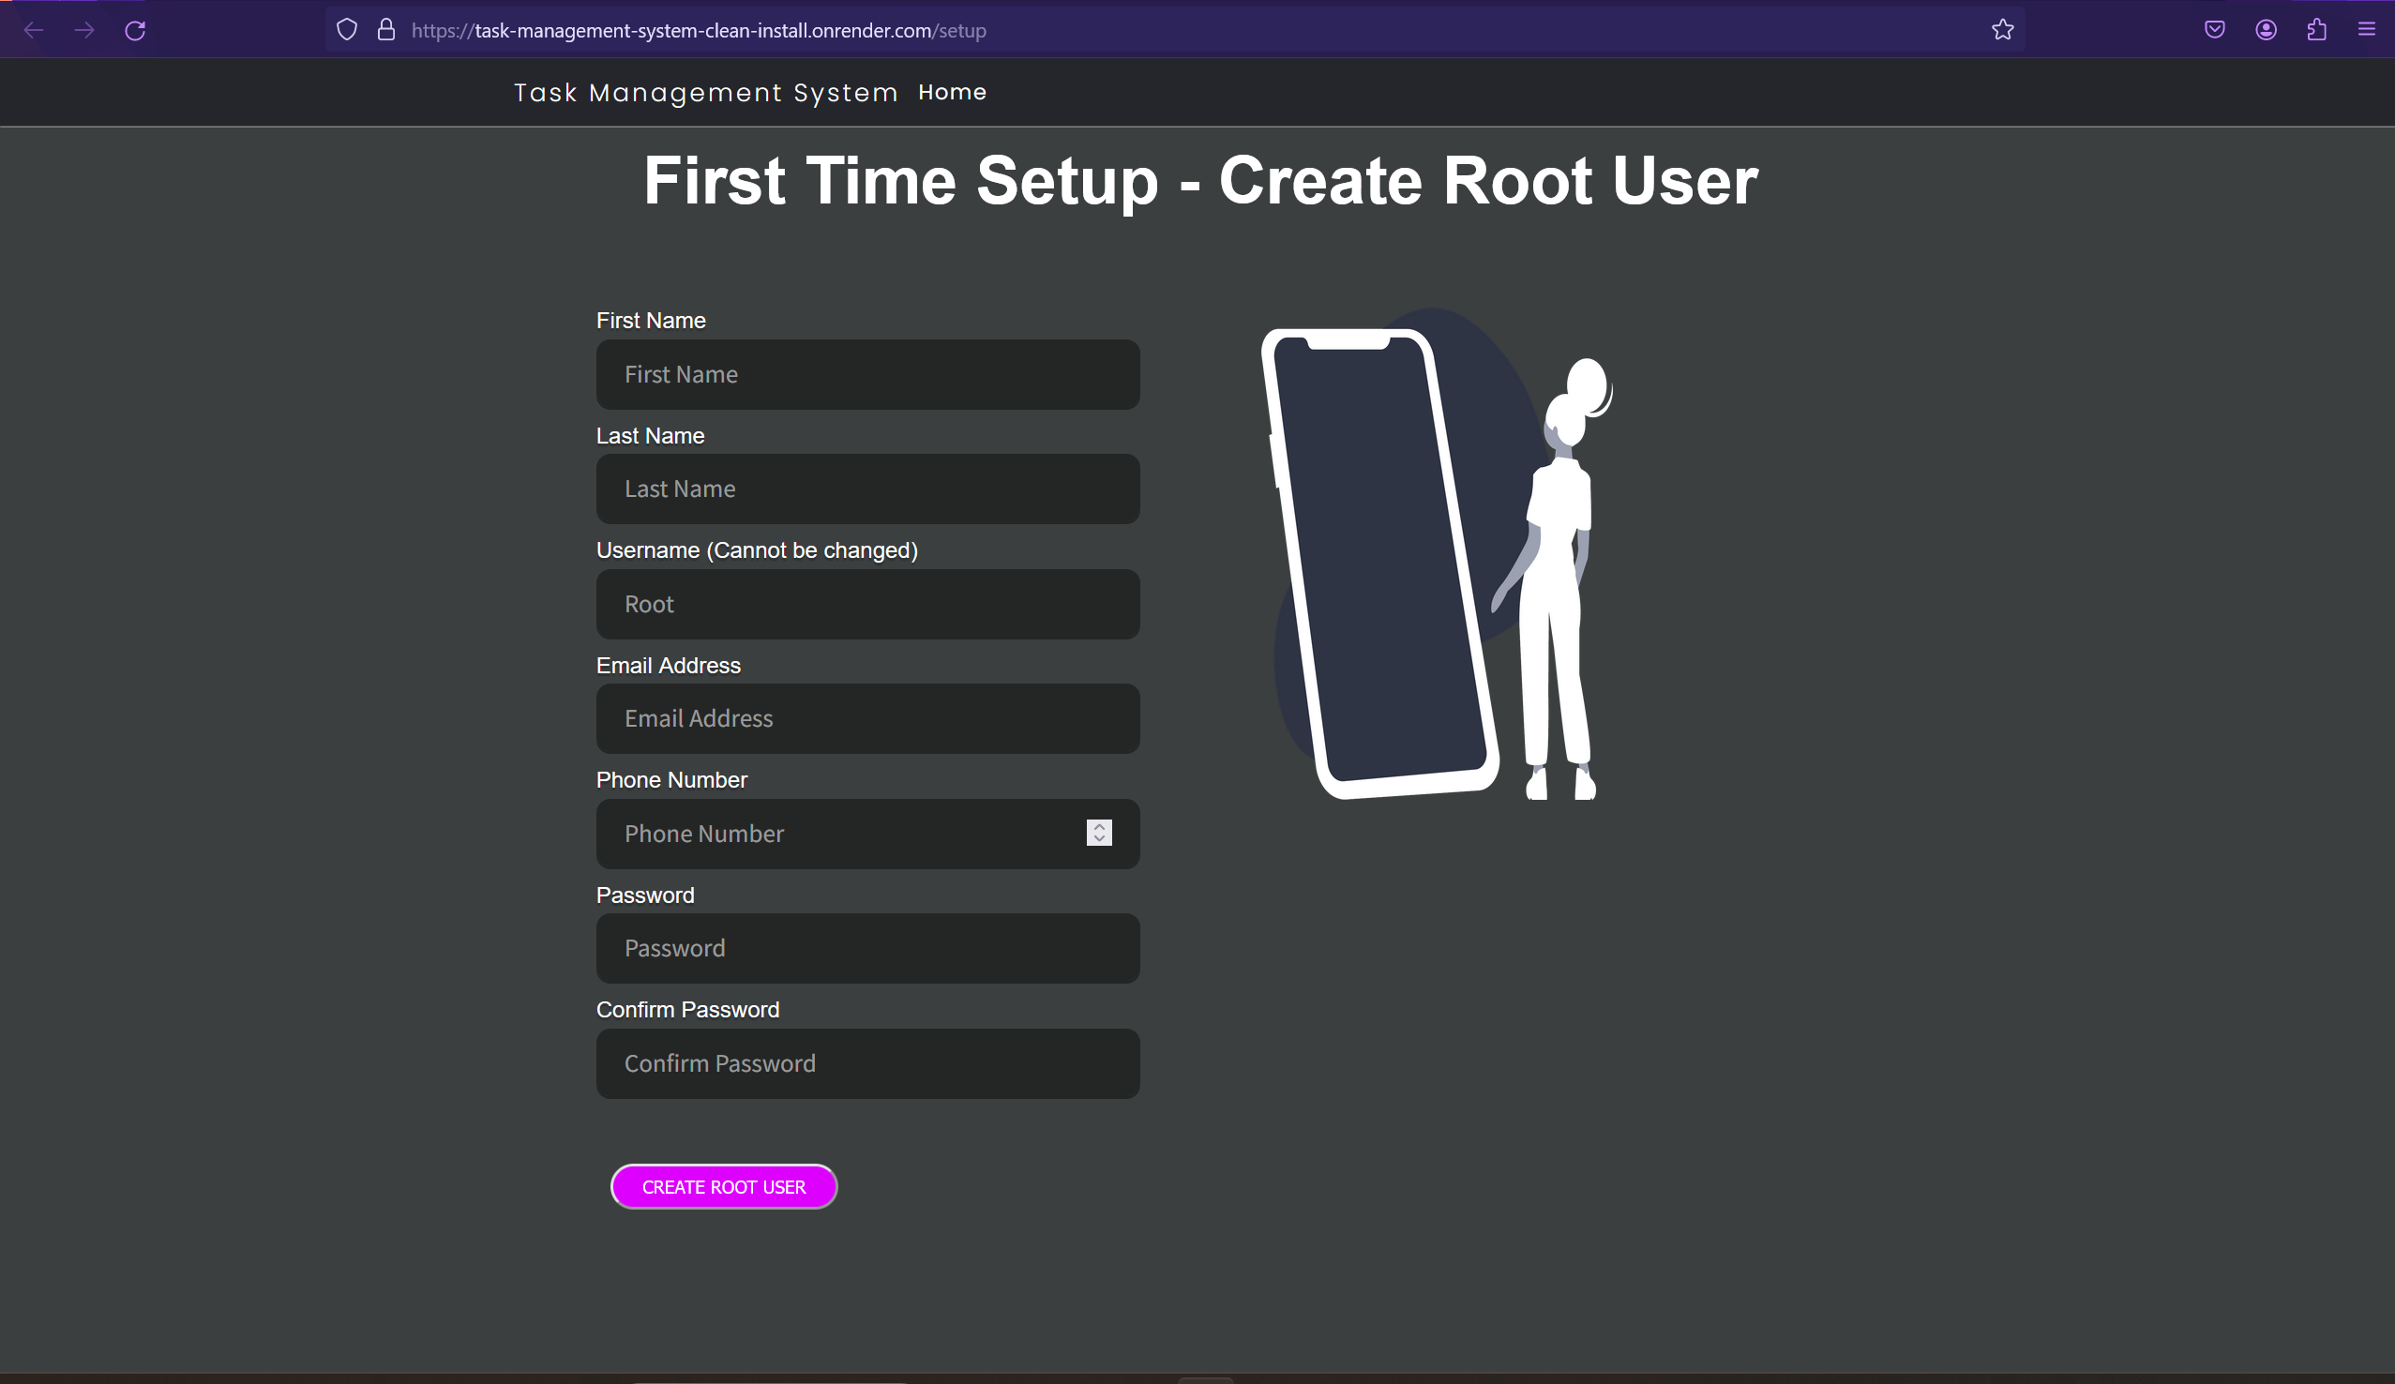

Figure 1 - Task Management System Setup Page

Fill in the fields in the form then click the *Create Root User* button. The Root username cannot be changed. The password must be a minimum length of 10 characters, have at least one capital letter, one lowercase letter, one number and one special character (ASCII characters only). The password must not be a common password. See the screenshot below for an example.

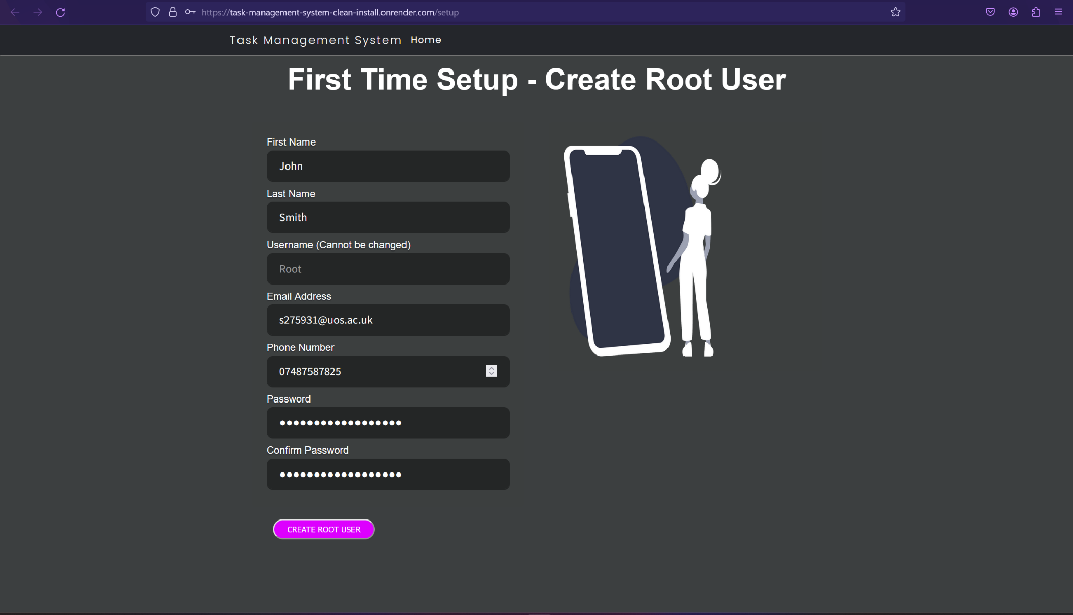

Figure 2 - Task Management System Setup Form Example

The Root user will then be redirected to the Home page and will be logged in to the Task Management System. The root user will automatically receive an email with their password sent to the email address entered in the setup form.

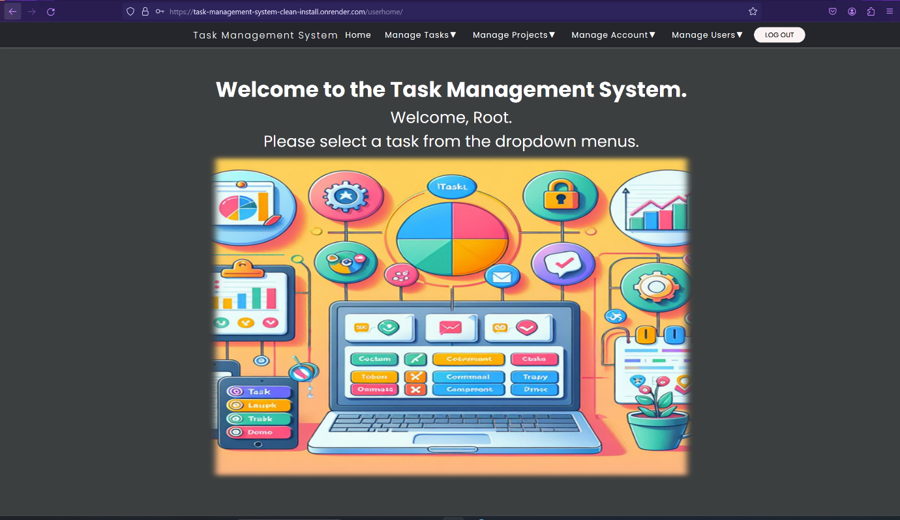

Figure 3 - Task Management System Home Page when logged in.

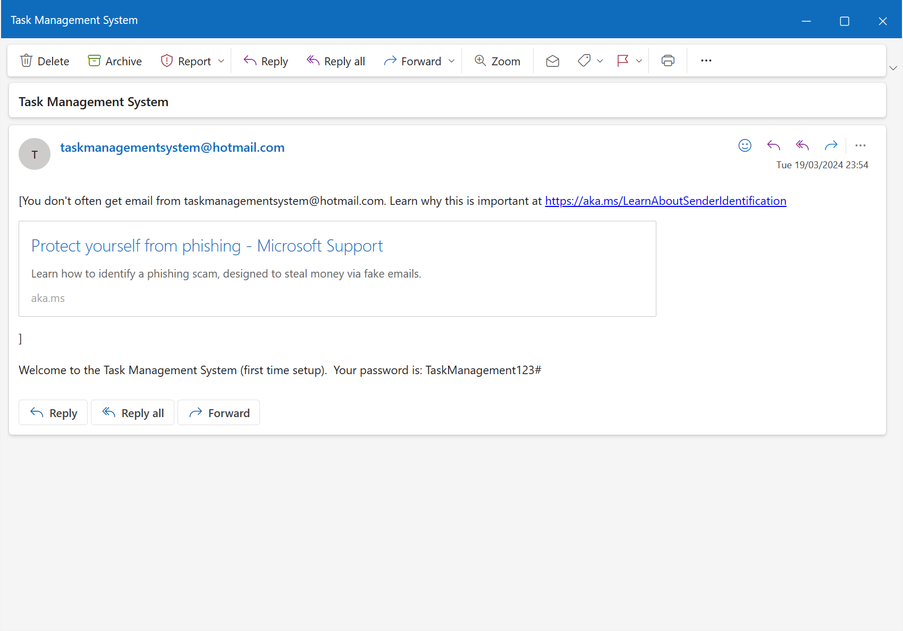

Figure 4 - Automatic email containing the Root User's password.

The Task Management System is now ready for use.

## Using the Task Management System

### First Time Setup

1. On the deployment platform of choice such as Render.com or Docker, open the link to the Task Management System (See Installation instructions above for details).

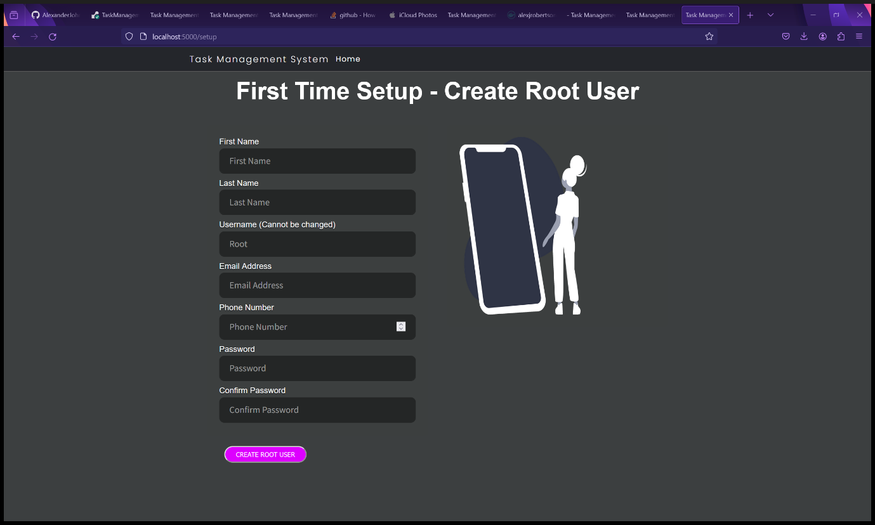

Figure 129 - Task Management System Setup page.

1. Fill in the First Time Setup form to create a Root user. Please note that the username is “Root” and cannot be changed for this user. All fields must be filled in with valid information. The password must be at least 10 characters long, have at least one uppercase letter, one lowercase letter, one number and one special character. The special character(s) must be an ASCII character due to technical limitations with the emailing function. Then click “Create Root User.” The password must be a common password.

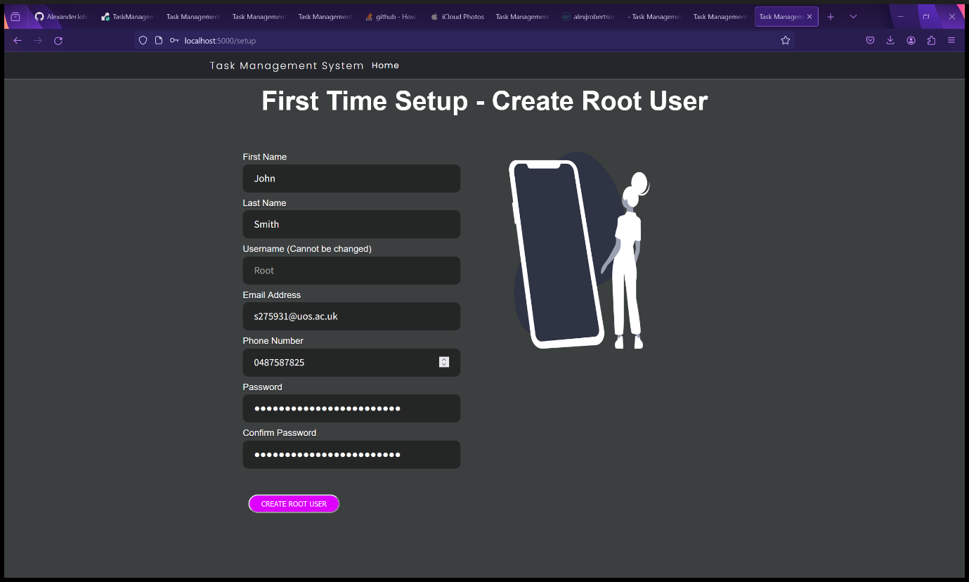

Figure 130 - Task Management System Setup page.

1. You will be redirected to the User home page and receive an email with the password you entered.

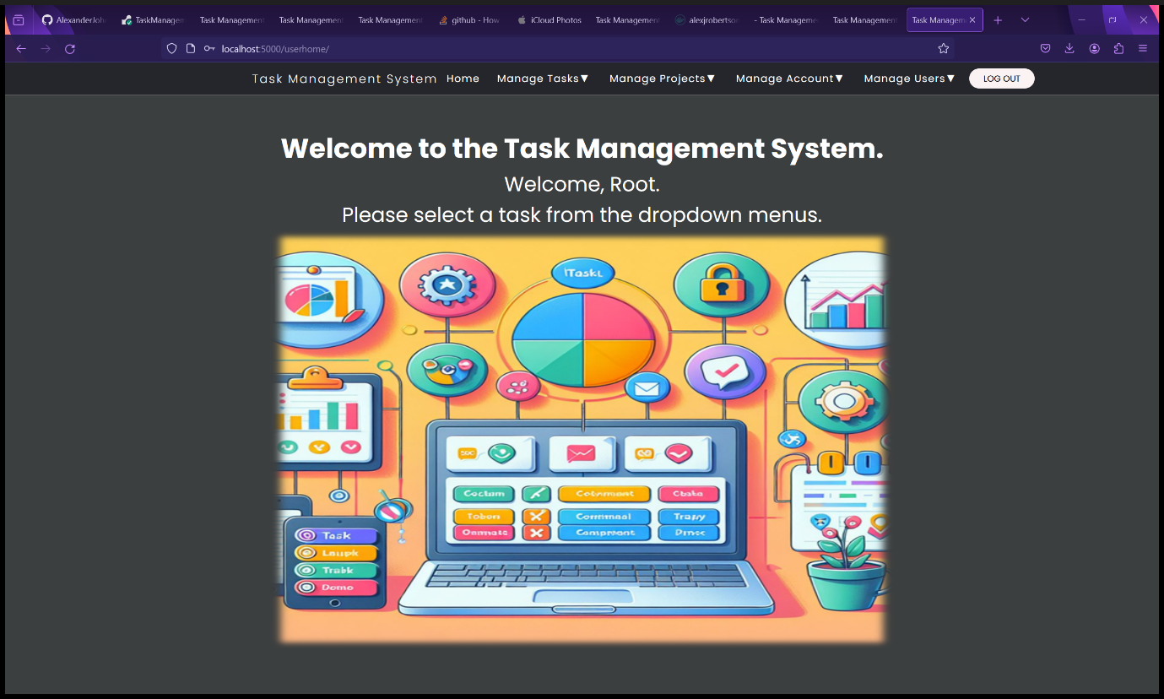

Figure 131 - User Home Page

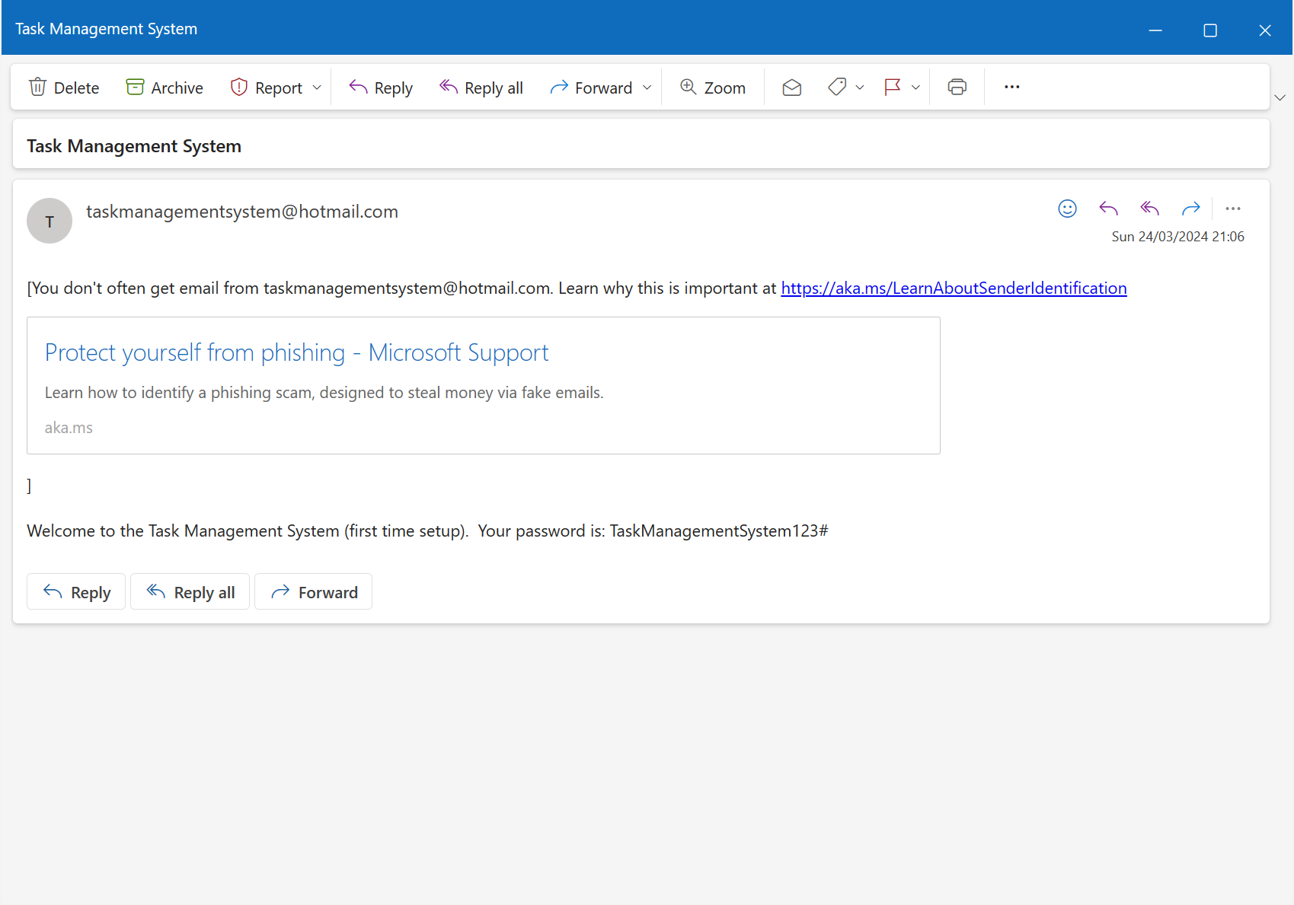

Figure 132 - Automatic email sent to Root User upon setup.

1. The Task Management System is now ready for use.

### Logging out

To log out, simply click the “Log Out" button in the top right corner of the navbar. You will be redirected to the Task Management System landing page.



Figure 133 - User Home Page while logged in.

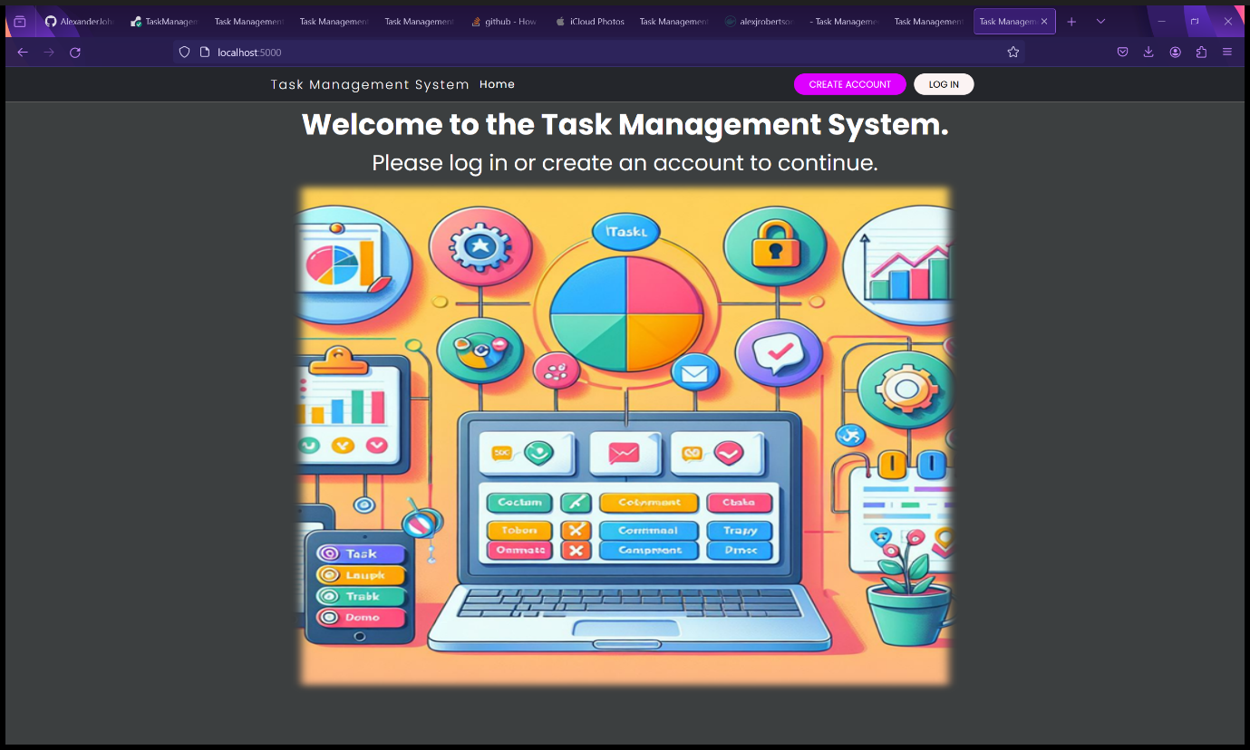

Figure 134 - Landing page after being logged out.

### Logging In

1. Click the “Log In” button in the navbar in the top right corner.



Figure 135 - Landing Page

1. Enter your username and password and click “Log In.” WARNING: If you enter the wrong password three or more times in a row, your account will be automatically blocked for security reasons. You will need to contact an administrator or Root user to unblock your account.

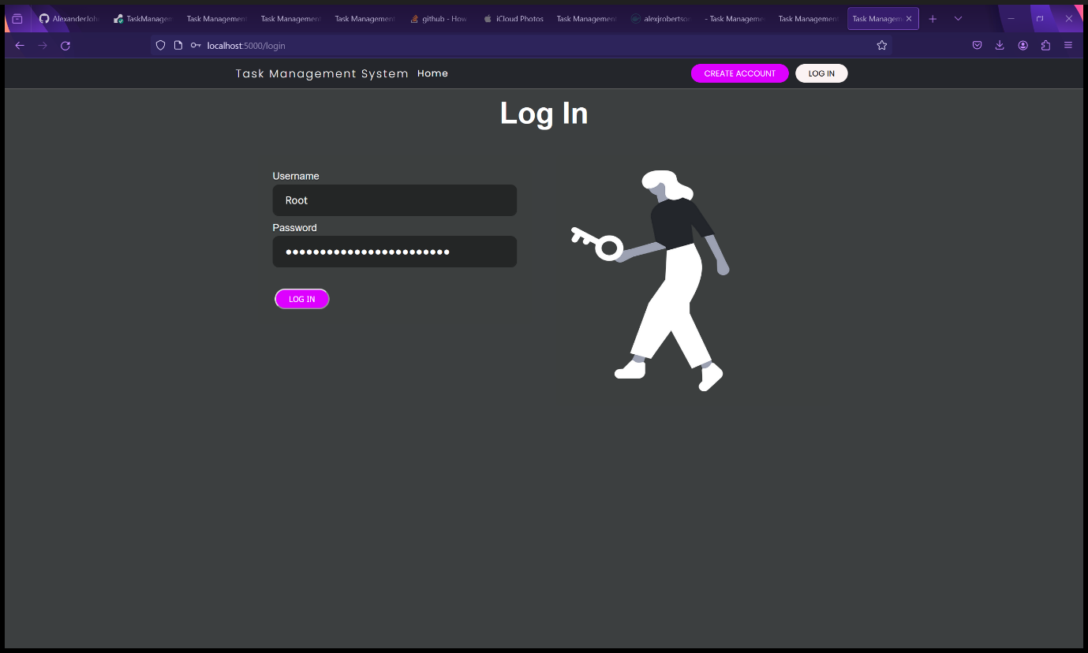

Figure 136 - Log In form.

1. You will be redirected to the User home page.

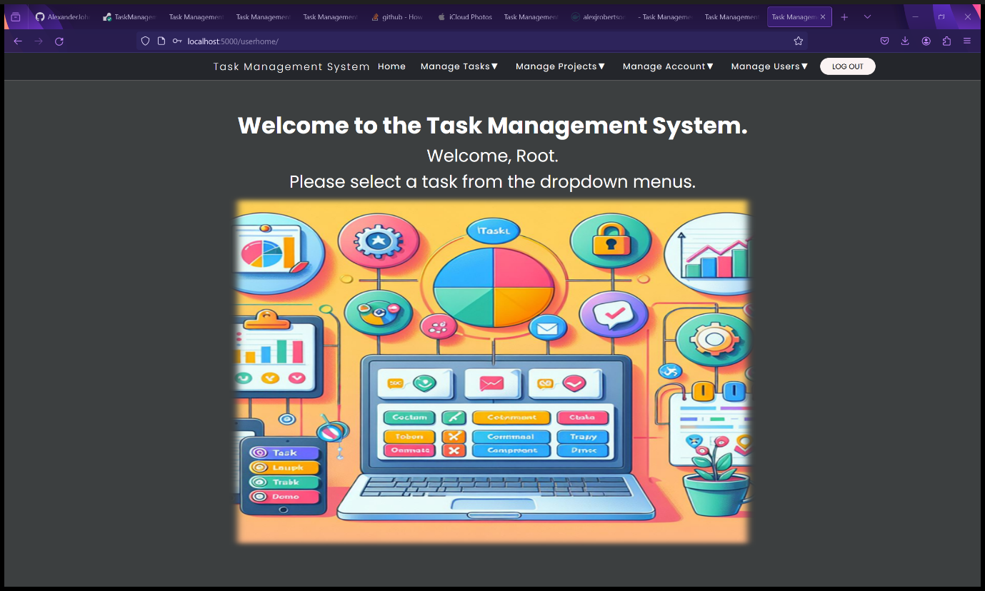

Figure 137 - User Homepage after logging in.

1. You are now able to use the Task Management System.

### Create Account

1. Click the “Create Account” button in the navbar in the top right corner.



Figure 138 - Landing Page

1. Fill in the Create Account form with your details then click the “Create Account” button. Please note that the password must be at least 10 characters long, have at least one uppercase letter, one lowercase letter, one number and one special character and must not be a common password. Non-ASCII characters such as UTF and Unicode characters are allowed as an email is not automatically sent in this case.

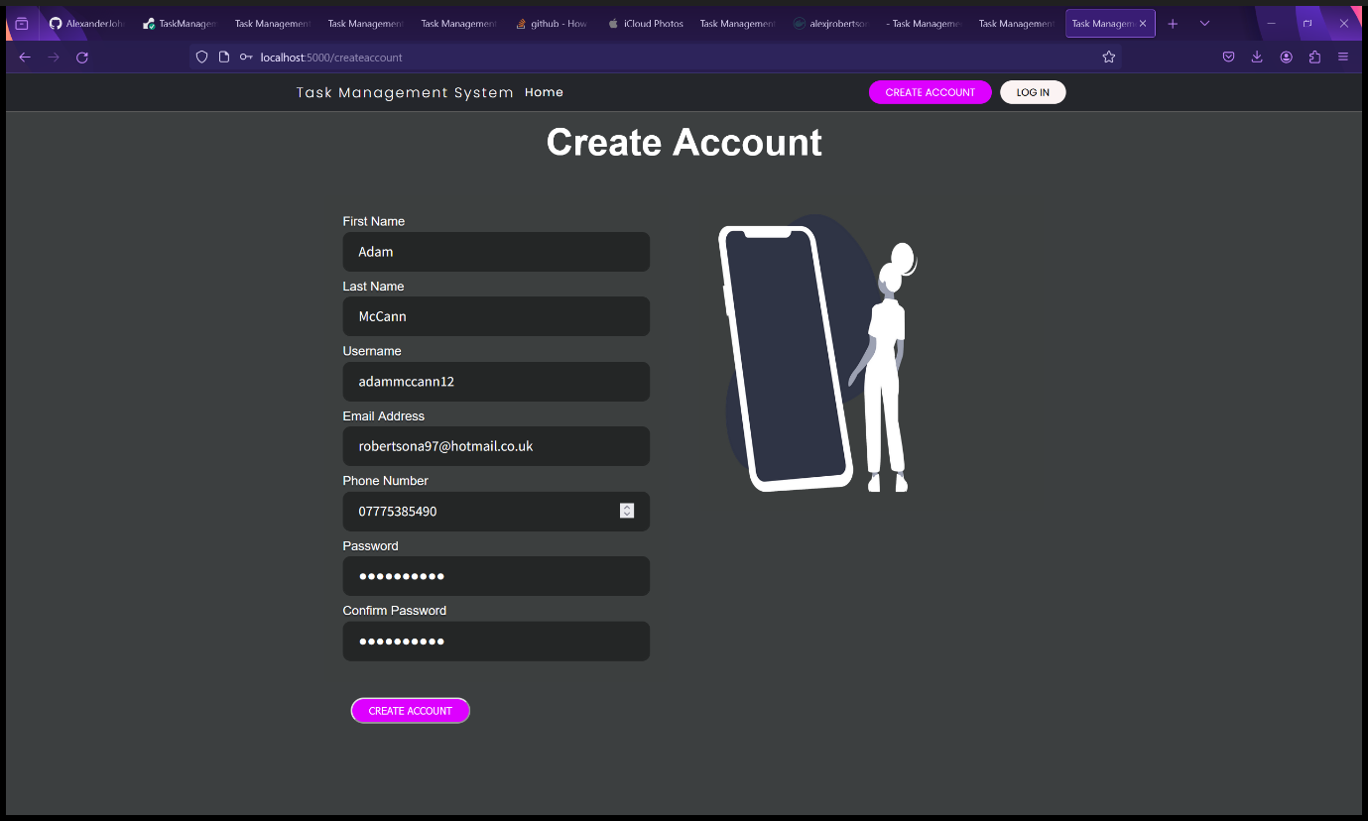

Figure 139 - Account Creation Form.

1. The user is redirected to their user home page and are now ready to use the Task Management System. Please note that new user accounts are created as a standard user by default for security purposes therefore there are restrictions on standard accounts. A standard account can add and view tasks, add and view projects, view and change their own account details except for their account type and block status. An administrator account and the Root user both have full control over the Task Management System and therefore can add, view, update and delete tasks, add, view, update and delete projects, manage other users and view other user details and perform administrative tasks. Administrators and the Root user can change the account type of other users, block and unblock users and factory reset the Task Management System.

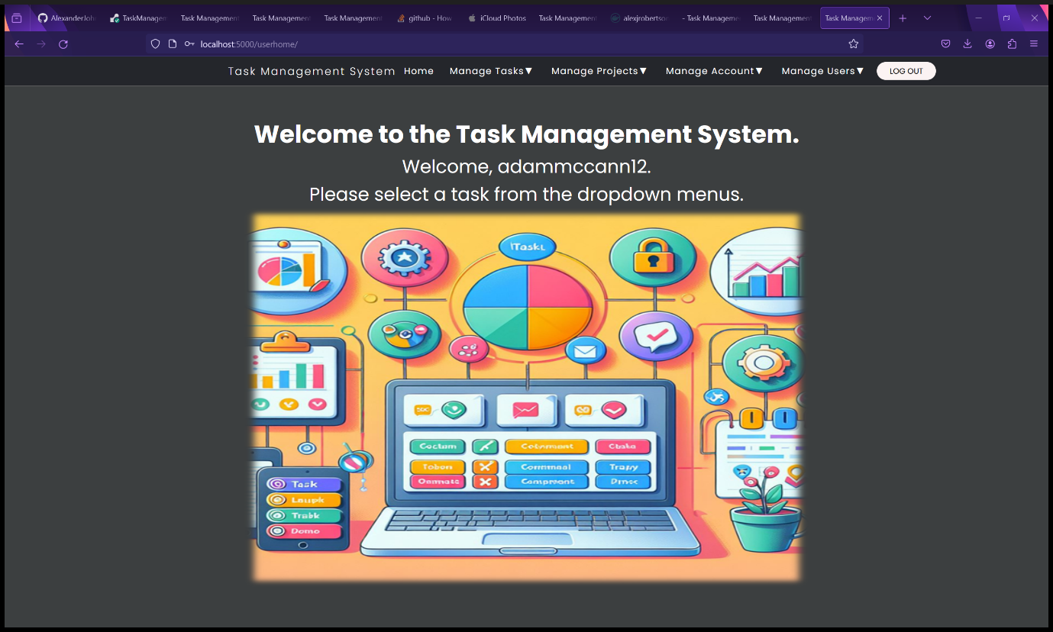

Figure 140 - User Home Page after Account Creation.

1. The Task Management System is ready for use.

### Manage Projects

#### Create a New Project

1. Select “Create Project” from the “Manage Projects” dropdown menu.

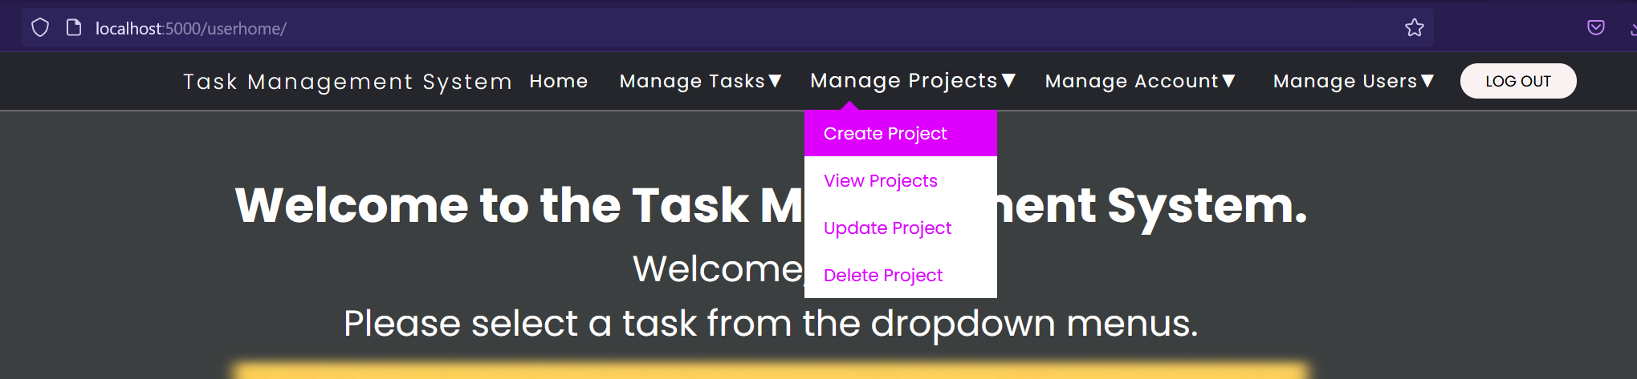

Figure 141 - Select "Create Project" from "Manage Projects" dropdown menu.

1. You will be redirected to the Add New Project form.
2. Fill in the details of the new project in the Add New Project form. All fields are mandatory.
   1. The Project ID must be a whole number. All project IDs must be unique.
   2. The Title is the project title. Any character is accepted. Foreign languages are supported.
   3. The Description text field contains the project description. Any Unicode character is supported and foreign languages and writing systems are supported.
   4. The Assigned Tasks field is where you enter a list of tasks separated by a comma. Unicode characters, foreign languages and writing systems are supported.
3. Click the “Add Project” button.

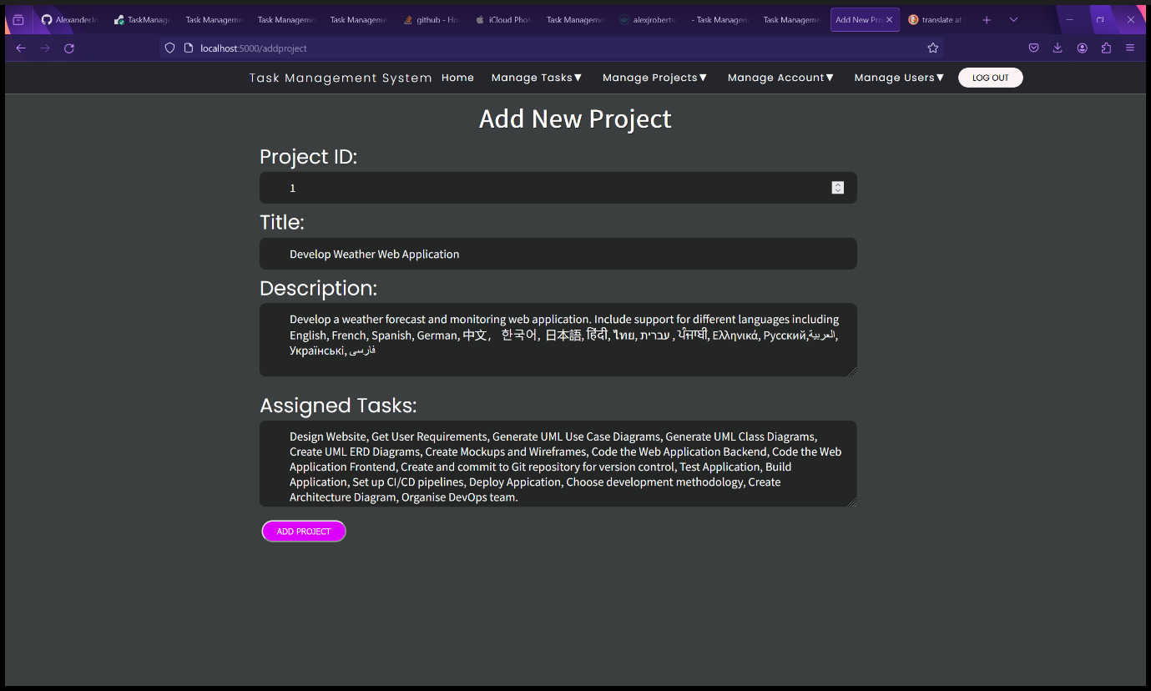

Figure 142 - Add New Project Form.

1. You will be redirected to the View Projects page where you can view the list of projects as a table.

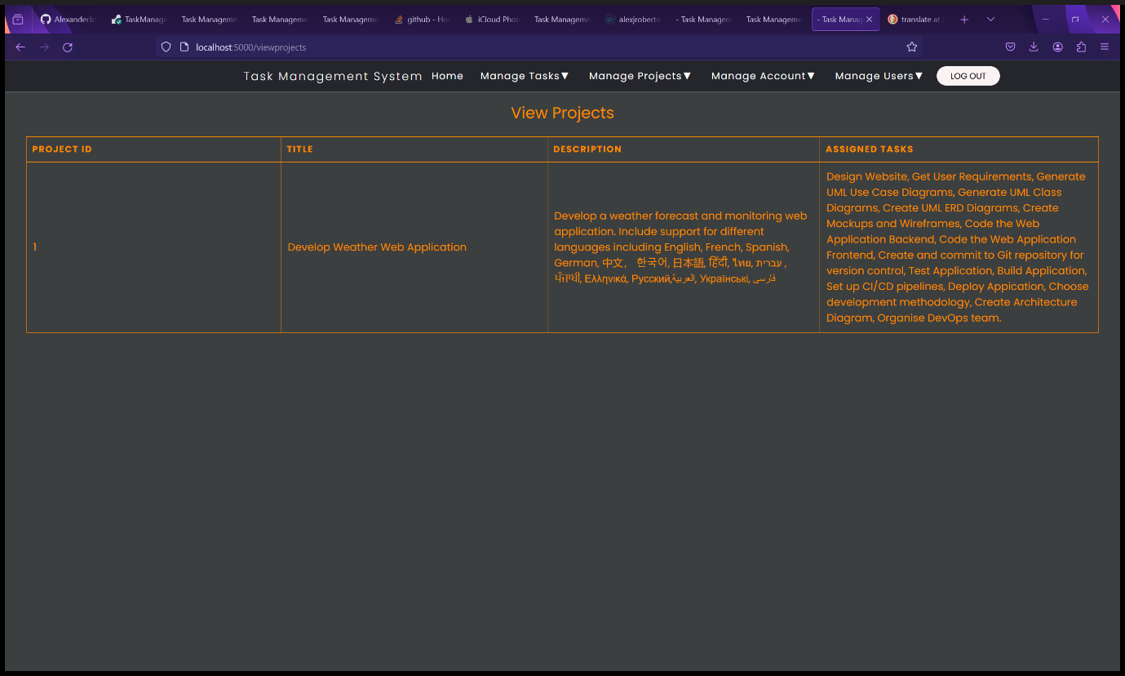

Figure 143 - Project added to View Projects Page.

#### View Projects

1. You can view the list of projects as a table by clicking “View Projects” in the “Manage Projects” dropdown menu.

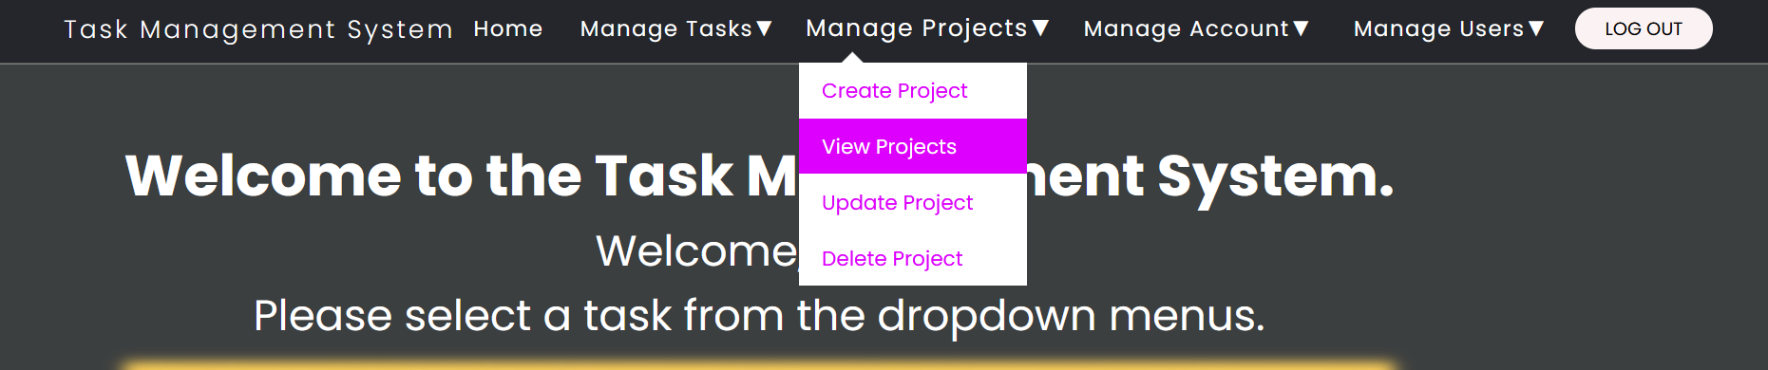

Figure 144 - Select "View Projects" from "Manage Projects" dropdown menu.

1. You will be redirected to the View Projects that displays a table of all the projects. See the two screenshots for examples.

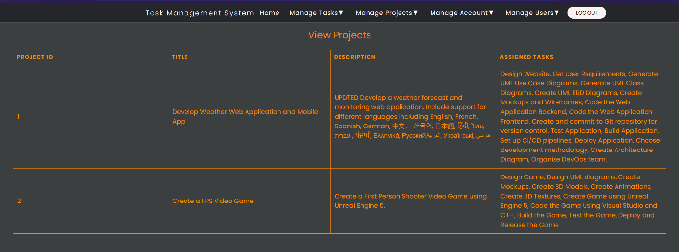

Figure 145 - View Projects page.

1. Select "Create Project" from "Manage Projects" dropdown menu.

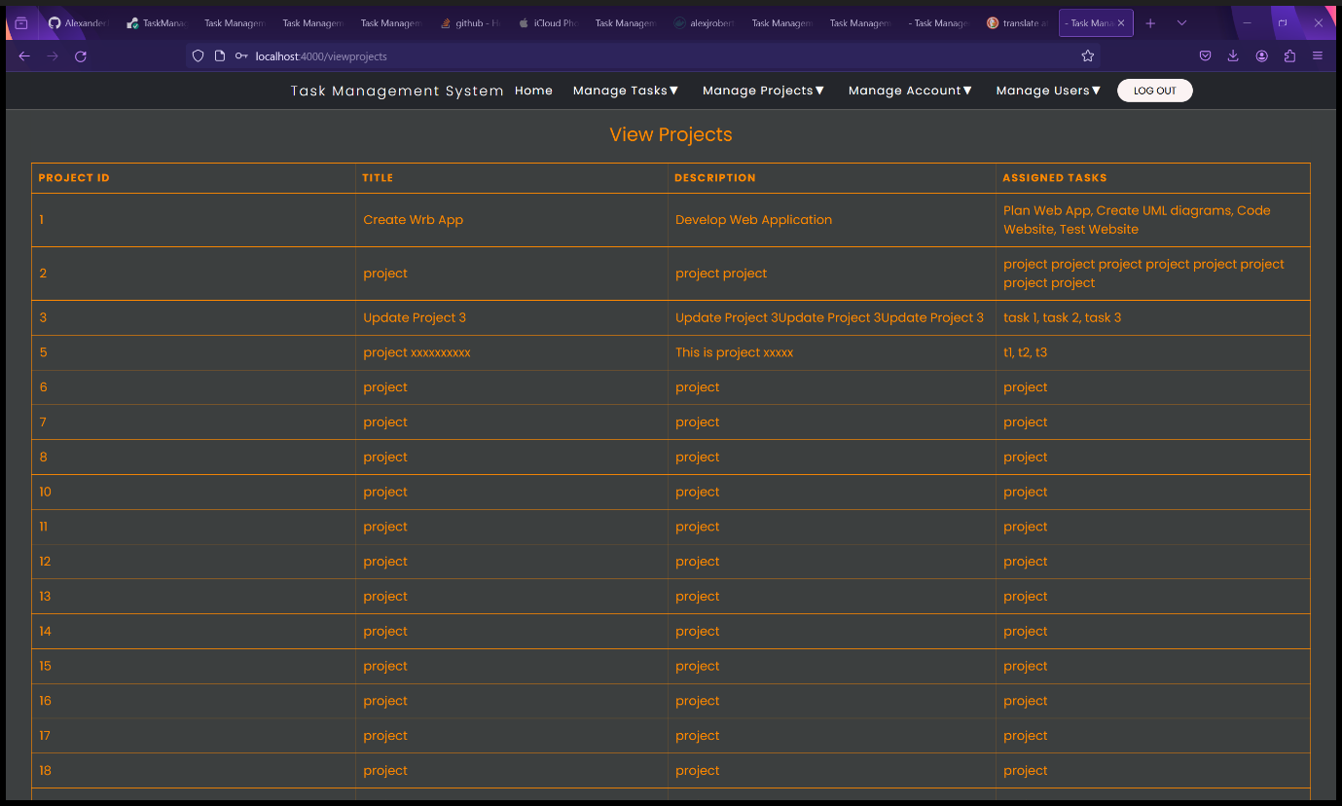

Figure 146 - View Projects page with example data.

#### Update a Project – Administrators and Root User Only

1. Select “Update Project” from the “Manage Projects” dropdown menu.

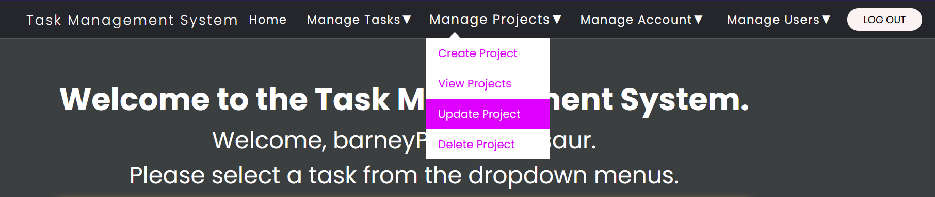

Figure 147 - Select "Update Project" from "Manage Projects" dropdown menu.

1. You will be redirected to the Update Project form.
2. Fill in the details of the new project in the Add New Project form. All fields are mandatory.
   1. The Project ID must be a whole number. All project IDs must be unique.
   2. The Title is the project title. Any character is accepted. Foreign languages are supported.
   3. The Description text field contains the project description. Any Unicode character is supported and foreign languages and writing systems are supported.
   4. The Assigned Tasks field is where you enter a list of tasks separated by a comma. Unicode characters, foreign languages and writing systems are supported.

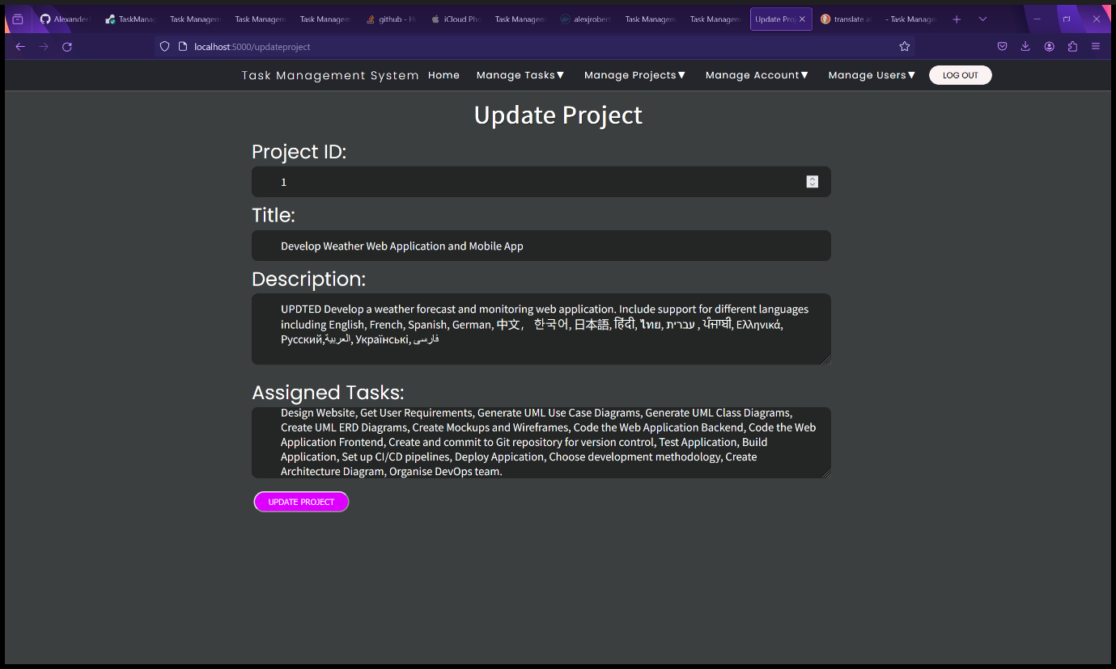

Figure 148 - Update Project form.

1. Click the “Update Project” button.
2. You will be redirected to the View Projects page where you can view the updated project.

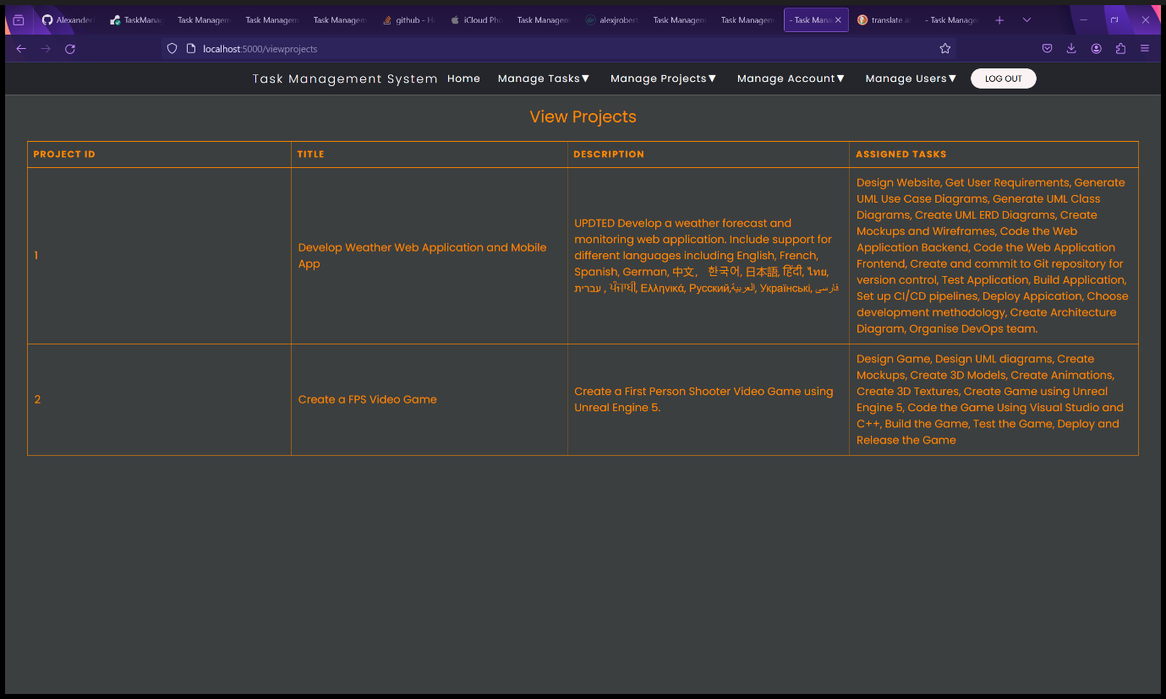

Figure 149 - View Projects page showing updated project.

#### Delete a Project – Administrators and Root User Only

1. Select “Delete Project” from the “Manage Projects” dropdown menu.

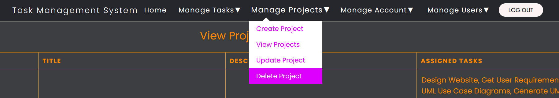

Figure 150 - Select "Delete Project" from "Manage Projects" dropdown menu.

1. You will be redirected to the Delete Project form.
2. Enter both the Project ID and Project Title into the form. The Project ID and Project Title must match to help prevent accidental deletion. In the example screenshot, Project 2 will be deleted.

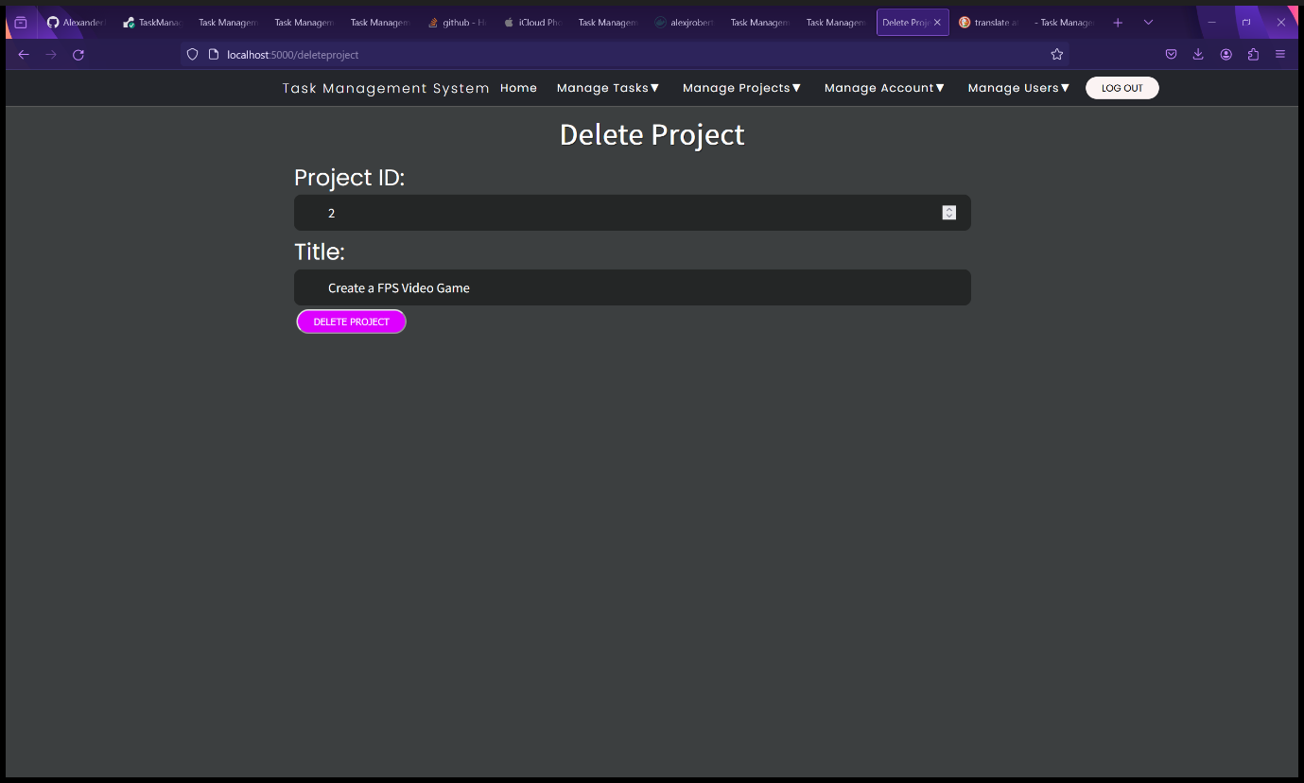

Figure 151 - Delete Project form.

* 1. Click the “Delete Project” button.
  2. You will be redirected to the View Projects page, and you will see that the project has been deleted from the database.

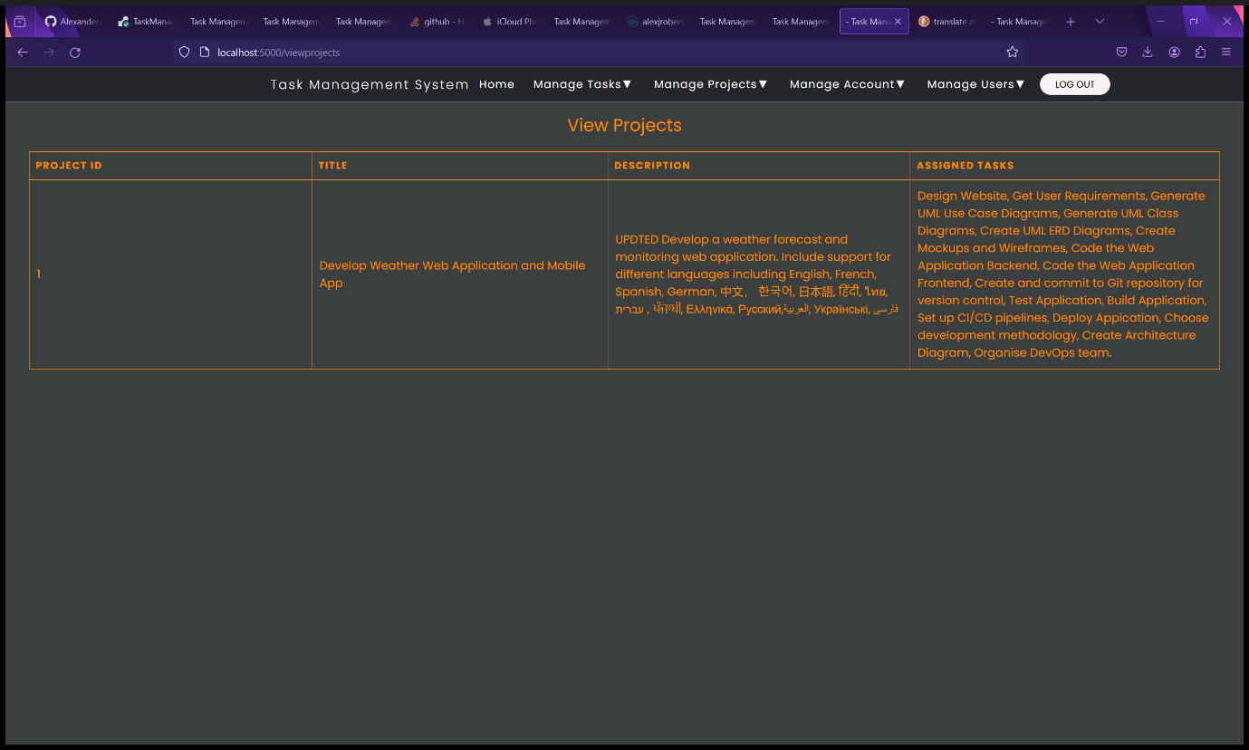

Figure 152 - Project deleted from View Projects page.

### Manage Tasks

#### Create a New Task

1. Select “Create Task” from the “Manage Tasks” dropdown menu.

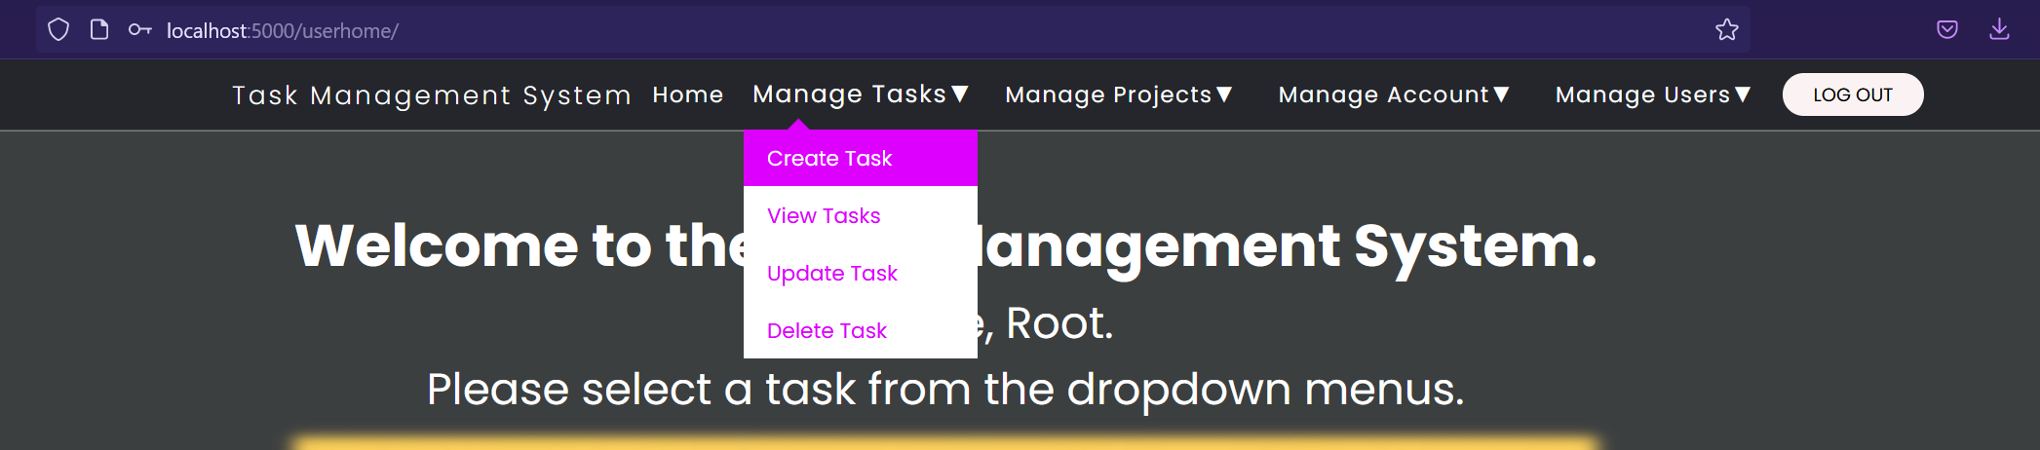

Figure 153 - Select "Create Task" from "Manage Tasks" dropdown menu.

1. You will be redirected to the Add New Task form.
2. Fill in the details of the new task in the Add New Task form. All fields are mandatory.
   1. Task ID must be a whole number and unique.
   2. Title is the title of the task. Unicode, foreign languages and writing systems are supported.
   3. Description it the description of the task. This text field is resizable and supports Unicode, foreign languages and writing systems.
   4. Due Date is the date the project is due. Must be in the format DD/MM/YYYY. Click the calendar icon in the date field for the menu to appear to select a date.

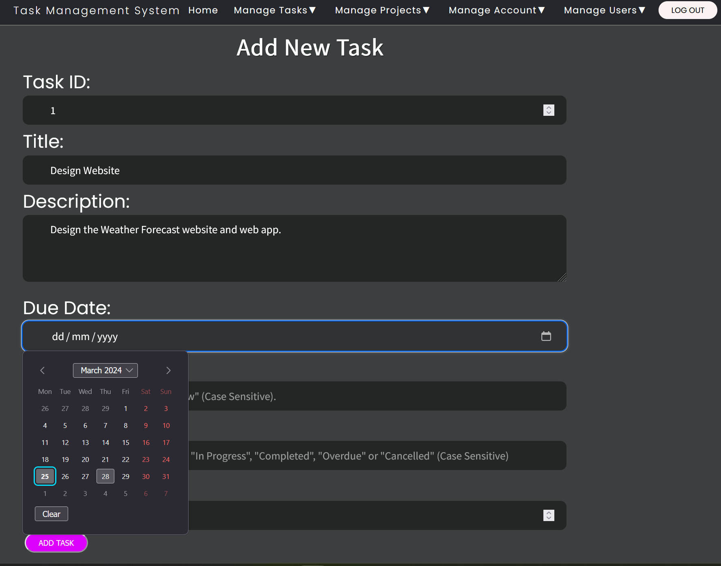

Figure 154 - Callender on Create Task form.

* 1. Priority is how urgently the task must be completed. Priority can only be “High,” “Medium” or “Low” and is case sensitive.
  2. Status is the status of the task. Status can only be “Not Started”, “Planned”, “In Progress”, “Completed”, “Overdue”, or “Cancelled” and is case sensitive.
  3. The Project ID must be a whole number and correspond to the Project ID of a project stored in the Task Management System’s database.

1. Then click the “Add Task” button.

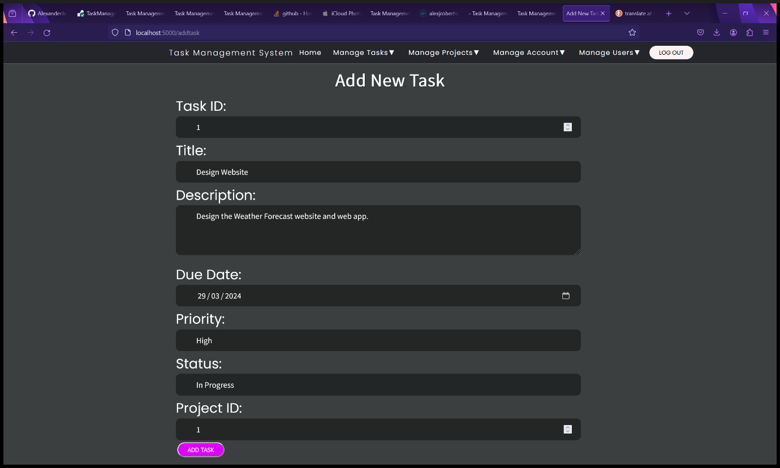

Figure 155 - Create Task form.

1. You will be redirected to the View Tasks page that displays all the tasks as a table. The task you have added will be available here.

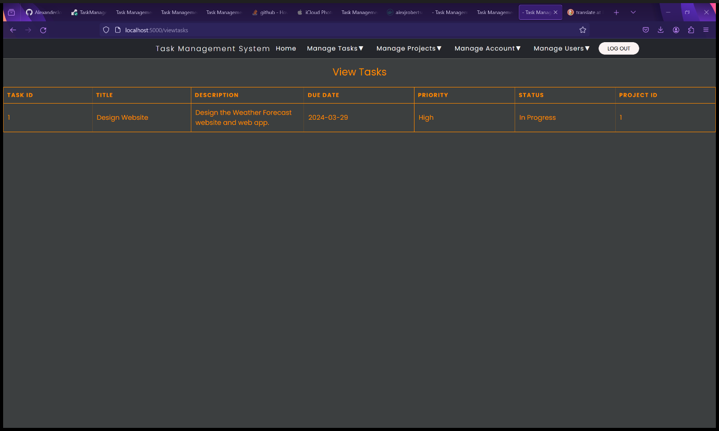

Figure 156 - New task added to View Tasks page.

#### View Tasks

1. Select “View Tasks” from the “Manage Tasks” dropdown menu.

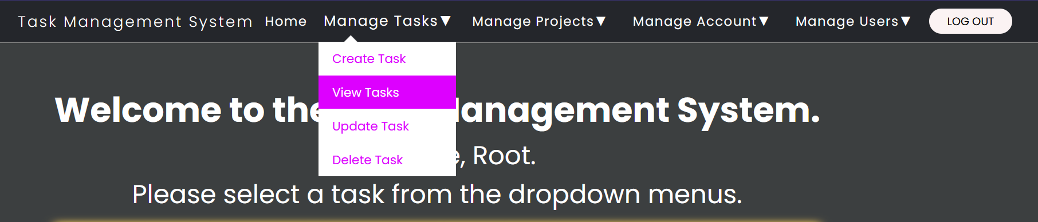

Figure 157 - Select “View Tasks" from "Manage Tasks" dropdown menu.

1. You will be redirected to the View Tasks page that displays a list of tasks and details of each task as a table.

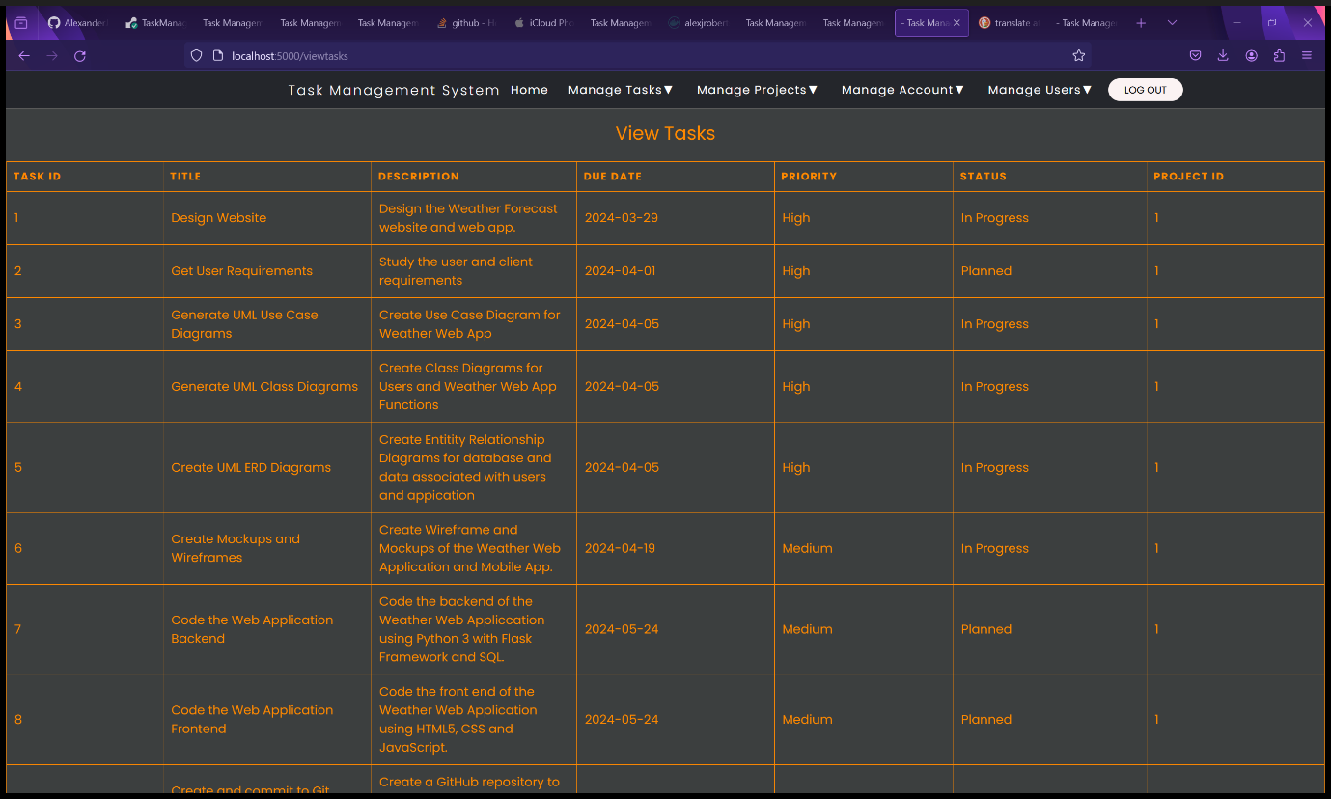

Figure 158 - View Tasks page with example tasks.

#### Update Tasks – Administrators and Root User Only

1. Select “Update Task” from the “Manage Tasks” dropdown menu.

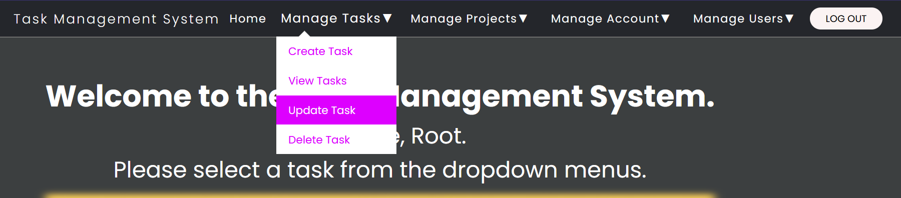

Figure 159 - Select "Update Task" from "Manage Tasks" dropdown menu.

1. Fill in the details of the new task in the Update Task form. All fields are mandatory.
   1. Task ID must be a whole number and unique.
   2. Title is the title of the task. Unicode, foreign languages and writing systems are supported.
   3. Description it the description of the task. This text field is resizable and supports Unicode, foreign languages and writing systems.
   4. Due Date is the date the project is due. Must be in the format DD/MM/YYYY. Click the calendar icon in the date field for the menu to appear to select a date.

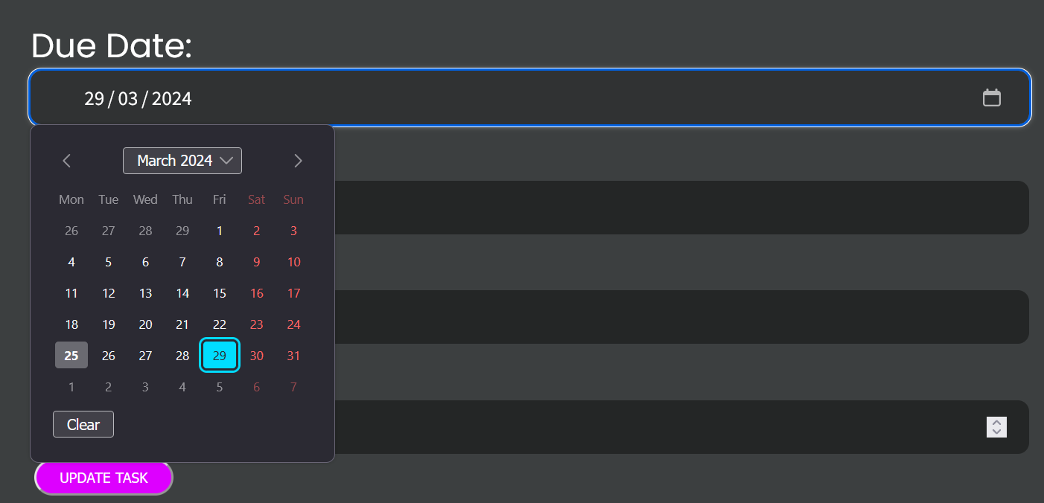

Figure 160 - Callender on Create Task form.

* 1. Priority is how urgently the task must be completed. Priority can only be “High”, “Medium” or “Low” and is case sensitive.
  2. Status is the status of the task. Status can only be “Not Started”, “Planned”, “In Progress”, “Completed”, “Overdue”, or “Cancelled” and is case sensitive.
  3. The Project ID must be a whole number and correspond to the Project ID of a project stored in the Task Management System’s database.

1. Then click the “Update Task” button.

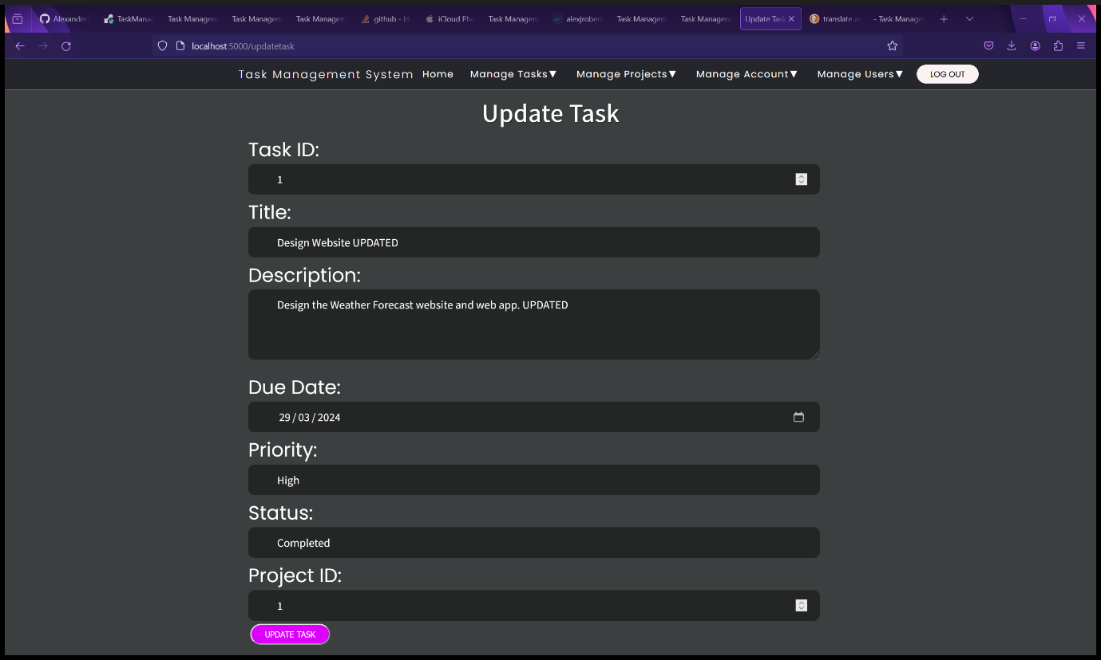

Figure 161 - Update Tasks form.

1. You will be redirected to the View Tasks page where you can view the updated task.

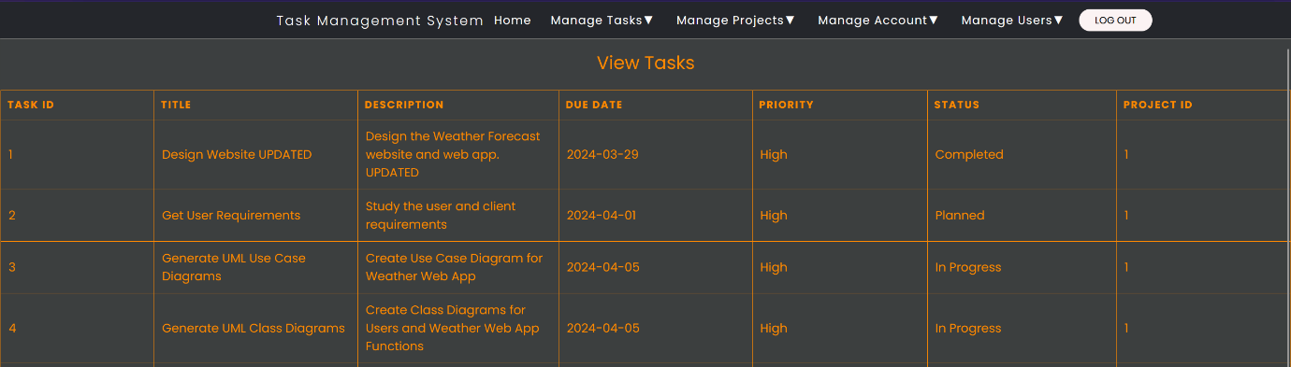

Figure 162 - View Tasks page with updated task.

#### Delete Tasks – Administrators and Root users only.

1. Select “Delete Task” from the “Manage Tasks” dropdown menu.

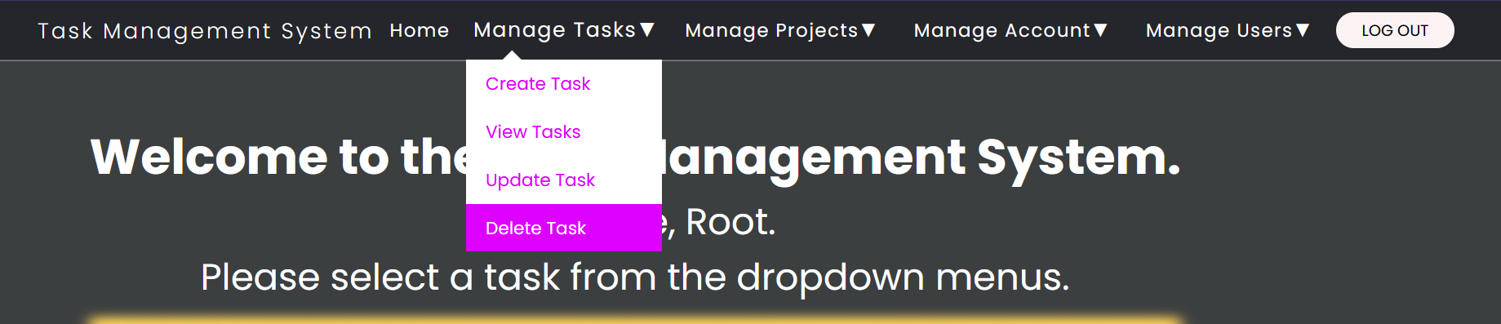

Figure 163 - Select "Delete Task" from "Manage Tasks" dropdown menu.

1. You will be redirected to the Delete Task form.
2. Enter both the Task ID and Task Title into the form. The Task ID and Task Title must match to help prevent accidental deletion. In the example screenshot, Task 4 will be deleted.

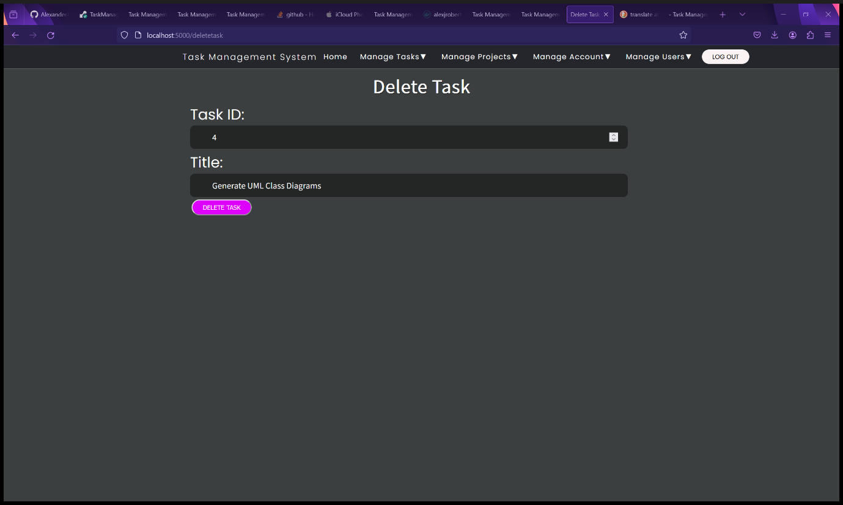

Figure 164 - Delete Task form.

1. Click the “Delete Task” button.
2. You will be redirected to the View Tasks page, and you will see that the task (Task 4 in this case) has been deleted from the database.

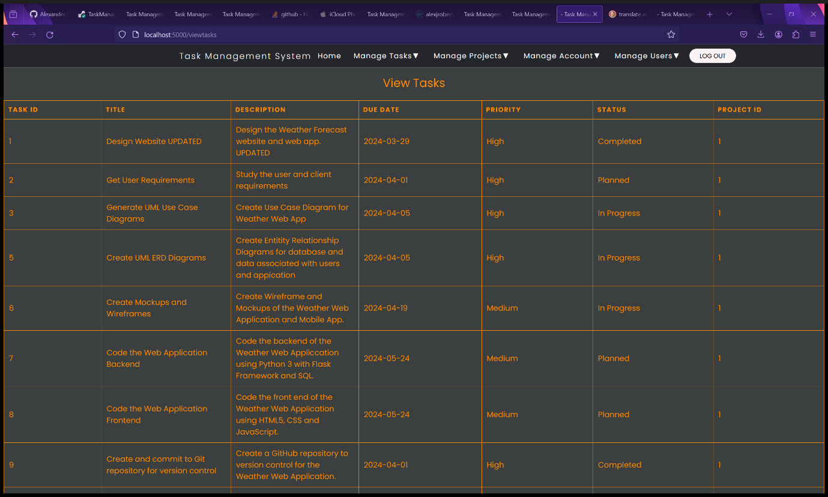

Figure 165 - View Tasks page after Task 4 has been deleted.

### Managing Your Account

#### View Your Account Details

1. Select “View Account Details” from the “Manage Account” dropdown menu.

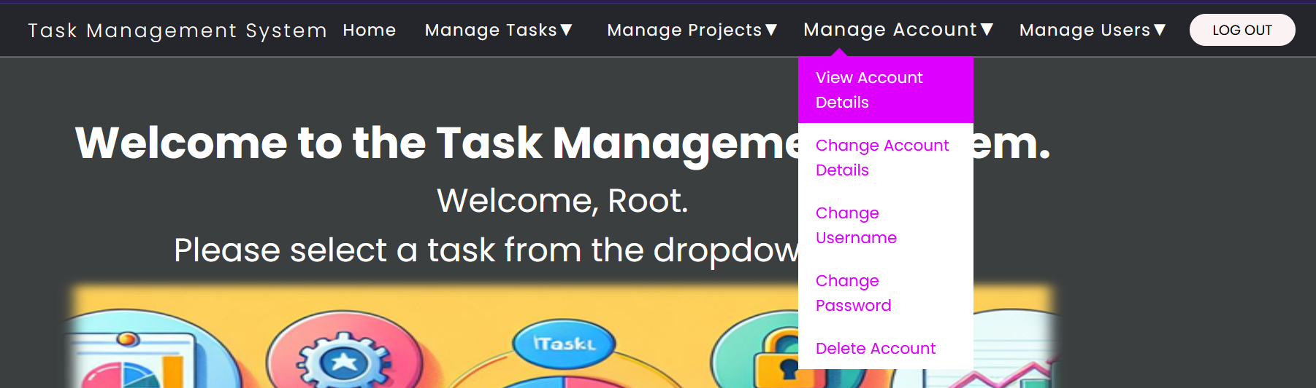

Figure 166 - Select "View Account Details" from "Manage Account" dropdown menu.

1. You will be redirected to the Your Account Details page.

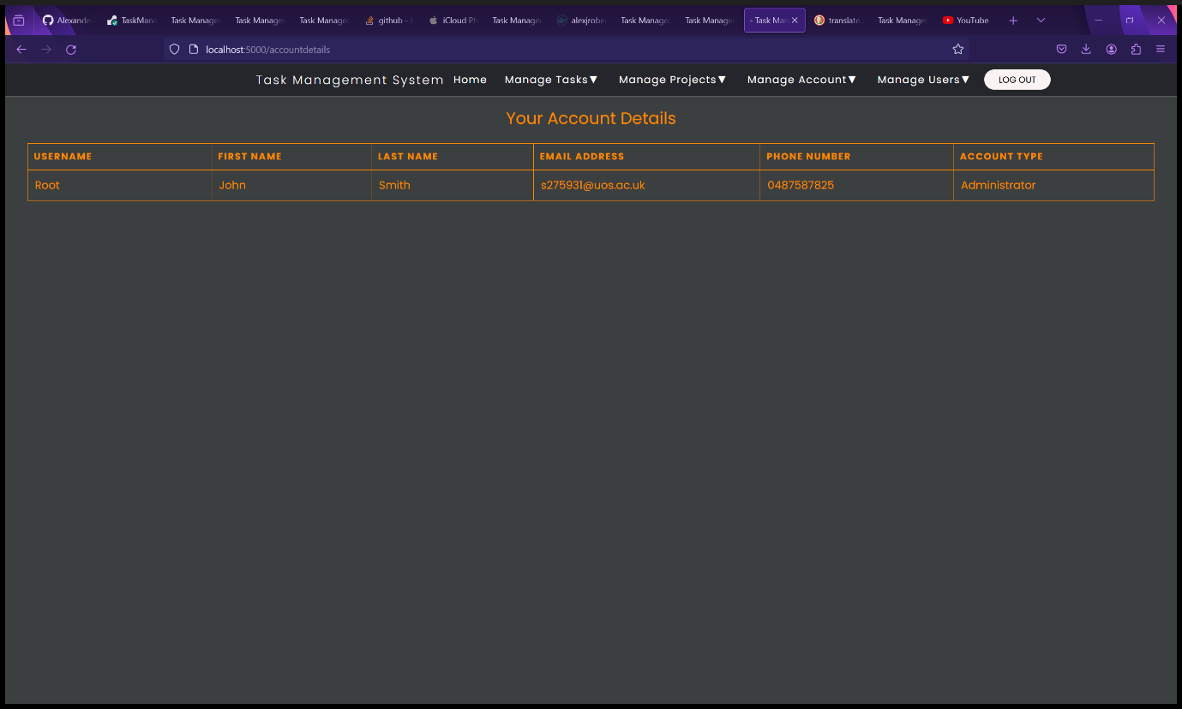

Figure 167 - Your Account Details page

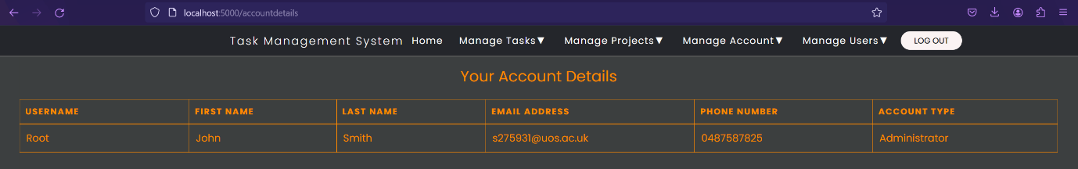

Figure 58 - Your Account Details.

#### Changing your Account Details

1. Select “Change Account Details” from the “Manage Account” dropdown menu.

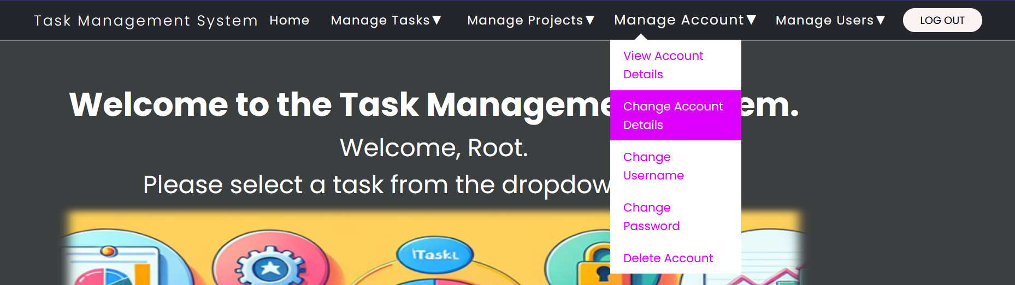

Figure 168 - Select "Change Account Details" from "Manage Account" dropdown menu.

1. You will be redirected to the Update Account Details page where you can change all your account details except your username and password which are done on a different page. You also cannot change your account type or blocked status – only an administrator or Root user can do this.

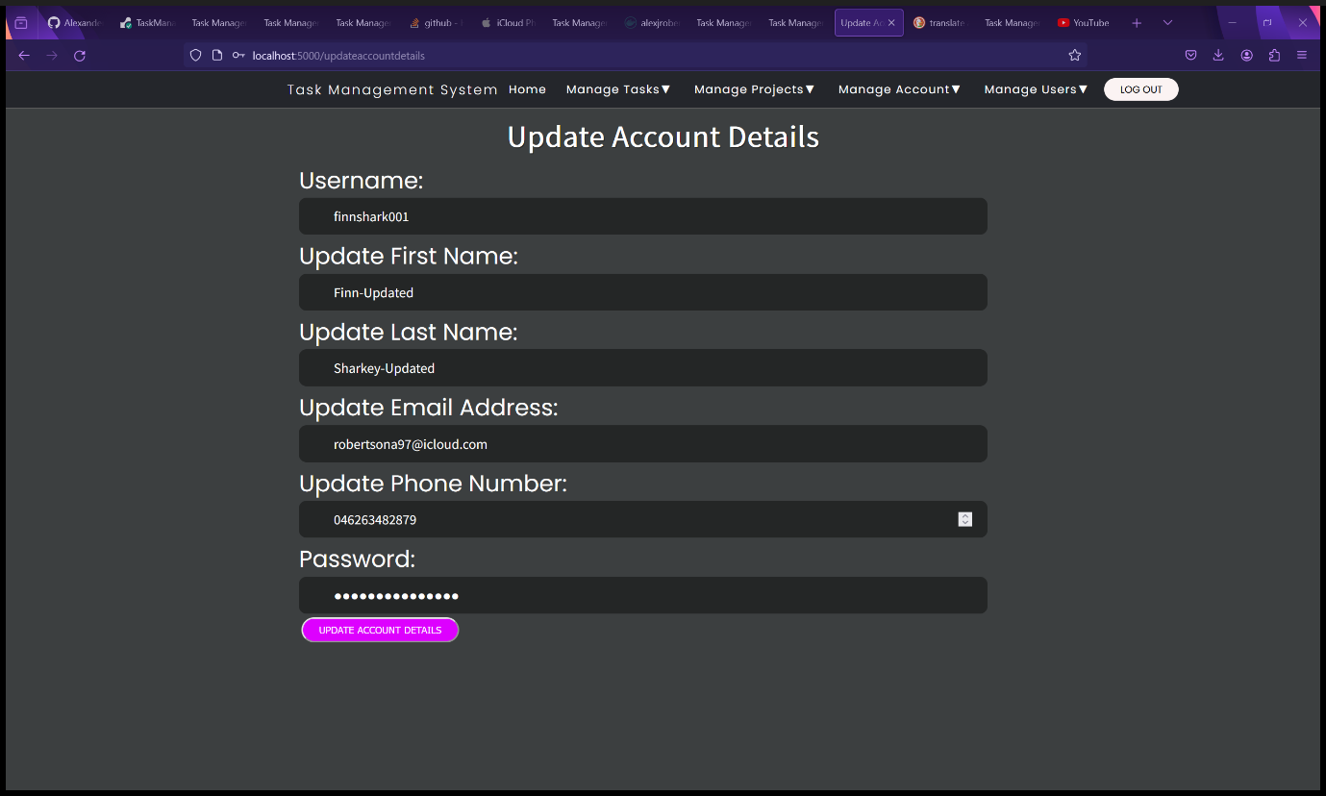

Figure 169 - Update Account Details form.

1. Fill in the Update Account Details Form and click the “Update Account Details” button.
2. You will be redirected to the User Home page with a message saying, “Account Details Updated Successfully”.

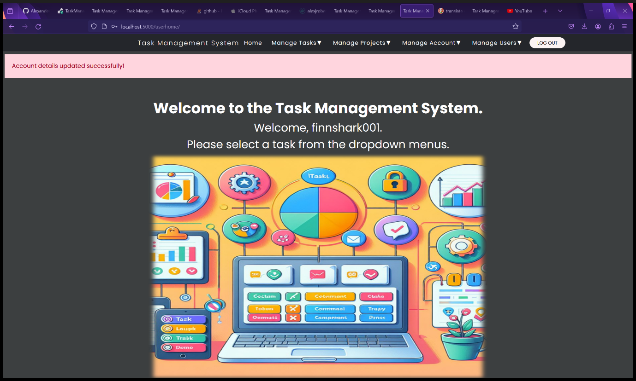

Figure 170 - User Home page after updating account details.

1. You can view your updated account details in the View Account Details page.

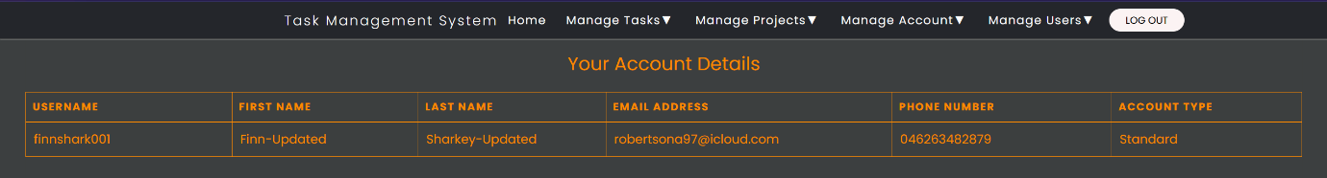

Figure 171 - Account details after being updated.

#### Changing your Username

1. Select “Change Username” from the “Manage Account” dropdown menu.

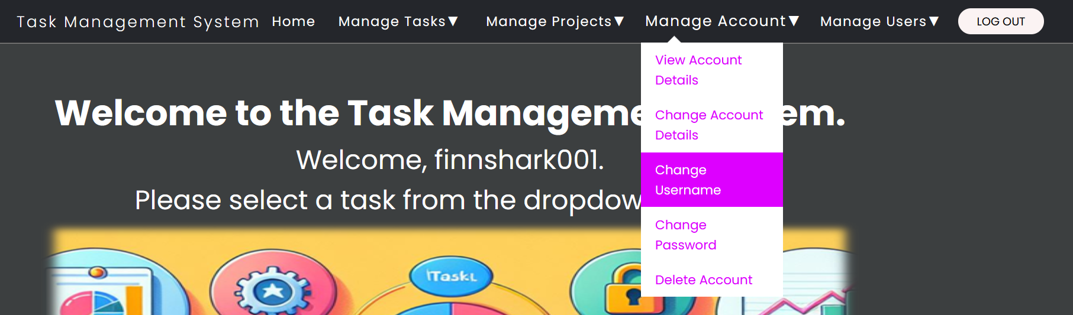

Figure 172 - Select "Change Username" from "Manage Account" dropdown menu.

1. You will be required to Change Username form page.
2. Fill in the Change Username form with:
   1. Your current username
   2. Your new username
   3. Confirm your new username so you remember it and prevent accidental changes.
   4. Enter your password to confirm your username change, for security to prevent unauthorized username changes and to prevent accidental username changes.
3. Click the “Change Username” button.

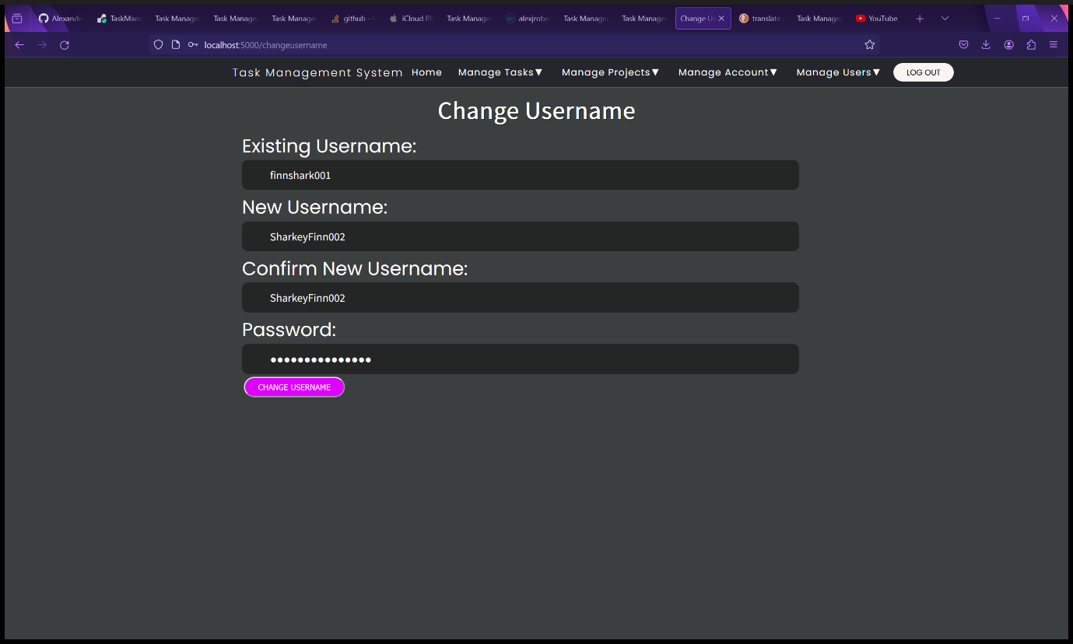

Figure 173 - Change Username form.

1. You will be redirected to the User Home Page with a message saying, “Username changes successfully!”.

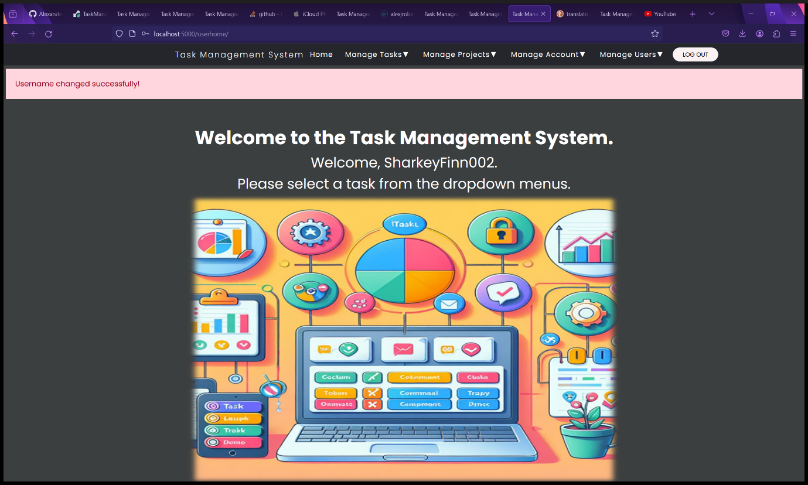

Figure 174 - User Home page after changing username.

1. You can view your username change in the View Account details page.

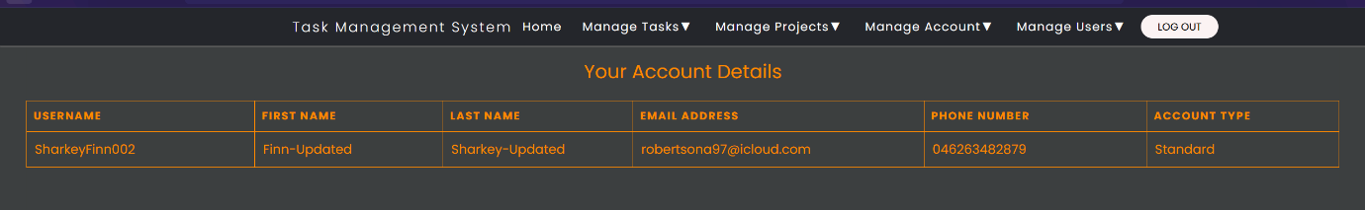

Figure 175 - Your Account Details page after changing username.

#### Changing your Password

1. Select “Change Password” from the “Manage Account” dropdown menu.

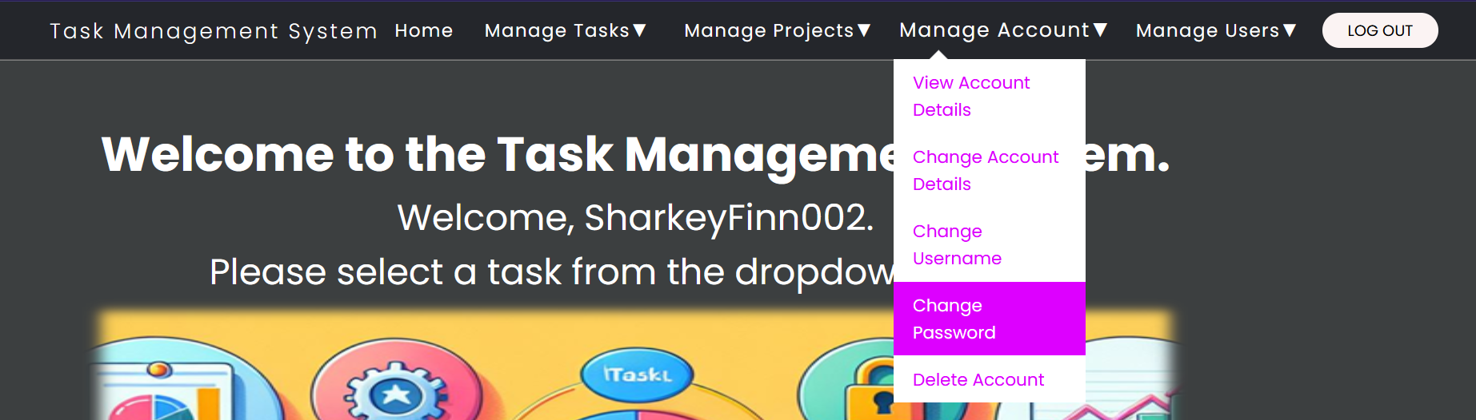

Figure 176 - Select "Change Password" from "Manage Account" dropdown menu.

1. You will be redirected to the Change Password form page.
2. Fill in the Change Password form:
   1. Username – Your current username.
   2. Existing Password – for security to prevent unauthorised and accidental password changes.
   3. New Password – must meet the following requirements: Minimum length of 10 characters, at least one capital letter, one lowercase letter, one number, one special ASCII, UTF or Unicode character and must not be a common password.
   4. Confirm new password so you are less likely to forget it.
3. Click the “Change Password” button.

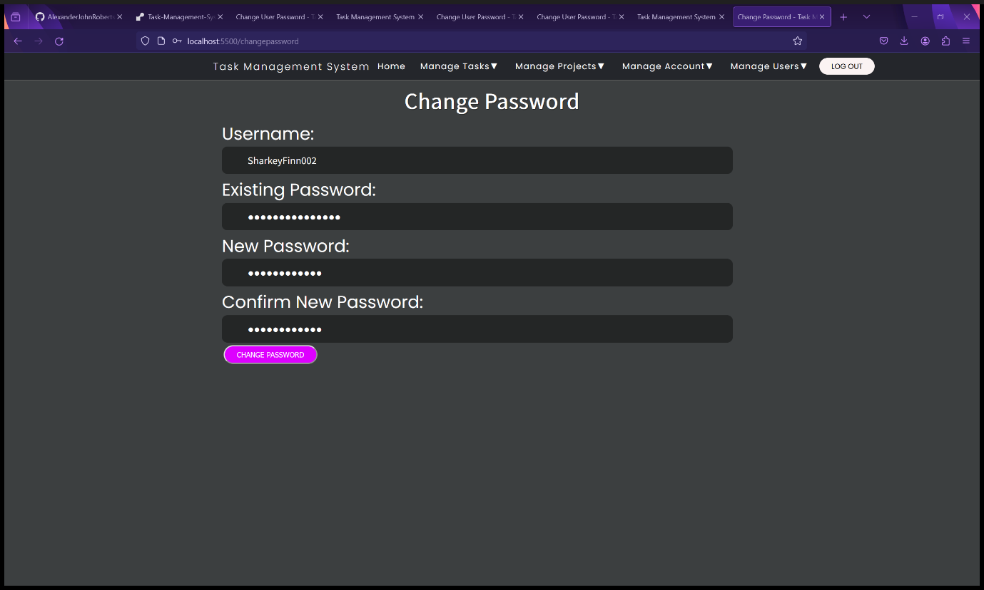

Figure 177 - Change Password form page.

* 1. You will be redirected to the User Home page showing a message saying, “Password Changed Successfully”.

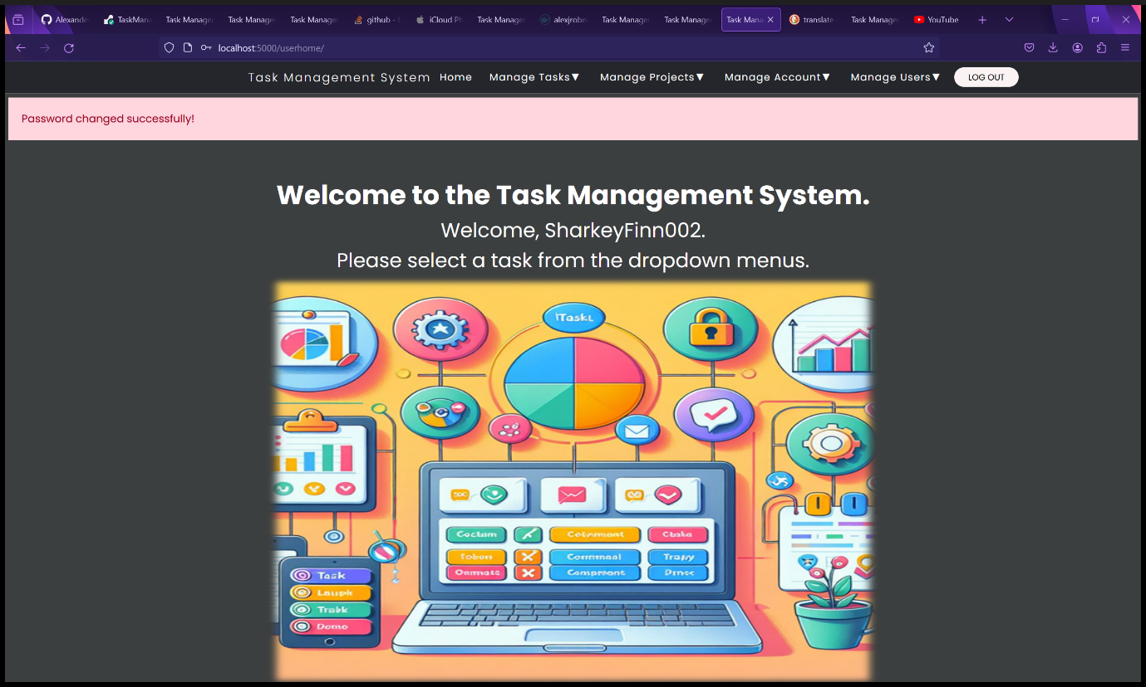

Figure 178 - User Home page after changing password.

1. You will not be able to view your password in the View Account Details page because of security and privacy reasons.

#### Deleting your Account

WARNING: DELETING YOUR ACCOUNT WILL BE PERMANENT.

1. Select “Delete Account” from the “Manage Account” dropdown menu.

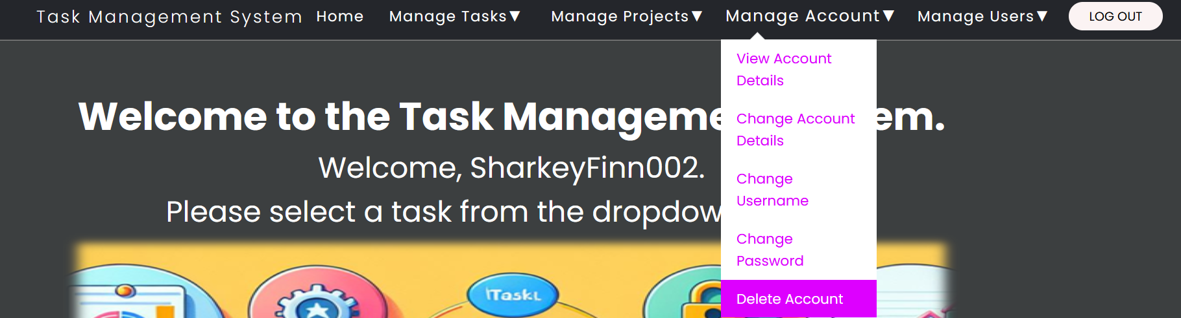

Figure 179 - Select "Delete Account" from "Manage Account" dropdown menu.

1. You will be redirected to the Delete Account form page.
2. Fill in the Delete Account form:
   1. Username
   2. Password – security to prevent unauthorized and malicious account deletion.
   3. Confirm Password – security to prevent accidental account deletion.
3. Click the “Delete Account” button.

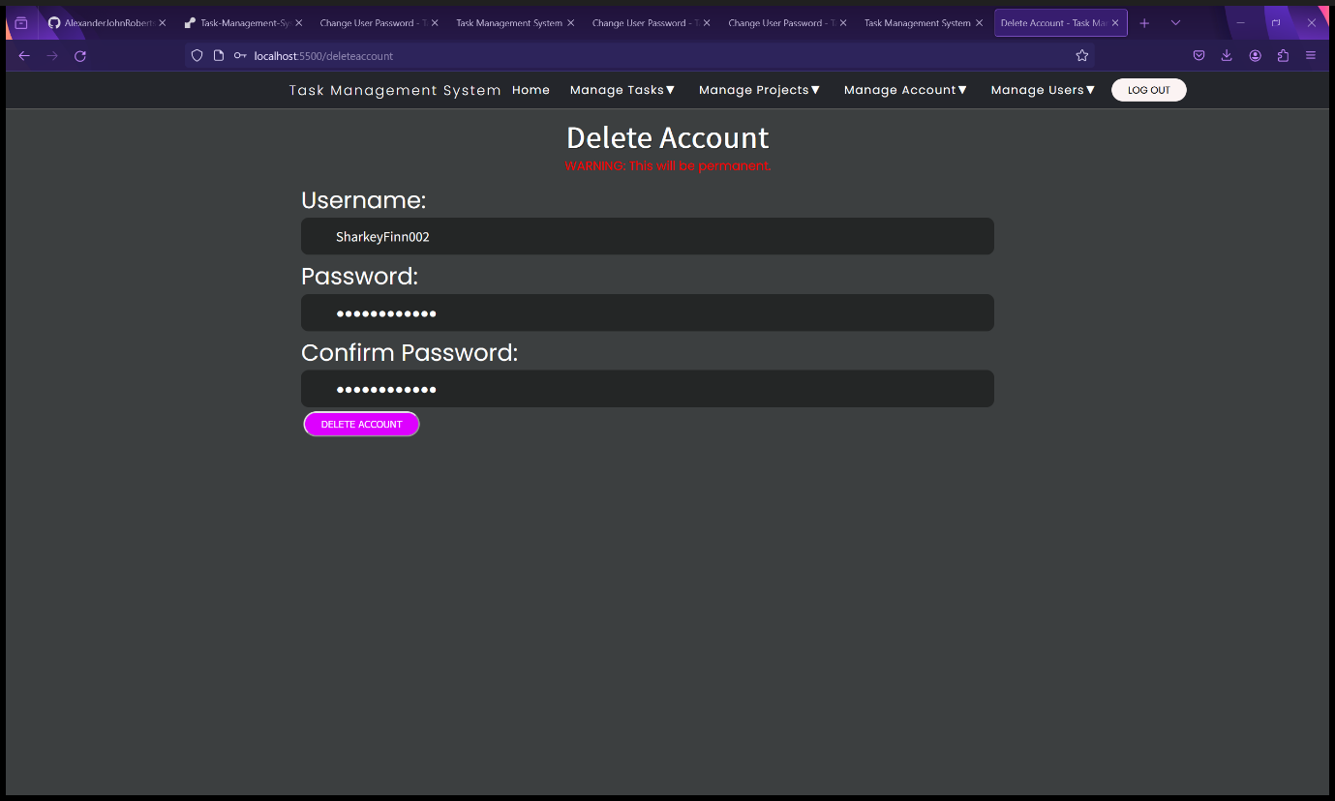

Figure 180 - Delete Account form.

1. You will be redirected to the Task Management System landing page with a message saying, “Account Deleted Successfully!”.

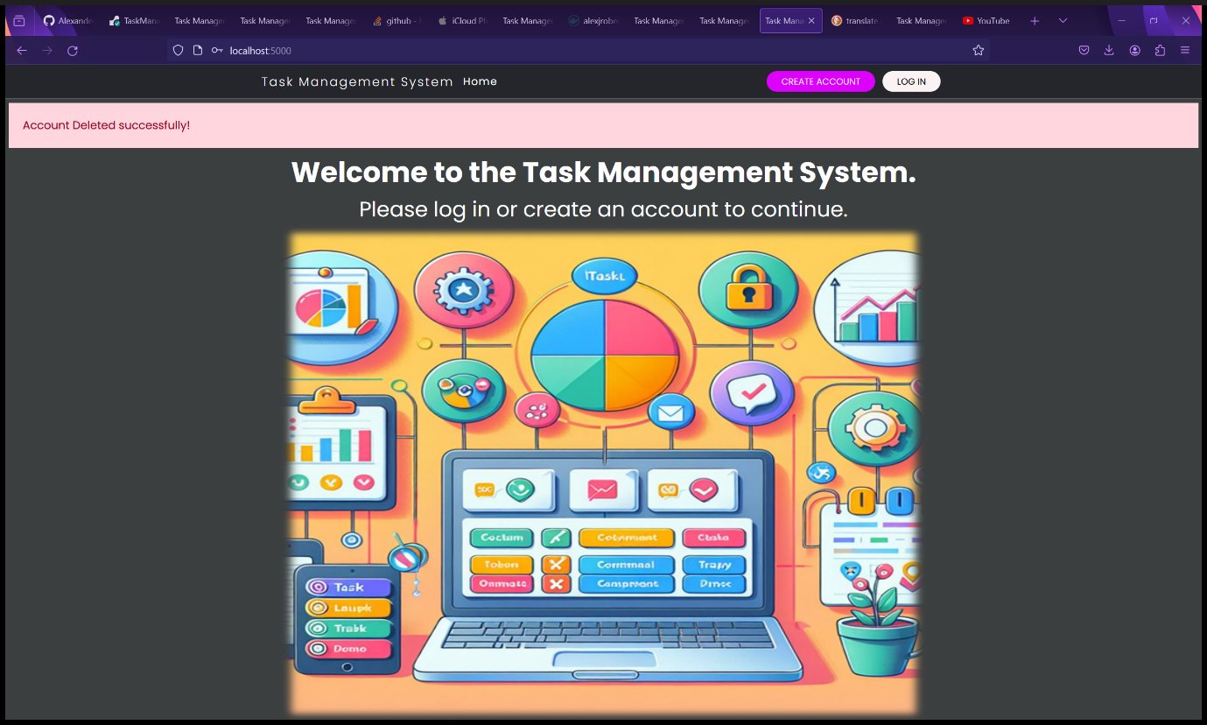

Figure 181 - Landing page after account deletion.

1. You will now be unable to log in proving that your account has been deleted. Instead, you will receive an error message saying, “Username does not exist” (See second screenshot).

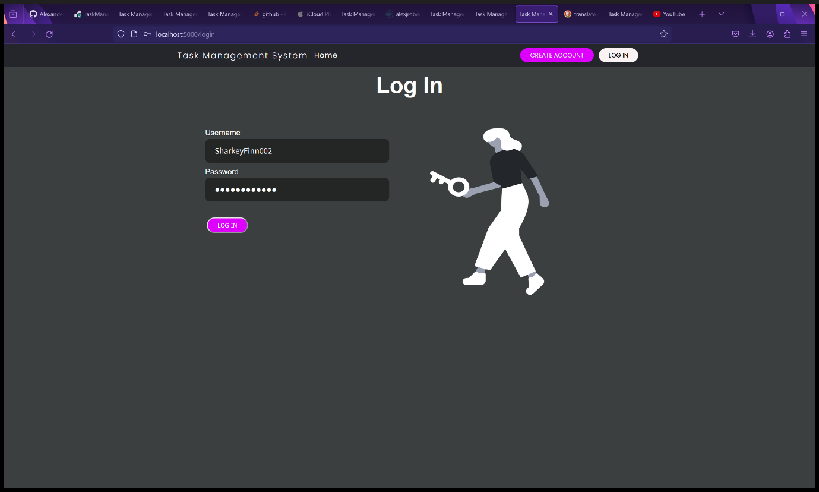

Figure 182 - Log In form.

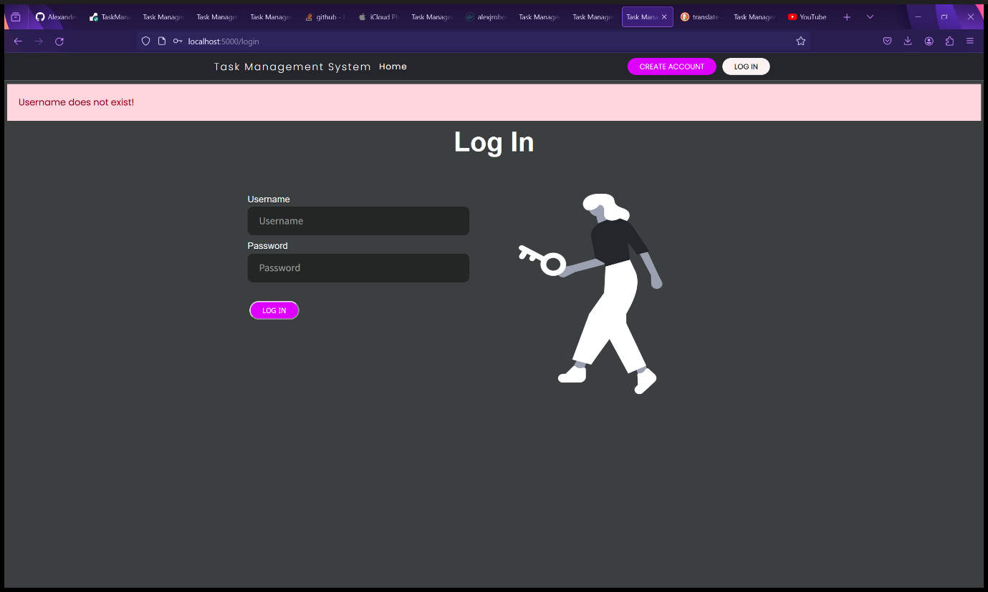

Figure 183 - The user is unable to log in because they have deleted their account.

### Managing Users and Administrative Tasks – Administrators and Root User Only

Please Note: Only administrators and Root Users have access to these features. Standard users will be denied access and will receive an Access Denied error.

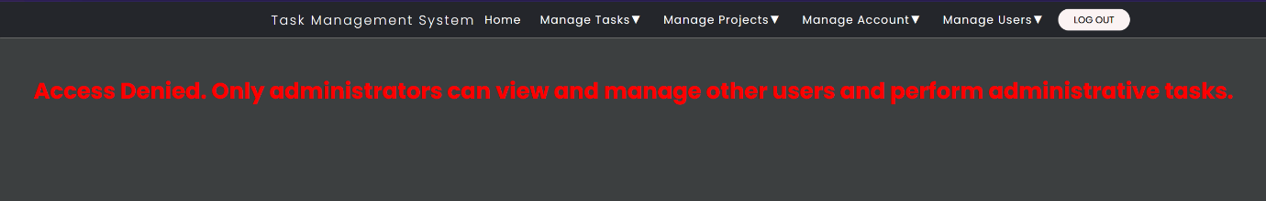

Figure 184 - Error messages that standard users get if they attempt administrative tasks or managing other users.

#### View the List of Users as a Table (Administrators and Root User Only)

1. Select “View Users” from the “Manage Users” dropdown menu.

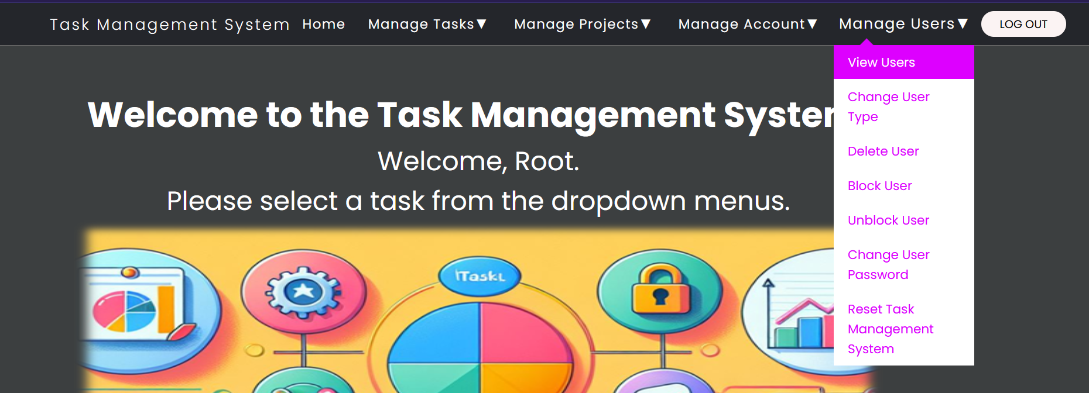

Figure 185 - Select "View Users" from "Manage Users" dropdown menu.

1. You will be redirected to the View Users page that displays a list of Users as a table with their details.

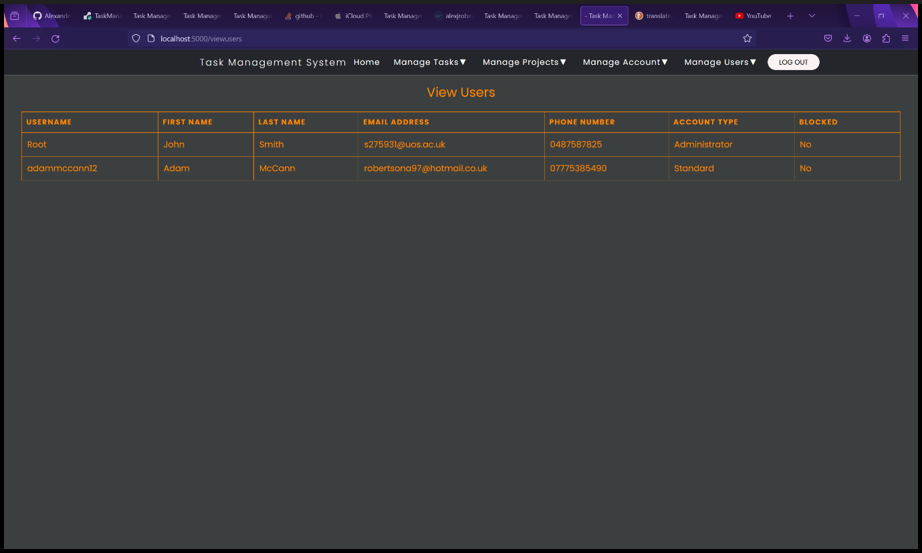

Figure 186 - View Users page with a list of users and their details.

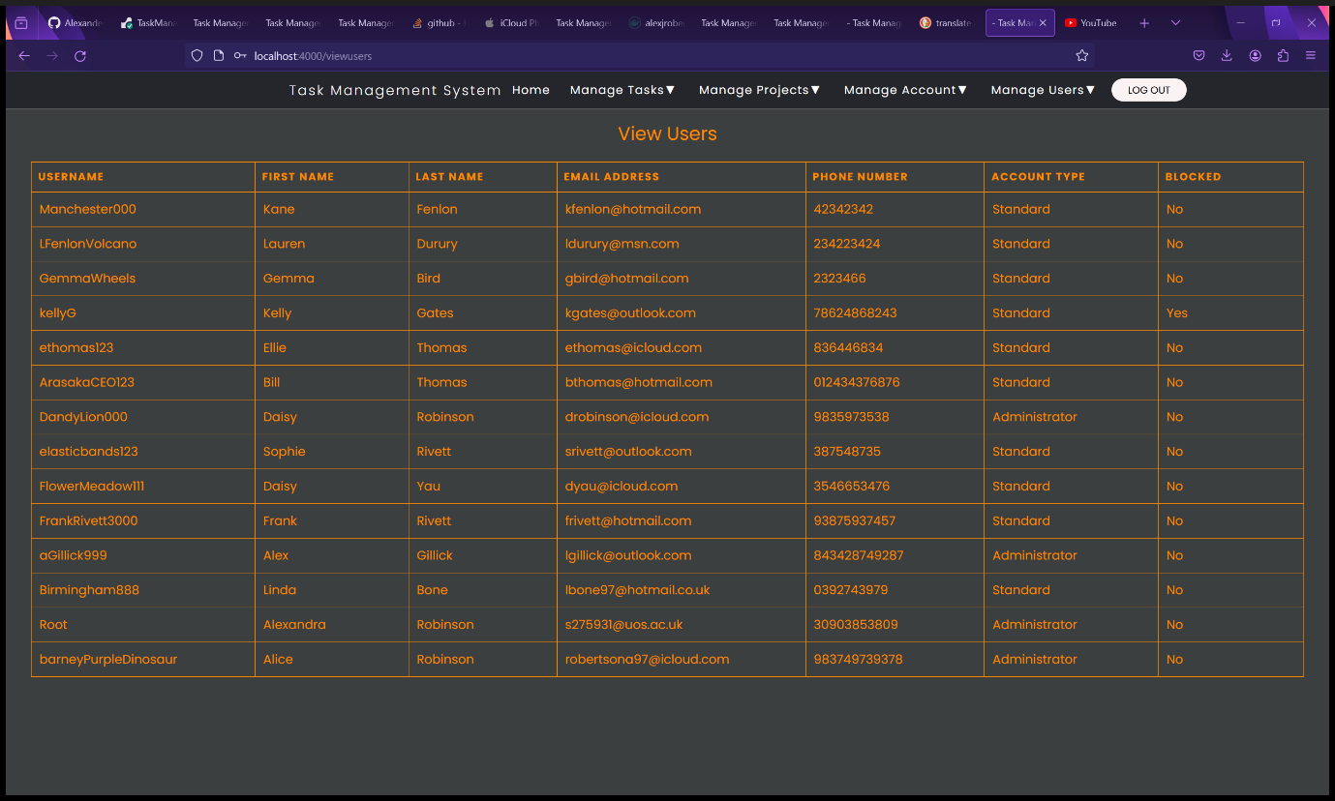

Figure 187 - View Users page with a list of users and their details (example users).

#### Change User Account Type (Administrators and Root Users Only)

Instructions for changing user account types between Administrator and Standard.

1. Select “Change User Type” from the “Manage Users” dropdown menu.

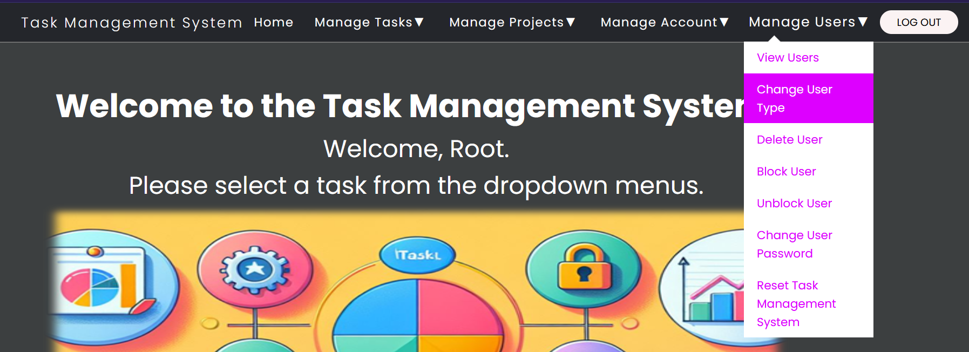

Figure 188 - Select "View Users" from "Manage Users" dropdown menu.

1. You will be redirected to the Change User Account Type form page.
2. Fill in the Change User Account Type form:
   1. Username – the username of the account to be changed.
   2. User Account Type – Type “Administrator” or “Standard” (case sensitive).
3. Click the “Change User Account Type” button.

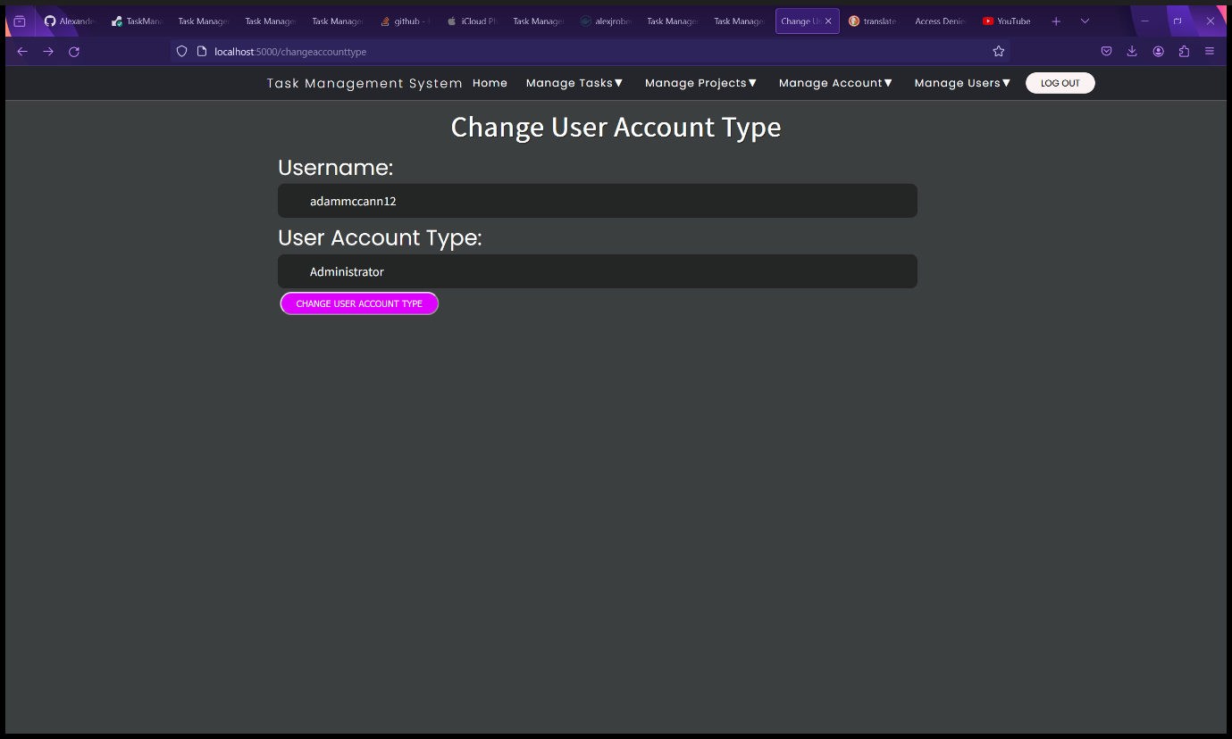

Figure 189 - Change User Account Type form.

1. You will be redirected to the View Users page showing the updated user type. A message will be displayed saying “Account type changed successfully”.

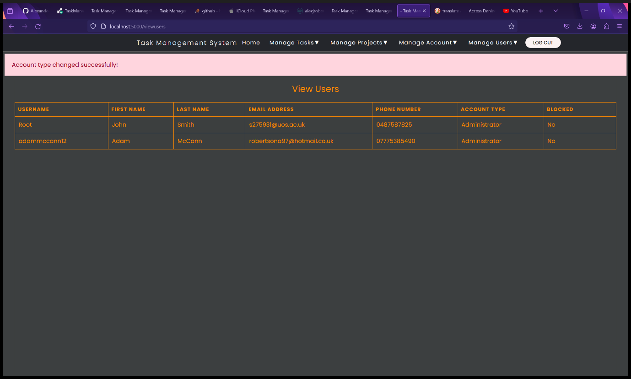

Figure 190 - View Users page after changing a user's Account Type.

#### Delete a User (Administrators and Root Users Only).

**WARNING: DELETING A USER WILL BE PERMANENT.**

1. Select “Delete User” from the “Manage Users” dropdown menu.

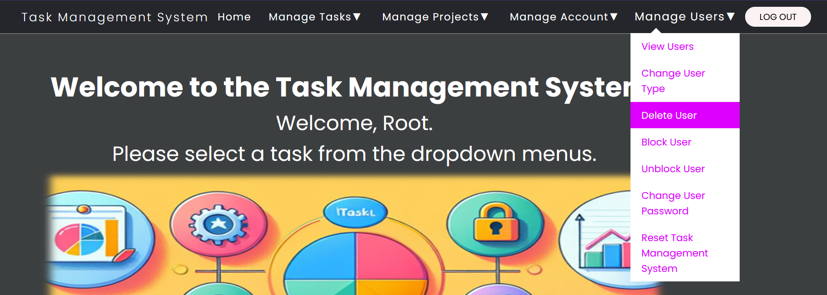

Figure 191 - Select "Delete User" from "Manage Users" dropdown menu.

1. You will be redirected to the Change User Account Type form page.
2. Fill in the Change User Account Type form:
   1. Username – the username of the account to be changed.
3. Click the “Delete User” button.

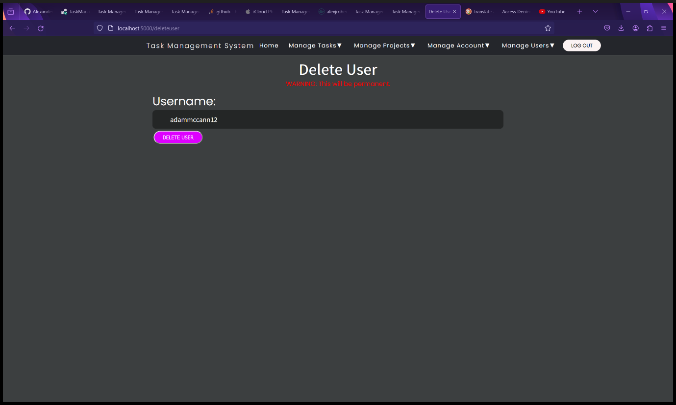

Figure 192 - Delete User form.

1. You will be redirected to the View Users page. A message will be displayed saying “User deleted successfully”.

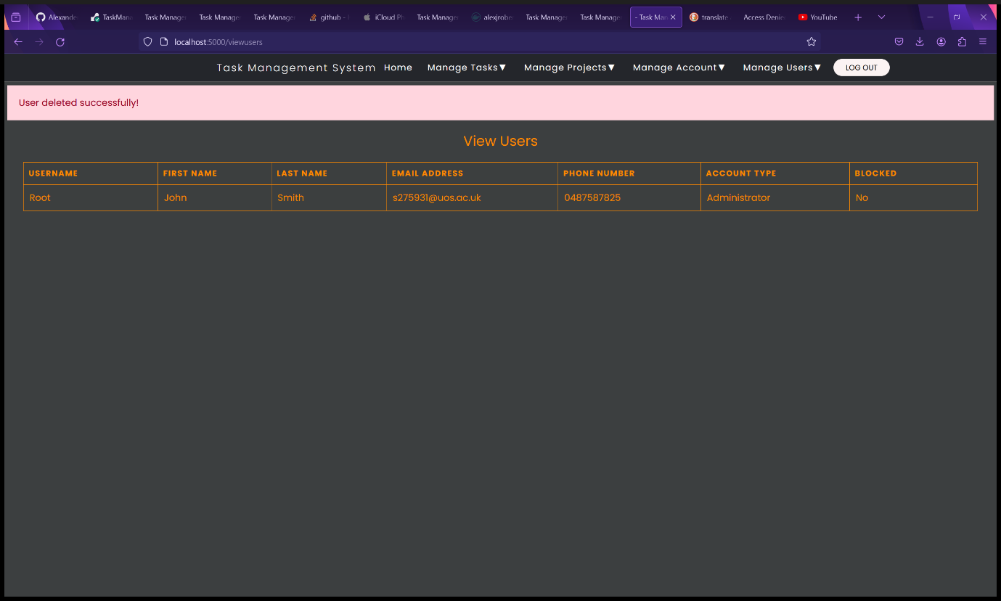

Figure 193 - View Users page after deleting a user.

#### Blocking a User (Administrators and Root Users Only)

1. Select “Block User” from the “Manage Users” dropdown menu.

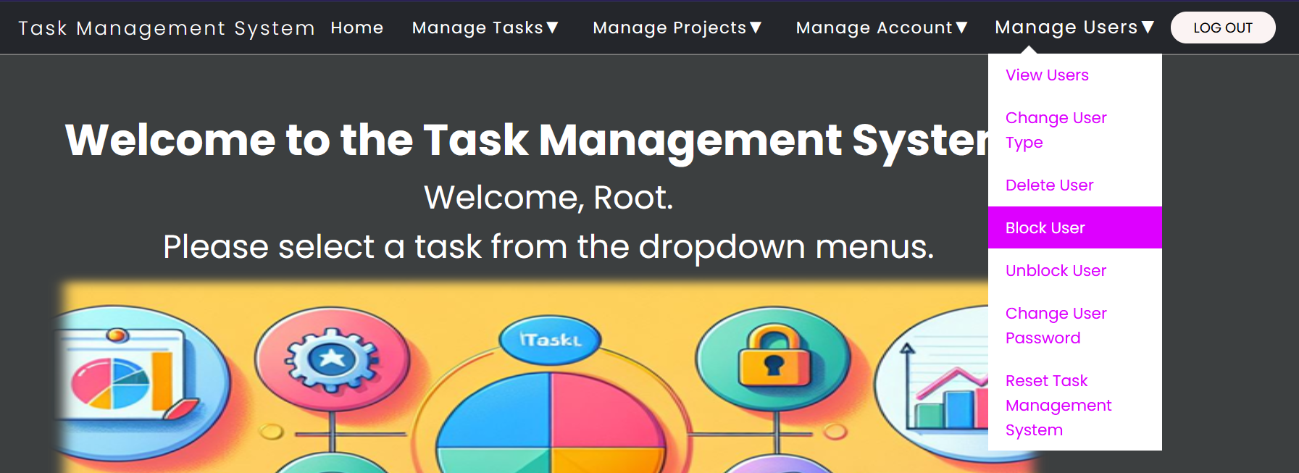

Figure 194 - Select "Block User" from "Manage Users" dropdown menu.

1. You will be redirected to the Block User form page.
2. Fill in the Block User form:
   1. Username – the username of the account to be blocked.
3. Click the “Block User” button.

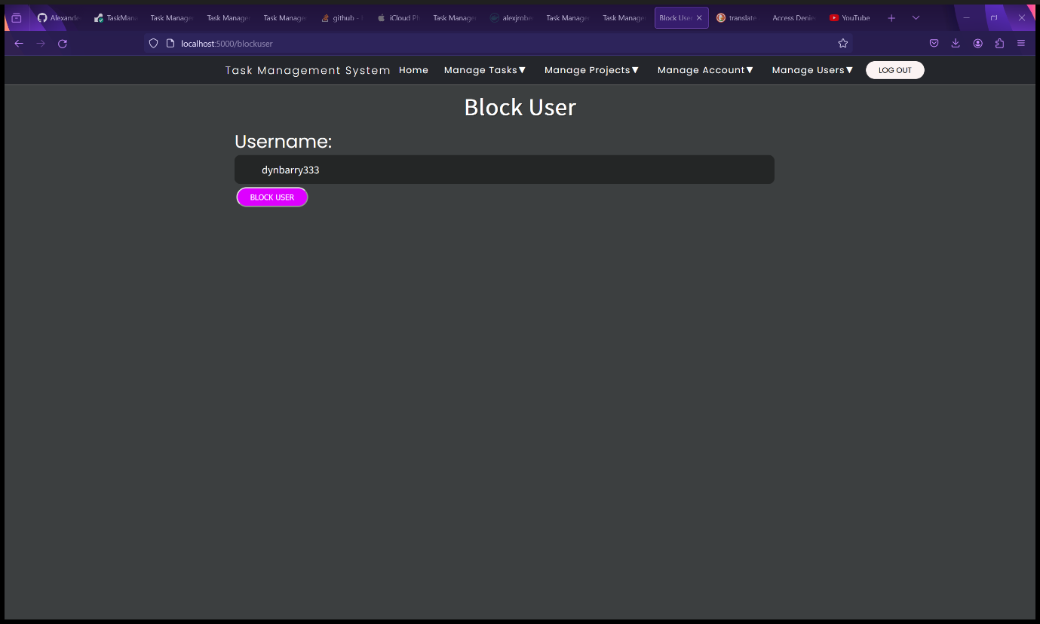

Figure 195 - Block User form.

1. You will be redirected to the View Users page. A message will be displayed saying “User blocked successfully!”. The user’s blocked status will be changed to “Yes”.

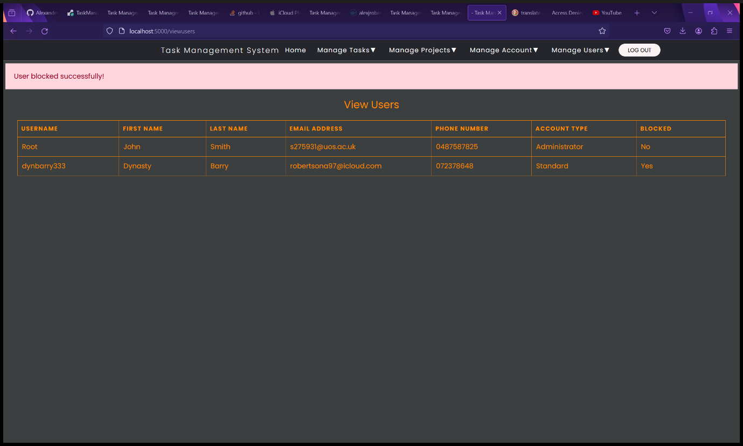

Figure 196 - View Users page after blocking a user.

1. The blocked user will now be unable to log in. Instead, they will receive an error message “You have been blocked. Please contact the administrator.”.

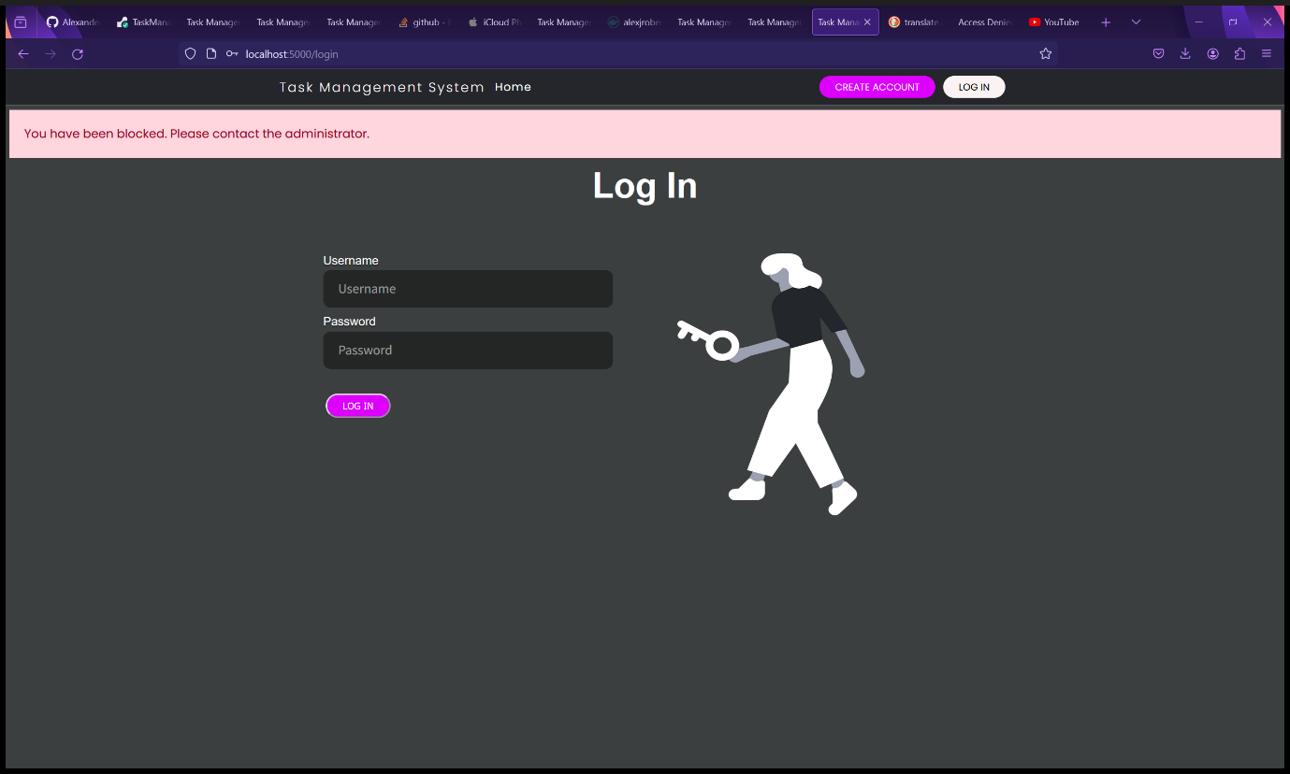

Figure 197 - The blocked user is unable to log in.

#### Unblocking a User (Administrators and Root Users Only)

1. Select “Unblock User” from the “Manage Users” dropdown menu.

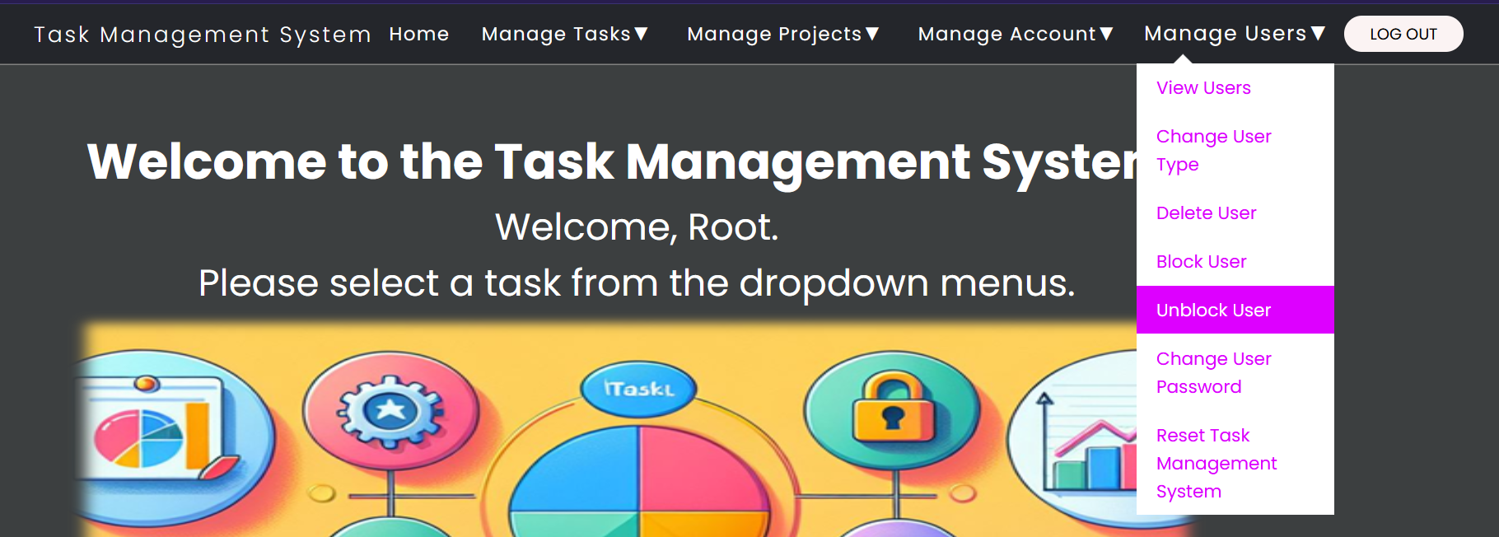

Figure 198 - Select "Unblock User" from "Manage Users" dropdown menu.

1. You will be redirected to the Unblock User form page.
2. Fill in the Unblock User form:
   1. Username – the username of the account to be unblocked. In the example, we will unblock the same user that we blocked in the previous step.
3. Click the “Unblock User” button.

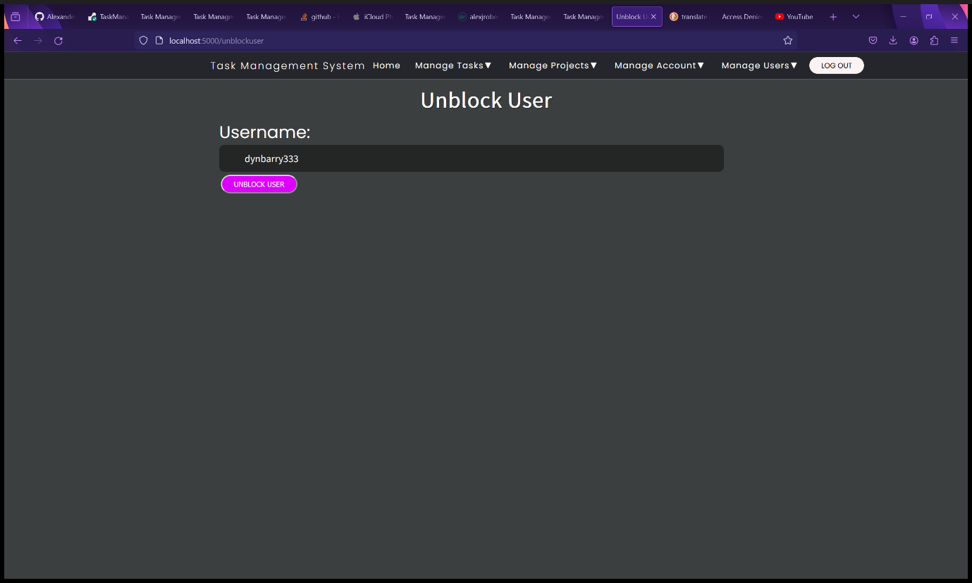

Figure 199 - Unblock User form.

1. You will be redirected to the View Users page. A message will be displayed saying “User unblocked successfully!”. The user’s blocked status will be changed to “No”.

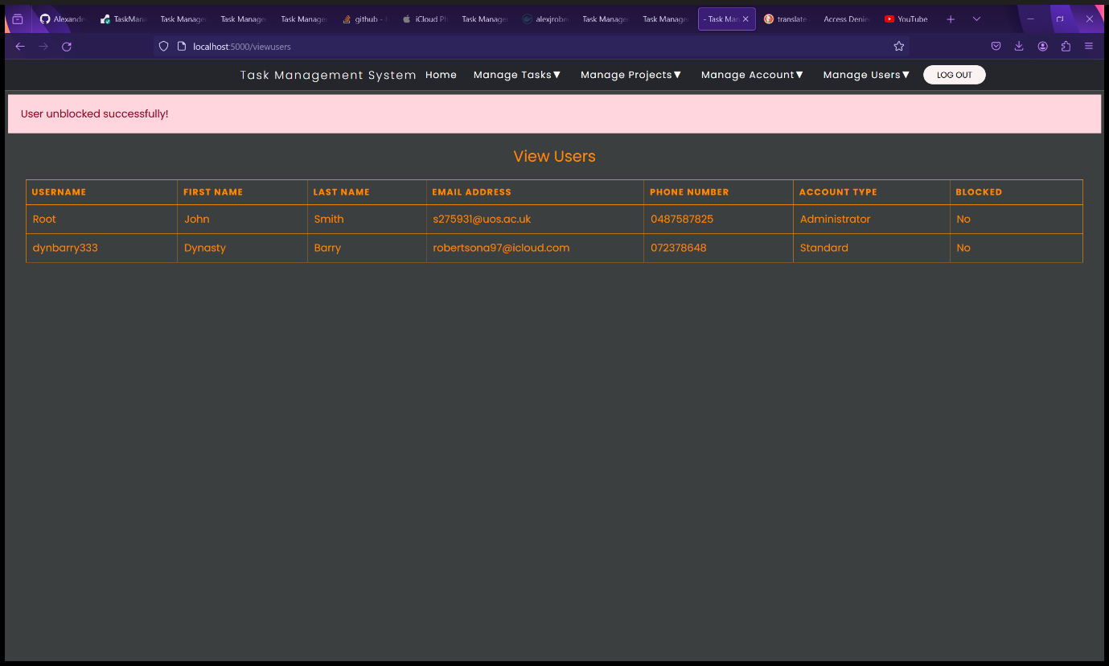

Figure 200 - View Users page after unblocking a user.

1. The unblocked user can now log in successfully.

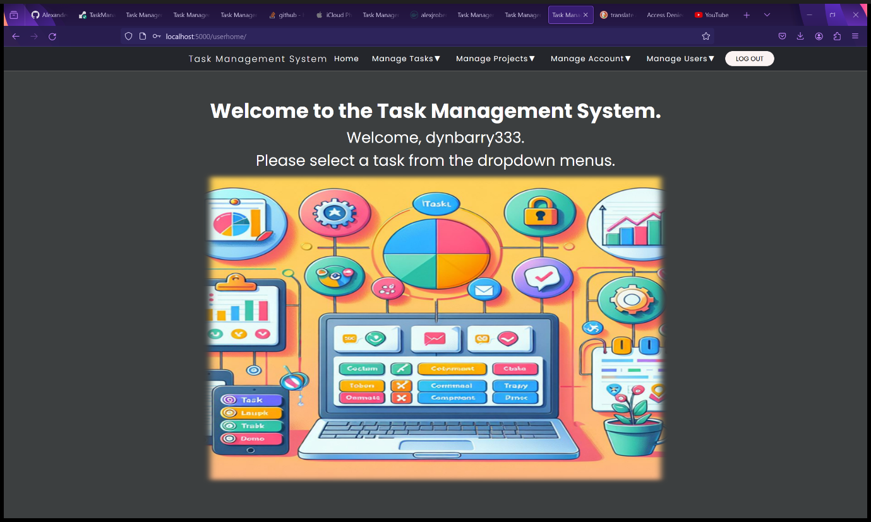

Figure 201 - The user is now able to log in again.

#### Changing Another User’s Password (Administrators and Root Users Only)

1. Select “Change User Password” from the “Manage Users” dropdown menu.

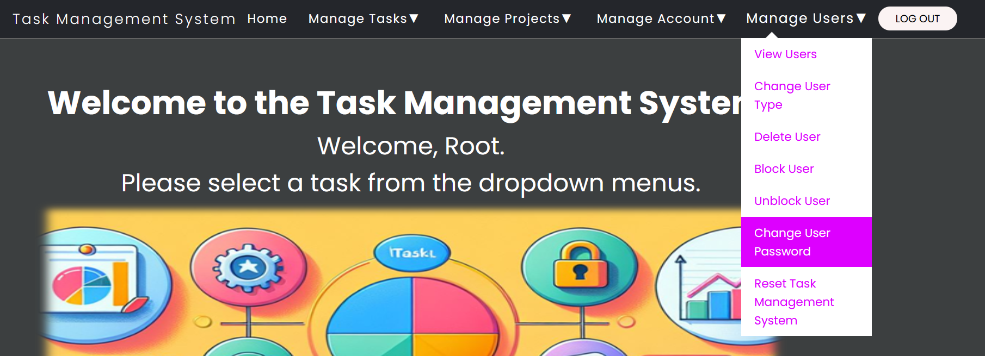

Figure 202 - Select "Change User Password" from "Manage Users" dropdown menu.

1. You will be redirected to the Change User Password form page.
2. Fill in the Change User Password form:
   1. Username – the username of the account to have their password changed.
   2. New Password – Enter the new password here. Password must meet the following requirements: Minimum length of 10 characters, at least one uppercase letter, one lowercase letter, one number and one special character. Special characters must be ASCII characters as UTF and Unicode characters are not supported in emailing the new passwords to users and will result in an error. The password must not be a common password.
3. Click the “Change User Password” button.

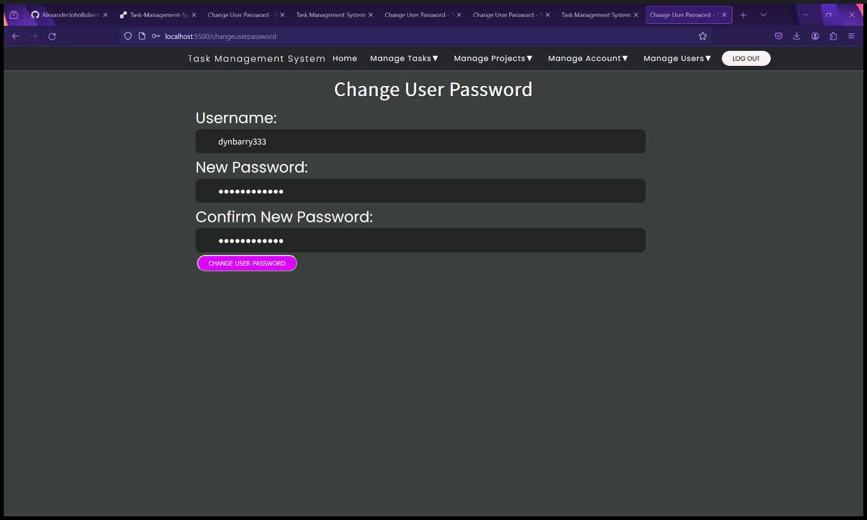

Figure 203 - Change User Password form.

1. You will be redirected to the View Users page. A message will be displayed saying “Password Changed successfully!”.
2. An email will automatically be sent to the user’s email address.

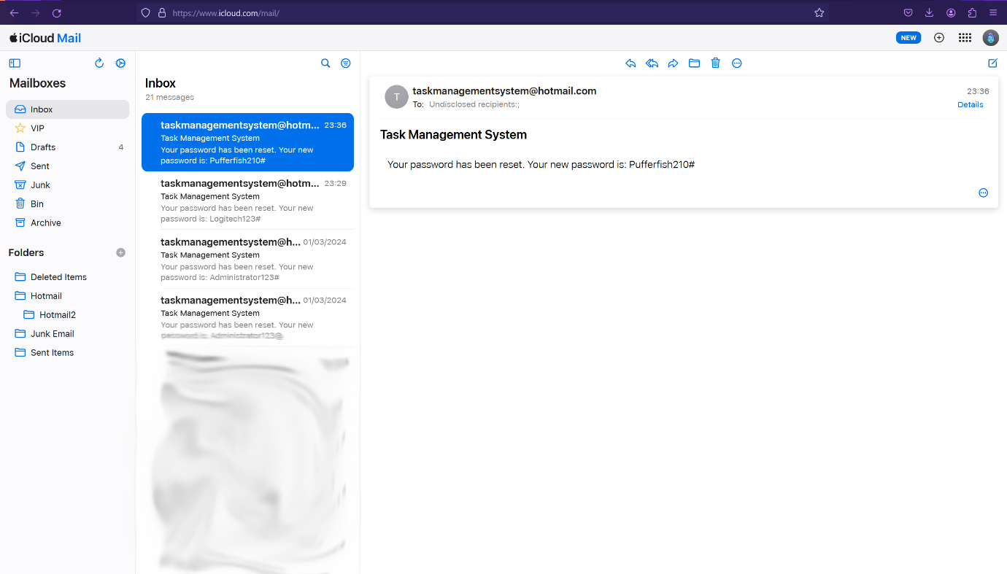

Figure 204 - Automated email sent to user of who’s password has been changed.

#### Factory Resetting the Task Management System (Administrators and Root Users Only)

**WARNINING: THIS WILL BE PERMANENT. ALL DATA WILL BE LOST. IF YOU WANT TO KEEP THE DATA MAKE A BACKUP FIRST.**

1. Select “Reset Task Management System” from the “Manage Users” dropdown menu.

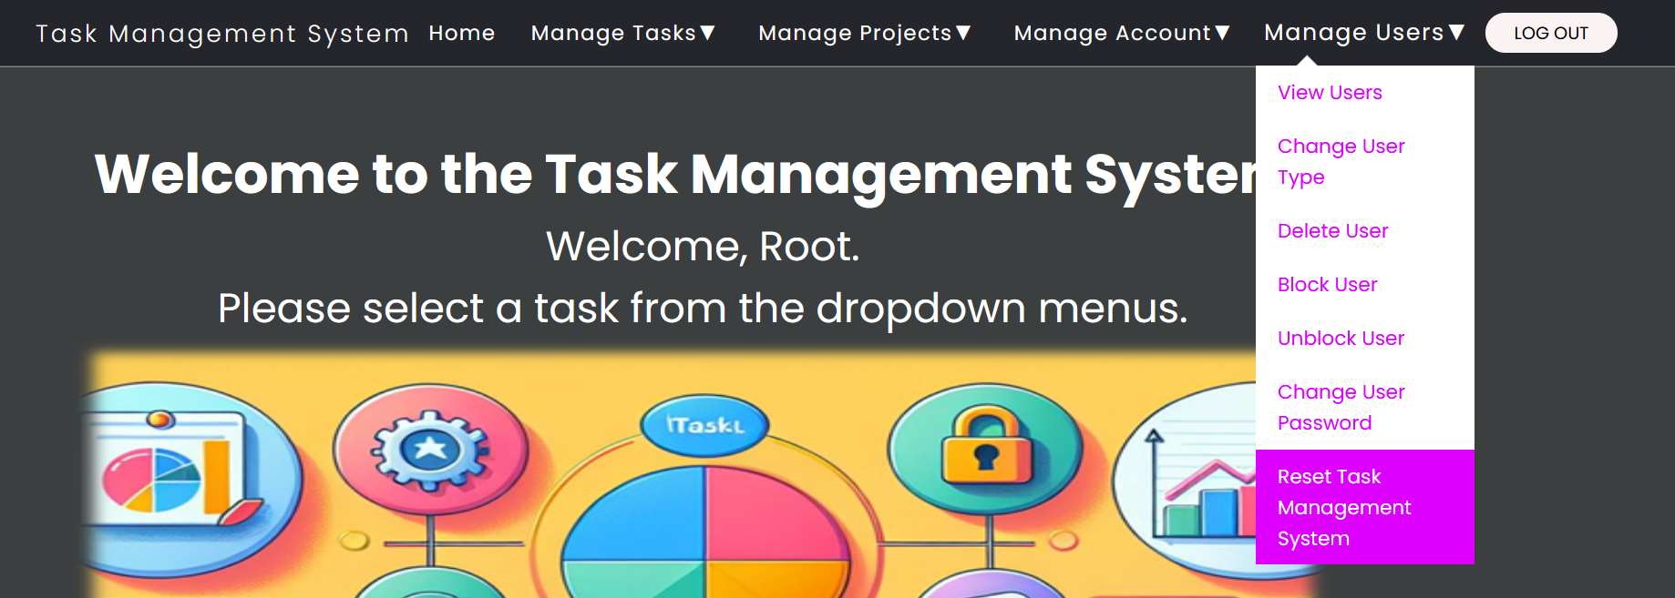

Figure 205 - Select "Reset Task Management System" from "Manage Users" dropdown menu.

1. You will be redirected to the Reset Task Management System form page.
2. Fill in the Reset Task Management System form:
   1. Administrator Password – Must be the password of your administrator or Root account – A security measure to prevent unauthorized and malicious factory resets resulting in unauthorized data loss.
   2. Confirm Password – Re-enter your password. Security measure to prevent accidental factory resets resulting in accidental data loss.
3. Click the “Reset Task Management System” button.

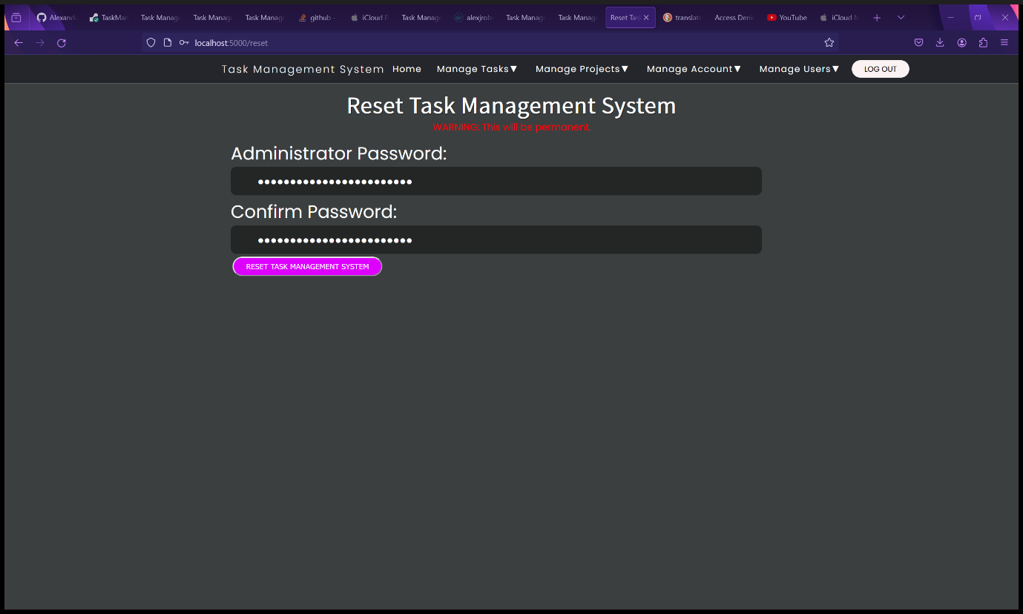

Figure 206 - Reset Task Management form.

1. The Task Management System will be factory reset and all data (projects, tasks, and users) will be wiped. You will be redirected to the Setup page. A message will appear saying “Task Management System Reset Successfully!” above the setup form.

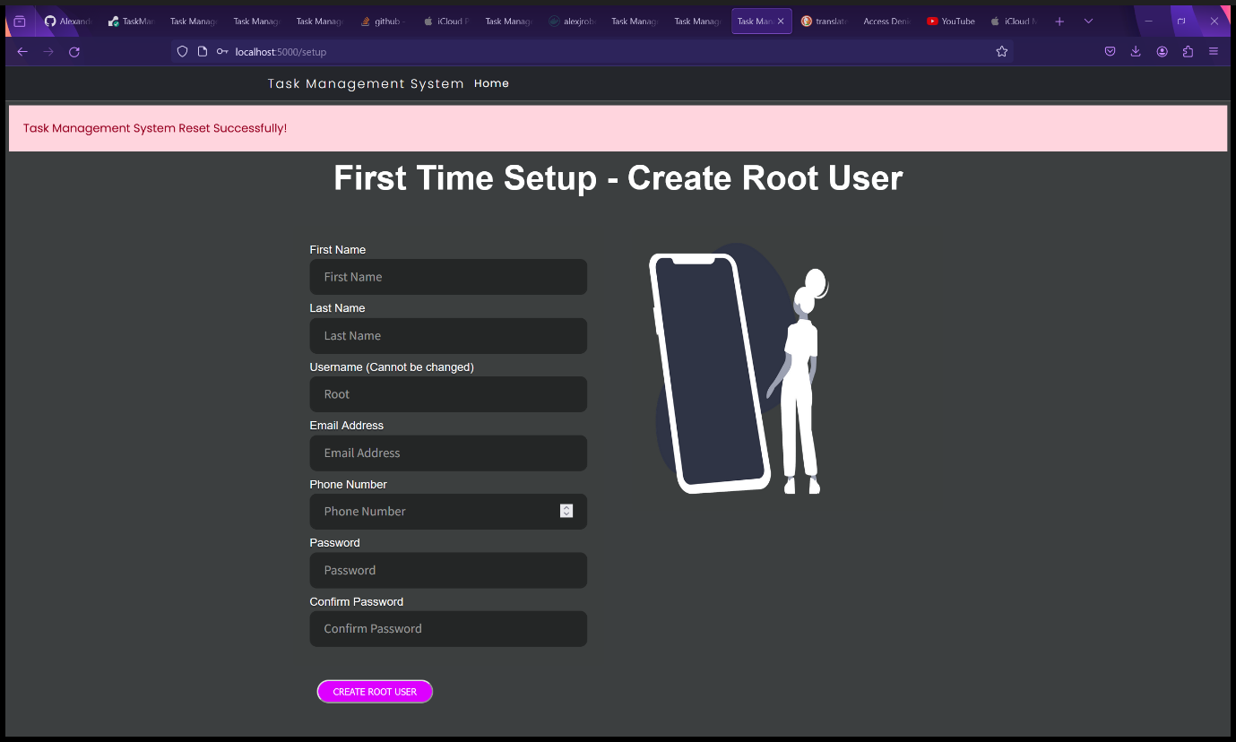

Figure 207 - Setup page after factory resetting the Task Management System.

1. Fill in the Setup form (see First Time Setup) for full instructions.



Figure 208 - Completed Setup form.

1. The Task Management System has been reset and is ready for use again.



Figure 209 - The Task Management System has been reset.

## Task Management System on Mobile Devices.

The Task Management System is a responsive web application and will therefore be displayed differently on mobile devices and displays that are too small or the resolution is too low to display the full navbar or tables. On these devices, the dropdown menus in the navbar can be accessed through a hamburger menu in the top right corner of the webpages. Each task, project and user are displayed in individual card like tables instead of the full table on mobile devices and small displays.

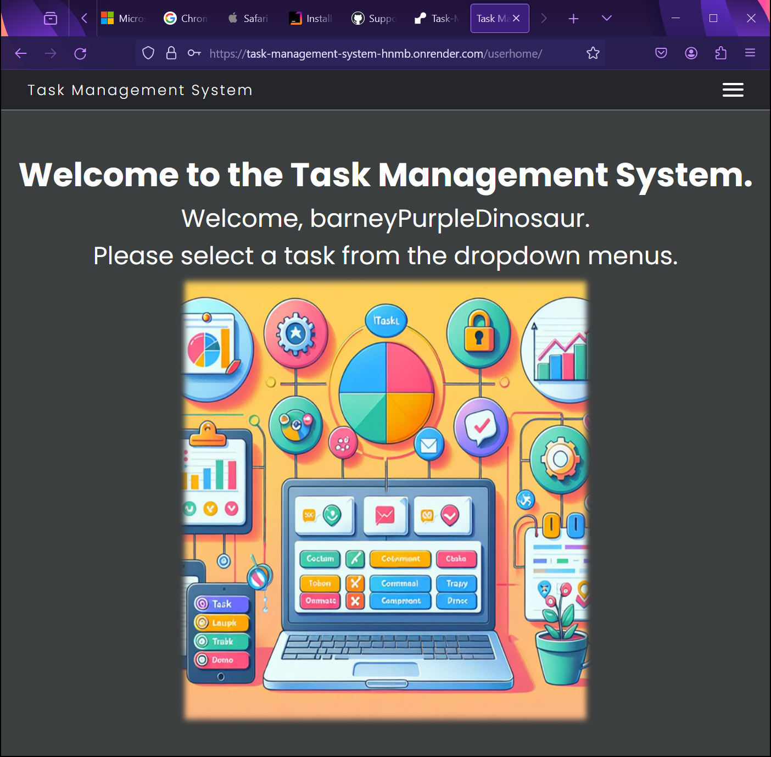

Figure 210 - Task Management System resized on Firefox.

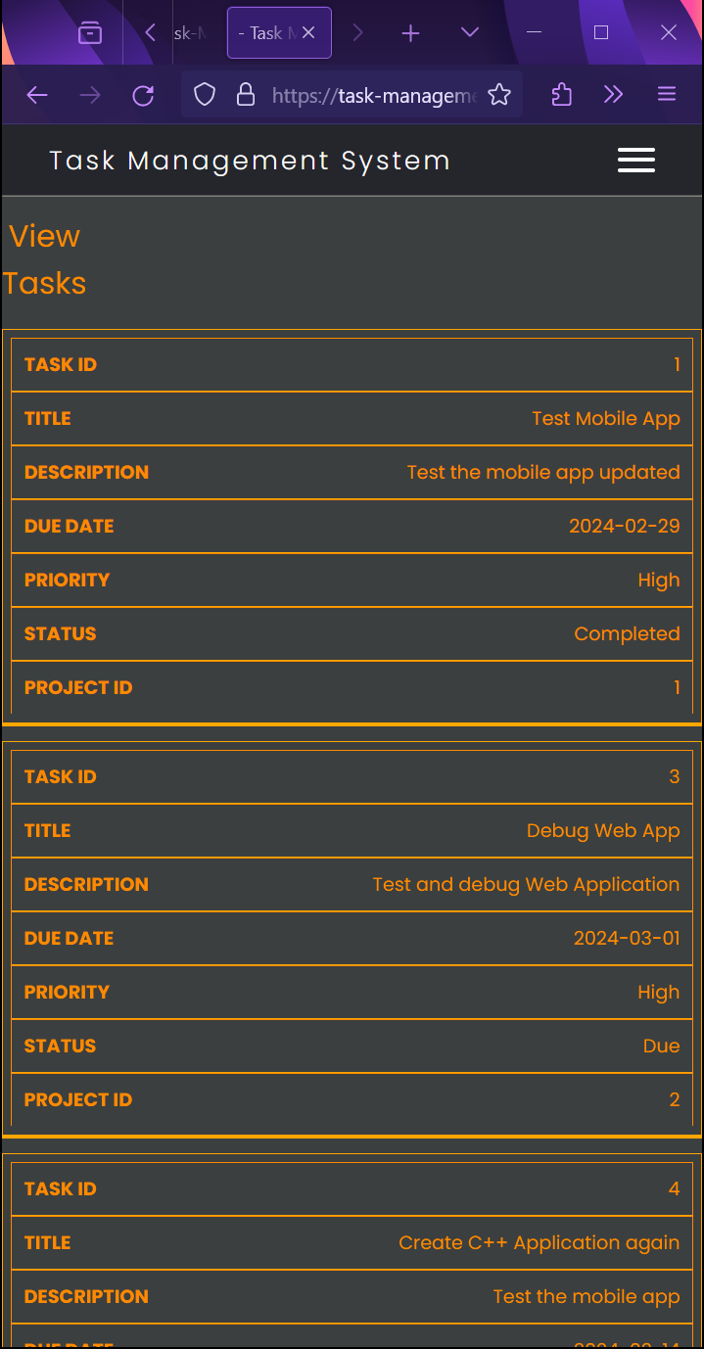

Figure 211 - Task Management System Task table on resized Firefox window.

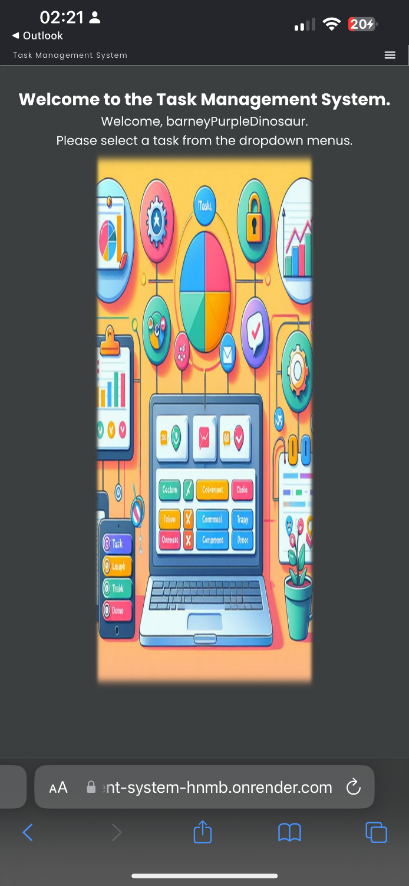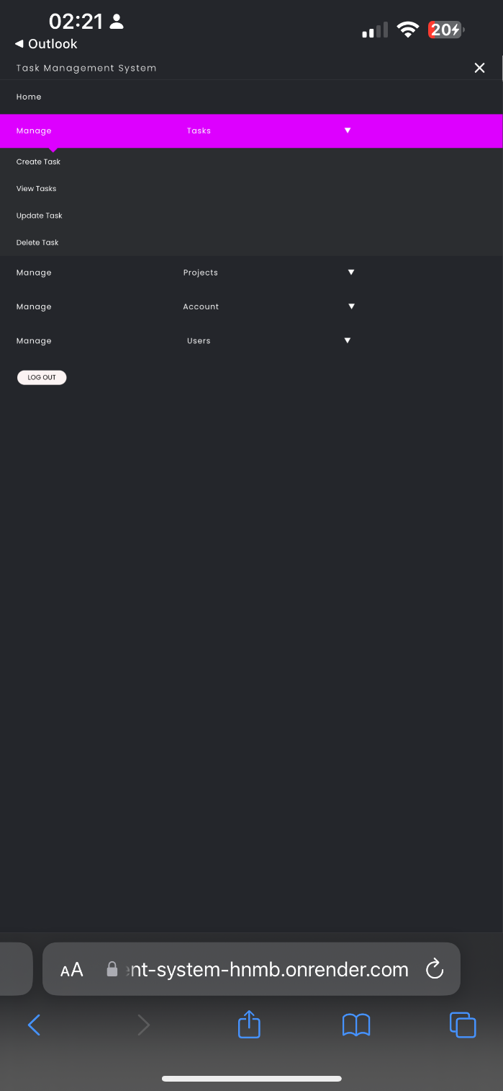

Figure 213 - Expanded Hamburger Menu with navigation (Portrait).

Figure 212 - Task Management System viewed on an

iPhone 13 Pro Max (Portrait). Hamburger Menu in the

top right corner instead of full navbar.

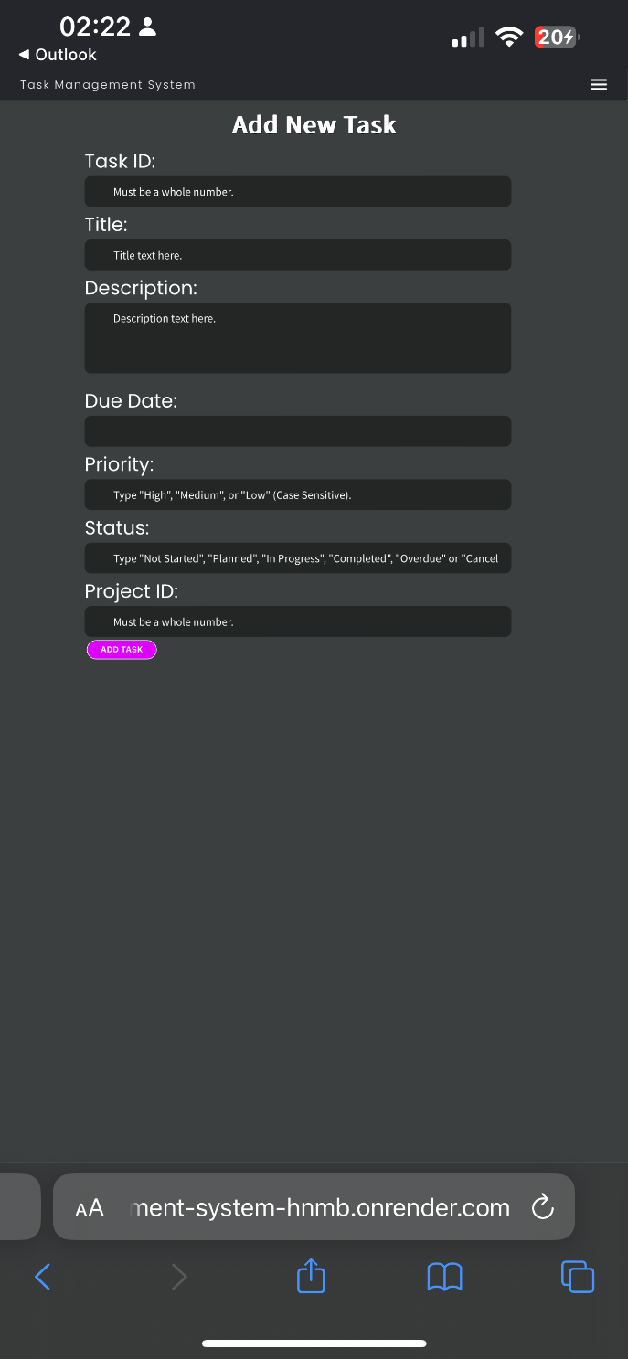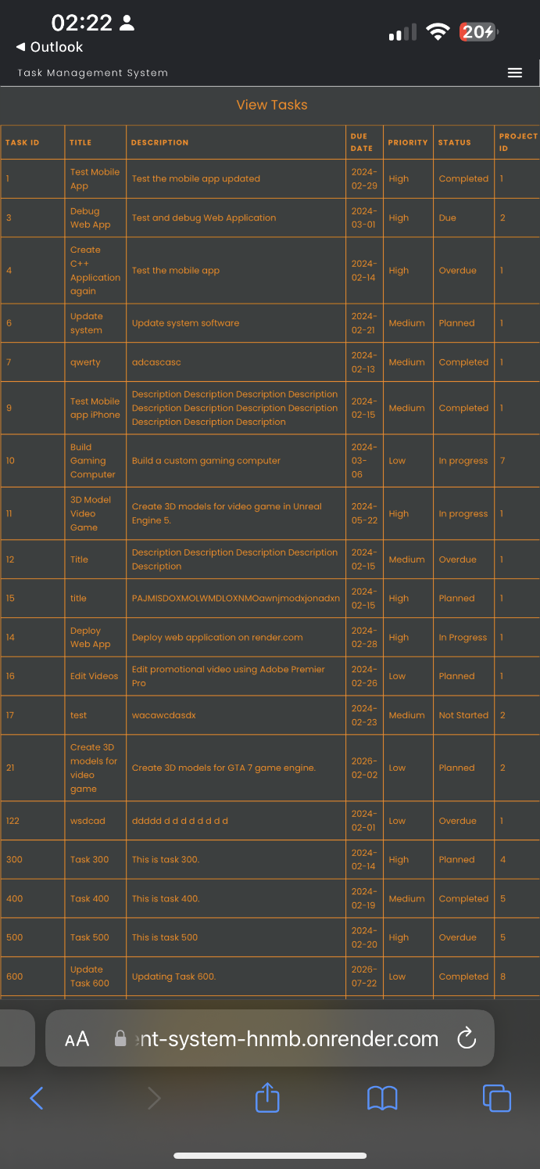

Figure 214 - Form and table viewed on iPhone 13 Pro Max (Portrait).

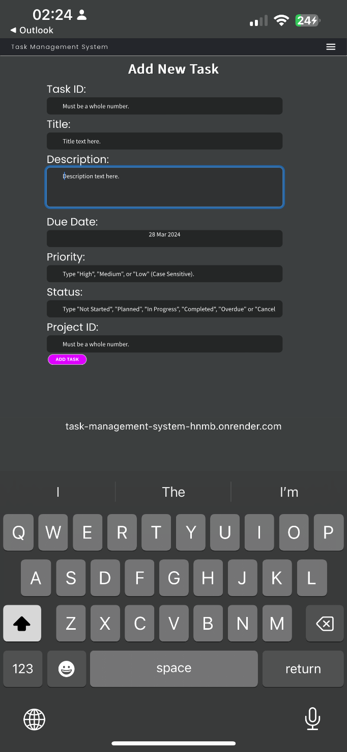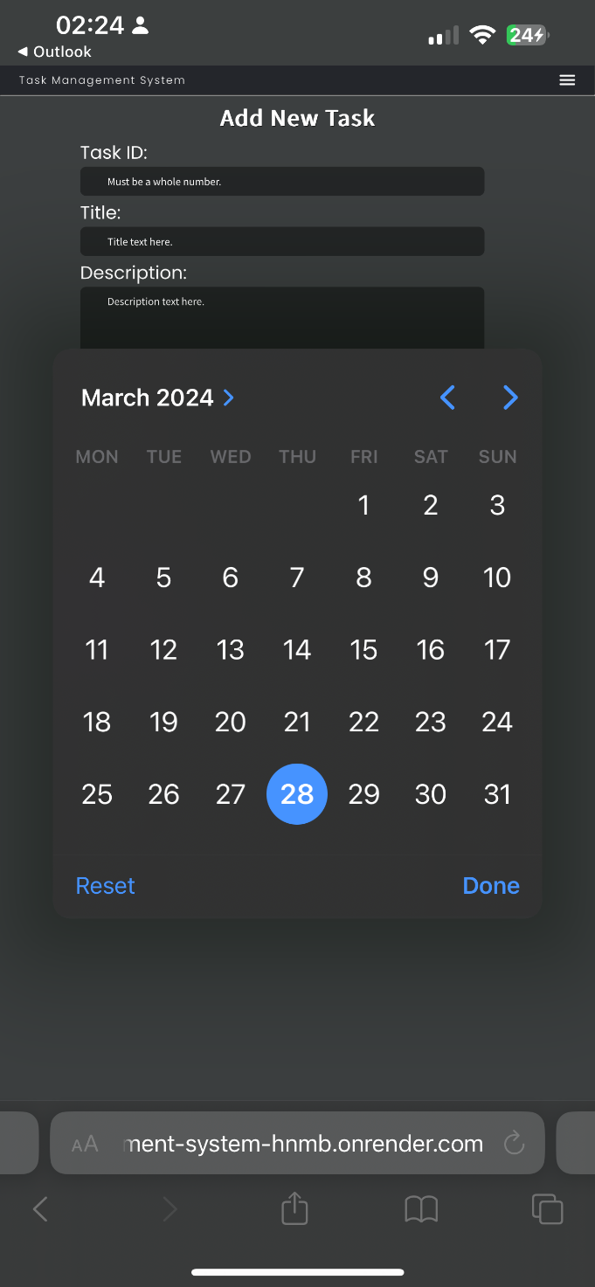

Figure 215 - On-screen keyboard and calendar for Add Task form on iPhone 13 Pro Max (Portrait).

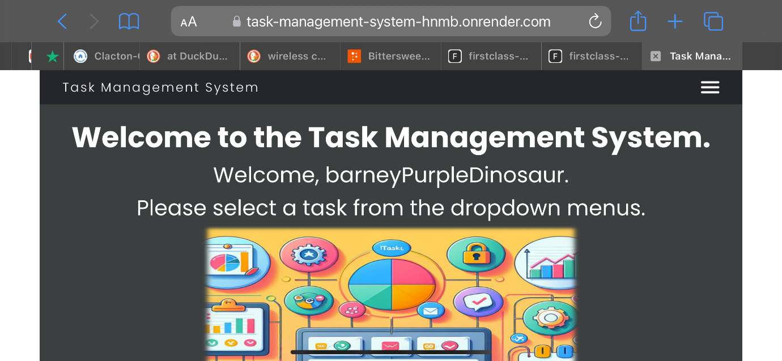

Figure 216 - Task Management System User Home page viewed on iPhone Pro Max (Landscape).

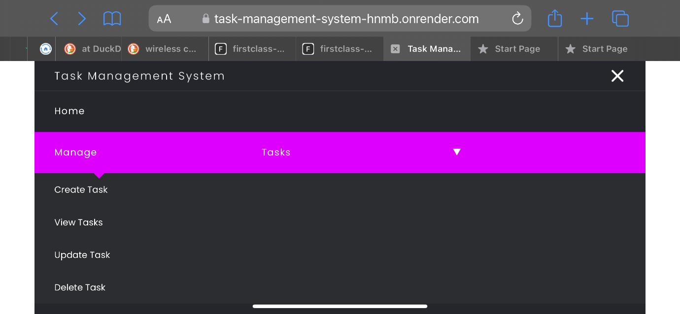

Figure 217 - Expanded Hamburger Menu with navigation (Landscape).

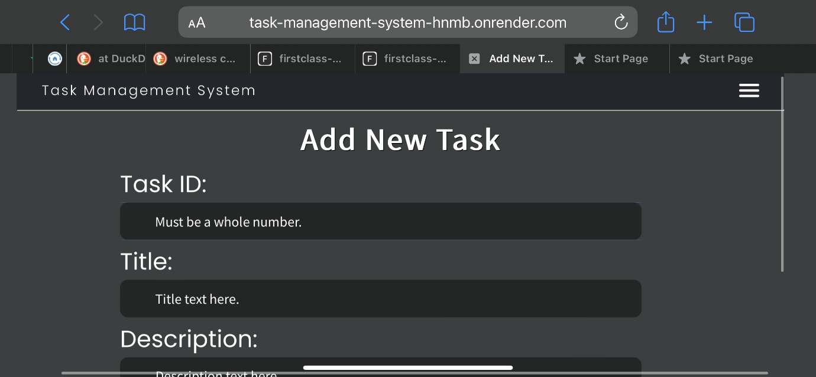

Figure 218 - Form viewed on iPhone 13 Pro Max (Landscape).

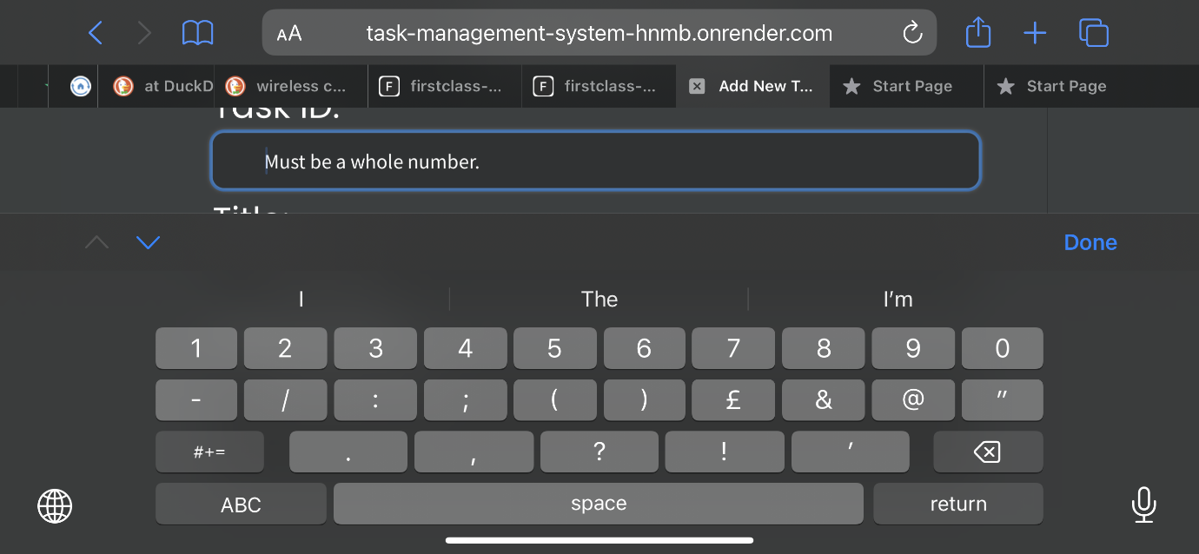

Figure 219 - Form viewed on iPhone 13 Pro Max (Landscape).

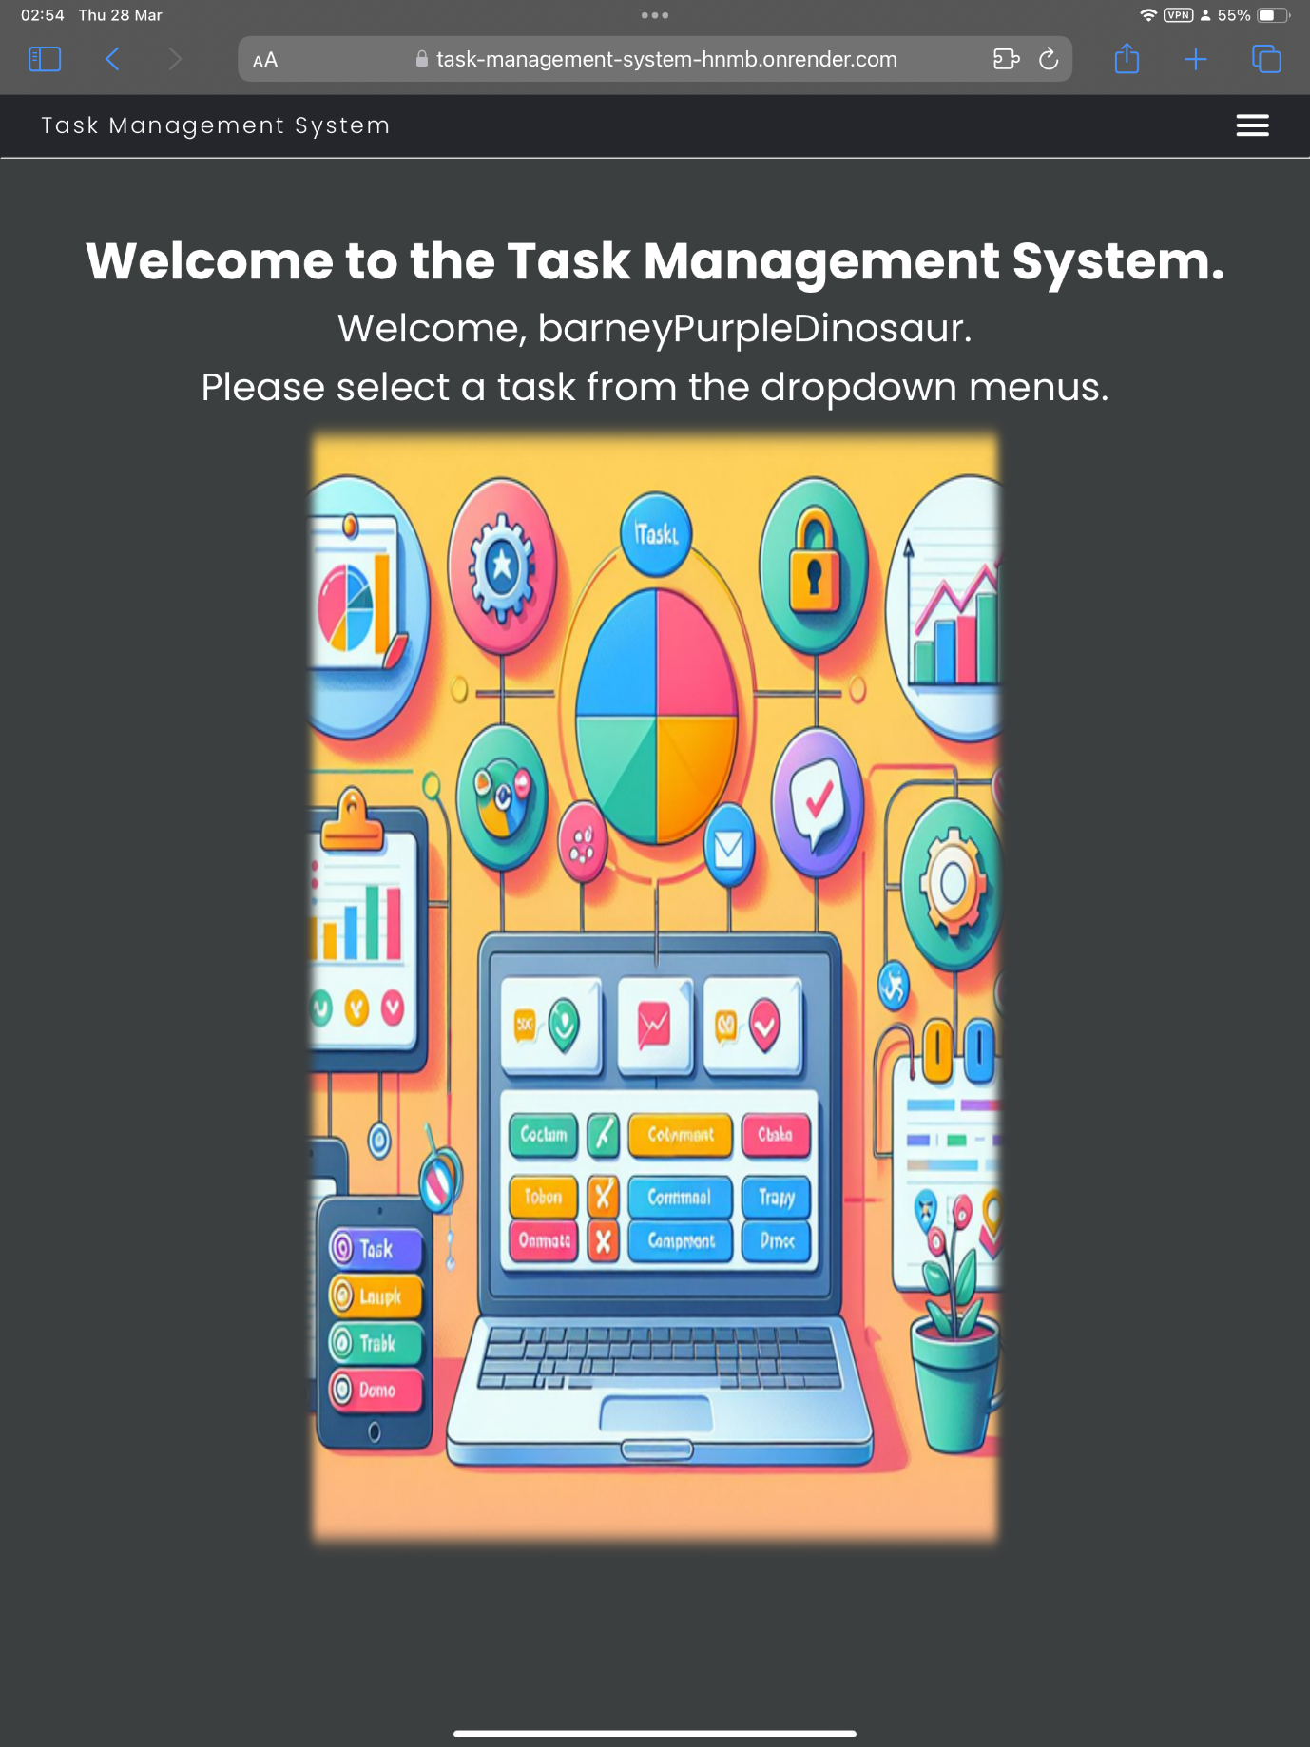

Figure 220 - Task Management System User Home Page viewed on iPad Pro (Portrait).

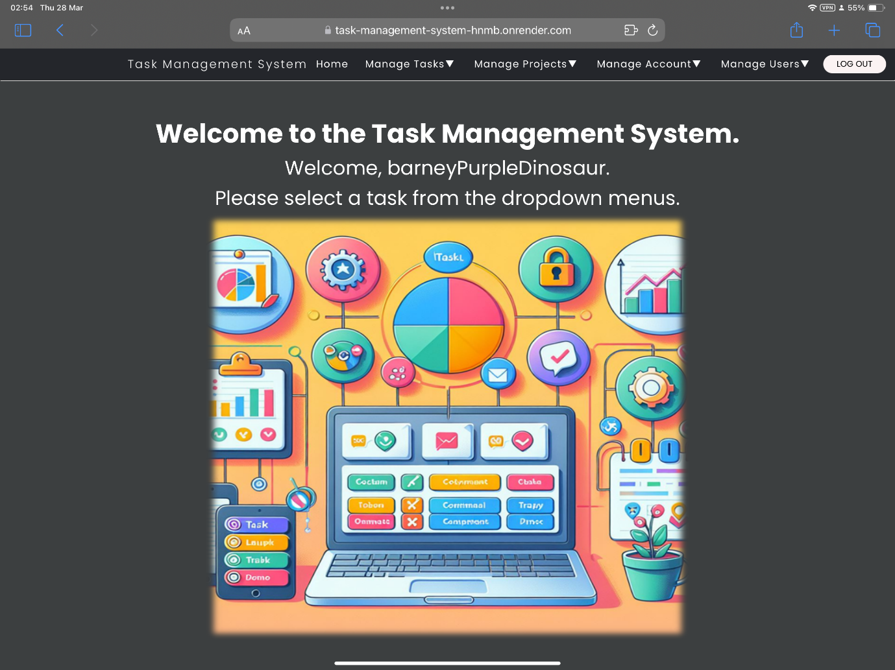

Figure 221 - Task Management System User Home Page viewed on iPad Pro (Landscape).

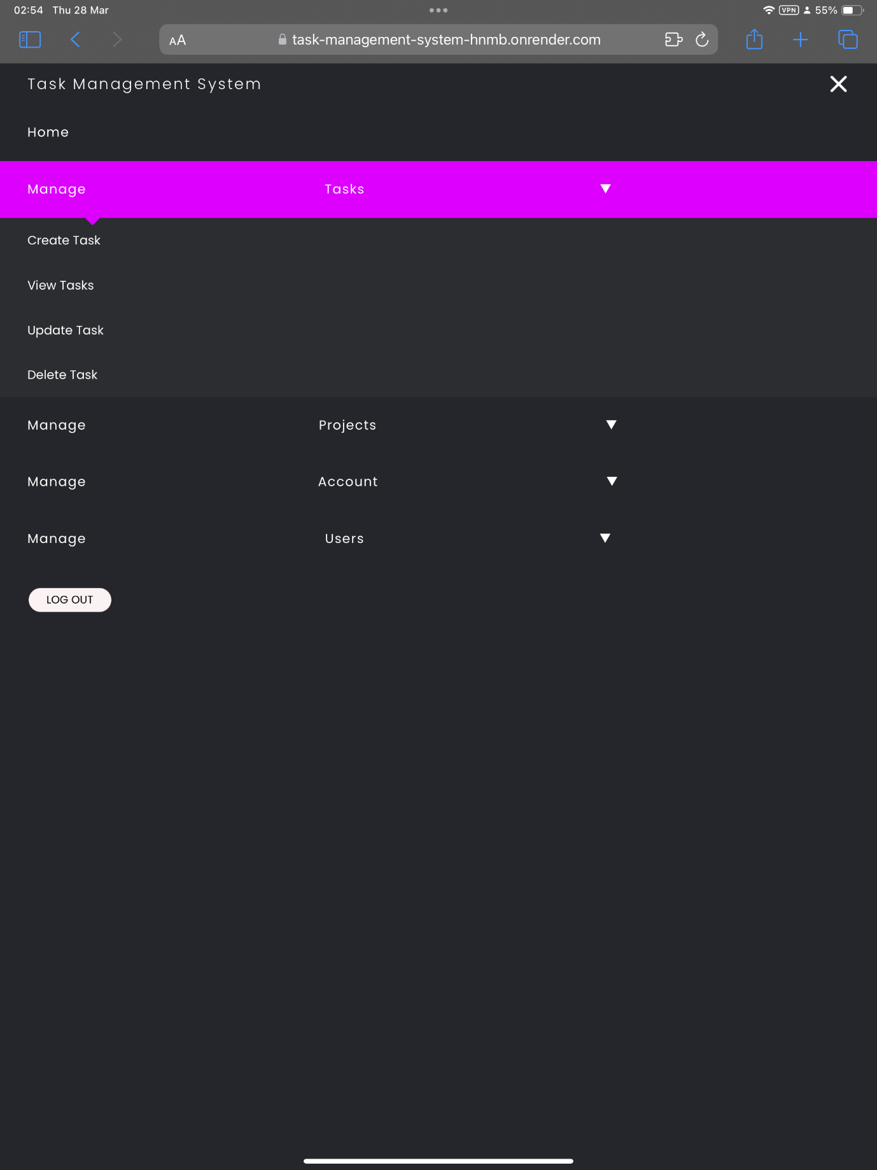

Figure 222 - Expanded Hamburger Menu instead of navbar on iPad Pro (Portrait).

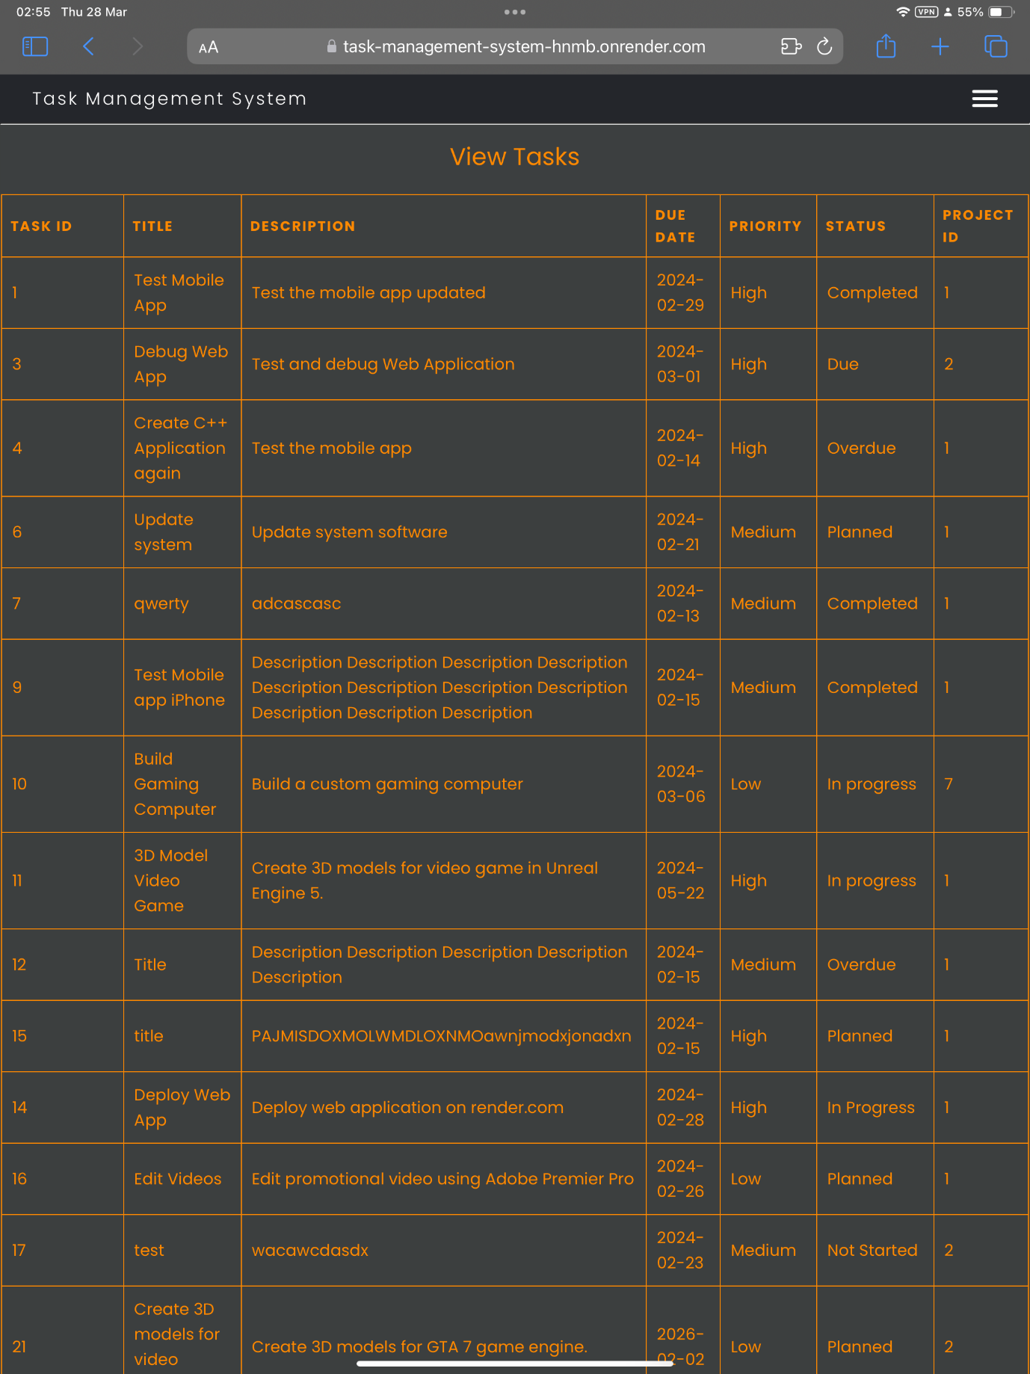

Figure 223 - Table viewed on iPad Pro (Portrait).

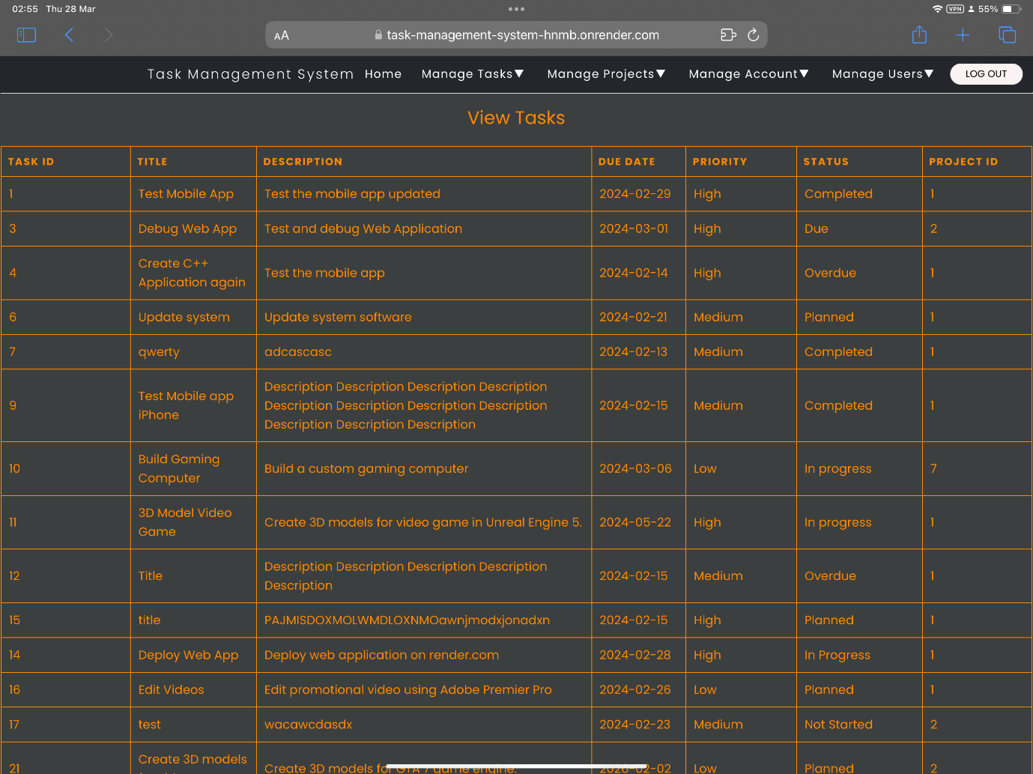

Figure 224 - Table viewed on iPad Pro (Landscape).

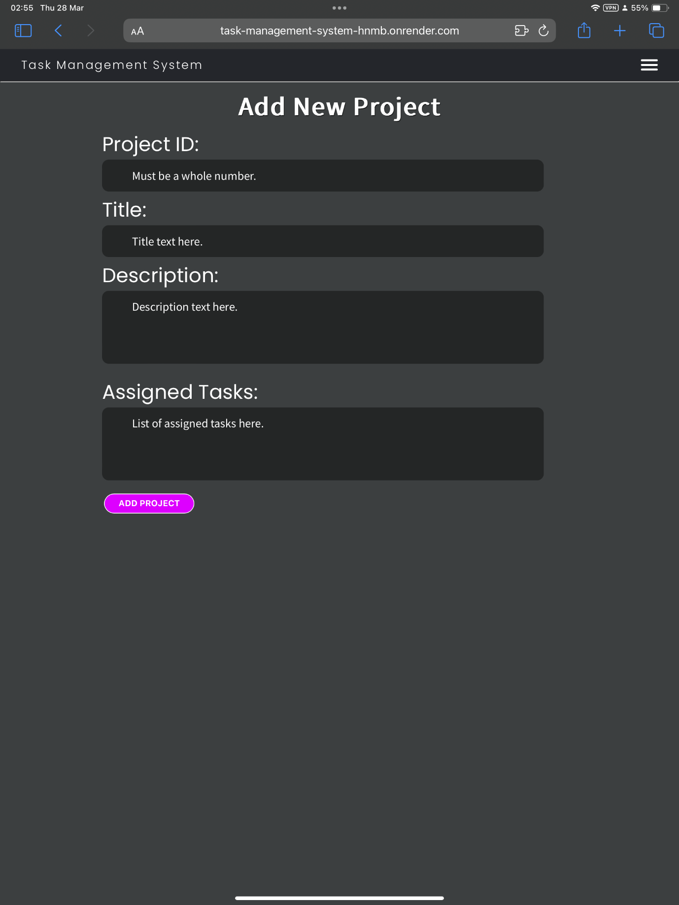

Figure 225 - Form viewed on iPad Pro (Portrait).

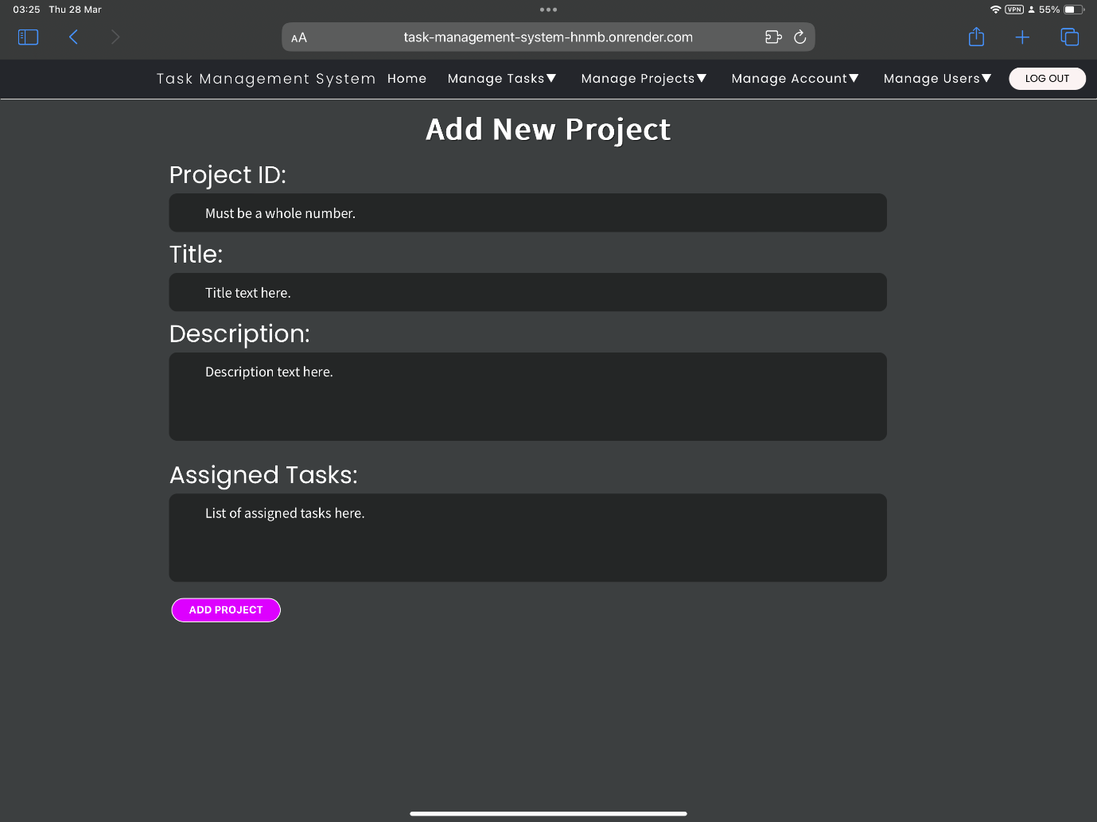

Figure 226 - Form viewed on iPad Pro (Landscape).